MAXIMAL snow accumulation In the Ukrainian CARPATHIANS

V.Grishchenko, A.Obrizan

Ukrainian Hydrometeorological Research Institute (UHRI), Kiev, Ukraine,
e-mail: tavrov@inbox.ru

Abstract: In work, the researches of stocks of water in a snow cover for territory of the Ukrainian Carpathians are executed. The design procedure of the maximal snow accumulations is developed. The received data have allowed constructing detailed cards of maximal snow accumulations and dates of their approach for territory of the Ukrainian Carpathians.
Keywords: snow cover, snow accumulations, design procedure of maximal snow accumulations.

maximal accumulation des schnees in Ukrainischer Karpaten

Zusammenfassung: In der Arbeit sind die forschungen der vorrate des wassers in der schneedecke fur das territorium Ukrainischer Karpaten erledigt. Es ist die methodik der rechnung der maximalen vorrate des wassers im schnee entwickelt. Die bekommenen daten haben zugelassen, die ausfahrlichen karten maximal accumulation des schnees und der daten ihres eintretens fur das territorium Ukrainischer Karpaten aufzubauen.
Schlüsselworte: die schneedecke, accumulation des schnees, methodik der rechnung der maximalen vorrate des wassers im schnee.

In connection with intensive industrial and recreation the development of mountain territories, increase of repeatability of the mixed high waters, growth water use arises necessity of increase accuracy of estimation water resources, including as a snow cover. One of the most important characteristics of a snow cover is the stock of water in it. These data are used at hydrological and snow avalanches accounts, at designing and construction of structures (for accounts of loadings on structures), at a tentative estimation of conditions winter recreation etc.
By preparation of the given work, which purpose was the research maximal snow accumulation in the Ukrainian Carpathians, the data of supervision on a network of hydrometeorological stations and posts of State Hydrometeorological Service of Ukraine for the long-term period (behind height of a snow cover on basic meteorological ground both linear pentads and decade snow surveys - 88 meteorological station and posts for the period 1947-2003 years were used; the data routing snow surveys in river pools on 11 routes with 98 snow points for the period 1965-2003 years).
The given networks of stations and posts in the Ukrainian Carpathians reflect conditions snow accumulation mainly under located of areas (up to 700-800 m. abs.); routing snow surveys cover in the basic zone up to 1100 m. abs.
For reception of the characteristics of a snow cover higher located of zones the data of supervision snow avalanches of stations behind height of a snow cover on remote measuring rods and for water reserves and density of snow in zones of break avalanches for date of readout of height of snow were used.
As in mountain the very strong influence on redistribution of a snow cover renders a wind, and remote measuring rods are established both in zones of accumulation, and in zones of snow blow, for definition of average long-term sizes maximal snow accumulation of measurement of height of snow on measuring rods averaged for group measuring rods, located in one high-altitude zone.
The supervision on remote measuring rods in area of stations Pozhezhevskaya and Plai will be carried out within 30 years (high-altitude zones from 1350-1900) and 22 years (height from 1100-1500) accordingly. With the help of the diagrams of connection of height and water reserves of snow on the data decade snow surveys and measurements of height of snow on remote measuring rods and water reserves, designed on the data of digging snow thickness (for dates close to dates maximal snow accumulation), 1680 m. abs. was possible to receive average long-term sizes maximal snow accumulation for three averaged levels -1330,1492, 1680 (Table 1).

Table 1. Average long-term maximal snow accumulation in areas snow avalanche stations Pozhezhevskaya and Plai

AS Pozhezhevskaya |  |  |  |  | AS Plai
W_{М}, мм | Wg₁  for Н=1492  m. abs., mm | $\frac{W_{М}+\text{Wg}}{2}$, mm | Wg₂  for Н=1680  m. abs., mm | Date of a maximum  W | W_{М}, mm | Wg₁  for  Н=1300  m. abs., mm | $\frac{W_{М}+\text{Wg}}{2}$, mm | Date of a maximum  W
310 | 459 | 385 | 488 | 12.III | 159 | 386 | 272 | 2.III
The note. Wm - water reserves of snow on the data of decade measurements on meteorological routes by extent in 1 Km; Wg - water reserves of snow on the data of supervision on remote snow measuring rods for date of realization snow surveys

On the data of supervision the diagram of dependence maximal snow accumulation from height of a snow cover in different pools was constructed, in view of the received sizes for mountain (Figure 1).
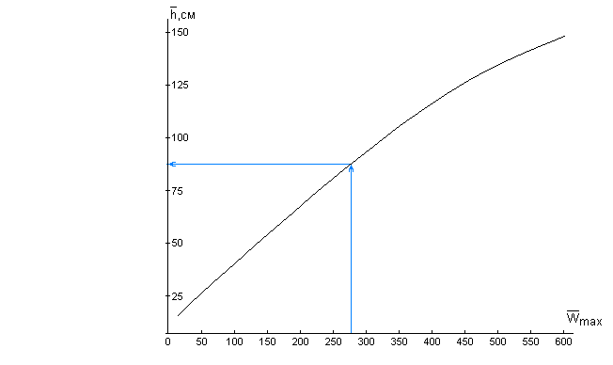
Figure 1. Connection of height of a snow cover (h, sm) with average maximal snow accumulation (Wmax, mm) for date of a maximum snow accumulation.

The average meanings of the maximal stocks of water in snow for river pools of the Ukrainian Carpathians were designed up to height 1750 M. The area of territory with higher marks is insignificant is small and if necessary snow accumulation on it is possible to determine by a way of extrapolation of the revealed dependence up to the uppermost high-altitude zones. Thus, with the help of the diagrams of connection average long-term maximal snow accumulation with absolute height in various pools has become to probable definition of these sizes for any high-altitude zone.
For definition settlement maximal snow accumulation of various security and the distributions them in various river pools were constructed curves of security of the given characteristic for the period 1946-2003 years. Thus the empirical security Р maximal snow accumulation was determined under the formula Krizkiy-Menkel, which corresponds to mathematical expectation of required probability of excess (1):
$P=\frac{m}{n+1}⋅\text{100}\text{\%}$, (1),
where m - serial number of the member of sizes maximal snow accumulation, located in the decreasing order; n - common number of the members.
The standard statistical parameters of curves of security Wc_{max}, Cv, Cs, were determined) by a graphoanalitical method of Alekseev on three basic coordinates Wc_{max5} of %, Wc_{max50} of %, Wc_{max95} of %, on which further it is possible to determine maximal snow accumulation of any interesting security.
For account maximal snow accumulation given security in any of items, proceeding from an assumption about normal distribution of the characteristics of a snow cover, the size coefficient Сs was accepted equal 2Сv.
The errors of definition of average size maximal snow accumulation, as is known, depend on factor of their variation and duration of the period of supervision. For items in the bottom parts of pools, where snow accumulation do not exceed 100 mm, the factors of a variation snow accumulation are equal and above 0,4-0,5.
In such cases, the greatest mistakes of definition of average sizes make on the average 15-20%. However, in the top, more multisnow zones, notwithstanding what here shorter numbers of supervision, the factors of a variation are reduced up to 0,3, and the mistakes of definition of average meanings snow accumulation make 10-15%.
The received data on a basis before the stated technique (Grishchenko, 1978) have allowed constructing detailed maps of average yearly maximal snow accumulation (Figure 2) and dates of their approach for territory of the Ukrainian Carpathians (Figure 3).

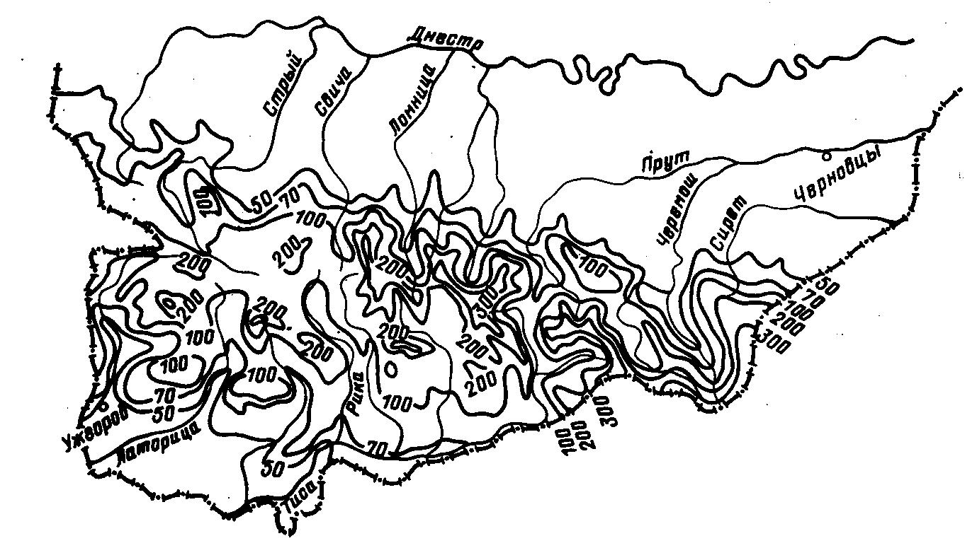Figure 2. Average long-term maximal snow accumulation

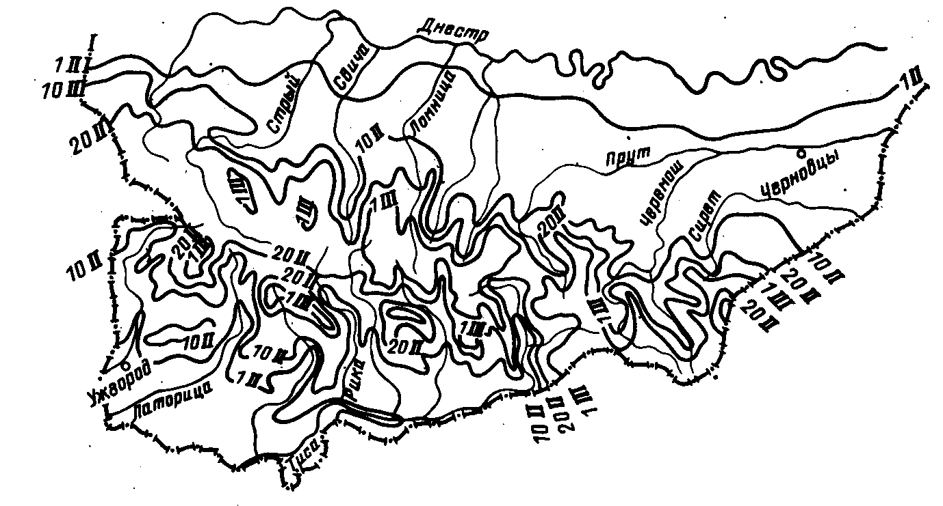

Figure 3. Average long-term dates maximal snow accumulation

The size greatest average maximal snow accumulation reaches size 250-300 Mm and it is necessary on files Chernogora and Svidovets (upper course of pools of the rivers a Rod, White and Black Tisa); Polonina mountain ridge and Gorgan (upper course of pools of the rivers Rika, Tereblya, Teresva, Lomnitsa); the a little bit smaller meanings are marked on northeast slopes. By results of given dependence the diagrams of connection for large river pools of the Ukrainian Carpathians were constructed
The settlement data have allowed making some conclusions about distribution of maximal snow accumulation in researched territory. The factors of a variation CV maximal snow accumulation change on territory from 0,25 up to 0,90. Moreover, for southwest slopes the amplitude them cycling is less (Cv = 0,39-0,66), than for northeast (Cv = 0,25-0,90). The relation Cs/Cv is steadier for areas of Zakarpatie, where it changes in limits from 1,8 up to 4,6; for Prikarpatie limits of fluctuation make from 0,8 up to 7,6 (Grishchenko, 1988).
Are similarly processed and the data on dates maximal snow accumulation are generalized. As the dates maximal snow accumulation of a steady snow cover less variability on territory, than snow accumulation, dependence of such dates on height region were under construction not for separate pools, and as a whole for territory of the Ukrainian Carpathians (Figure 4).

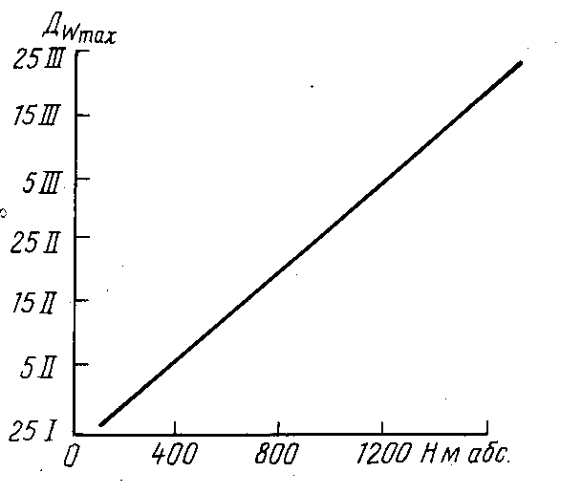
Figure 4. Dependence of average dates of a maximum snow accumulation Dmax
from absolute height of district Нabs

On the basis of actual and design of the data the map of dates maximal snow accumulation (Figure 3) was constructed, with which help it is possible to determine optimum terms of realization snow survive for the forecast of a spring drain for everyone concrete catchment area. Isolines on a card are carried out with a step per 10 days.
The researches which have been carried out in high-mountainous areas, have shown, that stocks of water in a snow cover it can much change and quite often considerably to exceed meanings determined by results of snow survive, carried out to height 1000 m. abs. Therefore, at realization of forwarding works of snow avalanches group of UHRI within winter 1980-81 years water reserves of snow on Dragobrat polonina changed from 798 mm (beginning of January) up to 2059 mm (end of March), and winter 1982-83 years- from 543 mm (January) up to 1020 mm (March).
The large value has the information on repeatability of multisnow winters, as they create inconveniences, and frequently both problem for the population and economic activity in region.
During last 60 years in the Ukrainian Carpathians, there were 11 multisnow winters, when the maximal stocks of water in snow on mountain catchment areas exceeded 200 mm (Table 2).

Table 2. Greatest snow accumulation in pool Tisa river during multisnow winters

Years | Snow accumulation, mm
Years | горные районы | низменные районы
1940-1941 | 200-450 | –
1951-1952 | 150-250 | 15-30
1954-1955 | 120-260 | 20-50
1955-1956 | 90-210 | 15-50
1963-1964 | 140-270 | 30-80
1966-1967 | 130-210 | 50-150
1967-1968 | 120-310 | 20-40
1973-1974 | 90-310 | 30-70
1975-1976 | 160-300 | 50-120
1986-1987 | 110-280 | 100-140
1998-1999 | 200-380 | 100-150
1999-2000 | 300-360 | 100-150
2000-2001 | 160-190 | 30-55
2001-2002 | 400-530 | 90-130
2002-2003 | 190-260 | 80-125

Especially the winters 1941, 1968, 1976, 1999 and 2001 years were multisnow that confirms absence of steady repeatability of multisnow winters. Thus, the certain law in spatial lie of a snow cover is observed: always more snow collects in territory of east part Zakarpatie (pools of the rivers Rika, Tereblya, Teresva, upper courses of Tisa).

References
Grishchenko V. (1978): Account of maximal height of a snow cover in the Ukrainian Carpathians (in Russian). Proceedings of UHRI, Vol. 168, pp. 100-104, Moscow.
Grishchenko V. (1988): A maximal snow accumulation in the Ukrainian Carpathians (in Russian). Proceedings of UHRI, Vol. 231, pp. 63-70, Moscow.
Sakali I. et al. (1985): Thermal and water mode of the Ukrainian Carpathians (in Russian). Leningrad, 366 p.

Maximum of Snow accumulation
in the Ukrainian Carpathians

The present research was executed in connection with necessity of reception of the detailed characteristic of distribution snow accumulation in mountains on the basis of a extensive material on snow cover on highlands of the Ukrainian Carpathians, accumulated in the last decade. As initial materials for research data decade and pentad snow depth observations 49 stations and posts, supervisions on 11 mountain snow measuring routes in 98 snow posts and in regions of avalanches stations have served.
The given networks of stations and posts in Ukrainian Carpathians reflect conditions snow accumulation predominary lower territories of regions (up to 700-800 m); routing snow depth observations cover basically zones up to 1100-1300 m a.s.l.
For reception of the characteristics snow cover at higher elevations of zones data of supervision avalanches stations Plai and Pozhezhevskaya (located in upstream of the river Prut and Latoritsa accordingly) at height snow cover on remote measuring rods for water capacity and density snow in zones of avalanches interruption were used.
As far as in highlands very strong influence to redistribution snow cover renders a wind, and remote measuring rods are installed as in accumulation zones, as in zones snow blowing, for determination of average long-term sizes maximum snow accumulations of measurement of height snow on measuring rods averaged for group measuring rods, located in one high-altitude zone.
The supervision on remote measuring rods in a region of avalanches stations Pozhezhevskaya and Plai are conducted more than 30 years. Therefore with the help of the schedules of connection of height and water capacity of snow on a data decade snow measuring and measurements of height snow on remote measuring rods and water capacity, designed on given digging snow thickness (on dates, close to dates maximum snow accumulations), has managed to extend numbers of supervision and to receive average long-term sizes snow accumulations for mountain territories, located higher the top border of wood, where distribution snow extremely non-uniformly.
The duration of numbers of supervision above snow cover in various regions changes over a wide range, but in given work data of supervision of stations and posts with 1947 on 2002 years are used. And on routes - with 1965 on 2002 years, i.e. not less than for 30 years.
Main way generalization of supervision average for period maximum snow accumulations was construction of graphic connections of these characteristics with height of a district. Integration was conducted on pools of the rivers, for which dependences W=f (H) where W – average years maximum stock of a water in snow cover, mm, Н - absolute height of a district, m, were under construction.
The average significances of maximum stocks of water in snow for Ukrainian Carpathians were received up to height of 1750 m. If necessary snow accumulations on it is possible to determine by a way extrapolation of revealed dependence up to the most top high-altitude zones.
Thus, with the help of the schedules of connection average long-term maximum snow accumulations with absolute height in various pools has become probable determination of these sizes for any high-altitude zone. The errors of determination of average size maximum snow accumulations, as is known, depend on a factor them variation and duration of a period of supervision. For items in the bottom parts of pools, where snow accumulations 100 mm, variation coefficient of snow accumulations are equal and above 0,4-0,5. In such cases the heaviest errors of determination of average sizes make on the average 15-20 %. However in top, more multisnow zones, notwithstanding that here shorter numbers of supervision, the variation coefficients are reduced up to 0,3, and the errors of determination average significances snow accumulations make 10-15 %.
The received data have allowed constructing detailed maps of average years maximum of snow accumulations and dates of their approach for a territory Ukrainian Carpathians.

