REGIONAL CHARACTERIZATION OF FLOODS ON SMALL CATCHMENT AREAS OF THE MOUNTAINOUS AND HILLY AREAS OF HUNGARY

Dr. techn. Kálmán Koris C. E., Kálmán Koris (Jr.) C. E.

Budapest University of Technology and Economics, Department of Hydraulic and Water Resources Engineering, Budapest, Hungary, e-mail: edinex@freestart.hu

Abstract: The determination of design flood is one of the most important tasks of technical hydrology. The work started with the creation of the geographical database of the catchments in concern. This is followed by the determination of the hydrological database. The basic data of the empirical tools are derived from the hydrological-statistical processing of the data of those catchments, which have long flow records. The runoff functions have been developed for each of Hungarian runoff regions. The runoff functions allow the calculation of the flood flow of p% probability with the formula Q_{p%}=a_{i}q_{5%}A. The general form of the flood flow formula is Q_{5%}=aA^{1-b}.
Keywords: design flood, empirical method, hydrological analogy, hydrological statistics, runoff regions, runoff equations.

1. Introduction

The determination of design flood is one of the most important chapters of applied hydrology. Most of the international procedures take a flood of given probability as design flow, which means that Q_{m} = Q_{p%}, in other words the problem is approached stochastically. The minority takes the “most highest” flood as design value, Q_{m} = Q_{max.max}, which is the physical approach of the extremity. It lies on uncertain physical-hydrological basis and gives unrealistic, very high value which is almost never economical. Considering optimal calculation probability means more accurate approach. This method also lies on the basis of probability, that is Q_{m} = Q_{opt} ( = Q_{p%} ). The application of the method is limited by the uncertainty of the economical-commercial functions and arguments. It is general to consider the authoritative design flow with an annual flood of given probability.
In most cases the determination of design flood is carried out by using empirical methods that might based on estimations, calculations or application of observed data. The most important basis of adaptation based on hydrological analogy - under the same climatic circumstances – can be regarded the geographical shape of the catchment and the physical qualitative parameters as well as data on coverage of the surface of catchment and the geological base.
At the determination of the design flood flow of hydrologically undeveloped catchments, the above data correspond with the similar data of the basis of the empirical method. We accept the hydrological analogy, that is, we regard the flood runoffs similar to the runoff conditions of the catchments, that constitute the basis of the method.
Naturally, if we have longer data series based on the discharge-observations in the section or nearby to the main flow of the examined catchment, the authoritative value can be determined statistically. The most various methods of hydrology can be used in the data region between these two extremes (absolute absence of hydrological data – long term discharge data series).

2. Briefly about the calculation of flood in Hungary

From the hydrological historical point of view, the first Hungarian processes were developed on the basis of the processes of international hydrological bibliography. It is important to note, that these methods – after adequate consideration – can be accepted and applied by Hungarian researches, but the parameter basis cannot be used. The deviations in climate and in flow regime in different regions of the Earth are so huge, that even the data of the neighboring countries cannot be applied for the catchments of our mountainous and hilly areas.
On undeveloped catchments, in case of massive application, the empirical methods come forth by all means. The first Hungarian processes are based on the formula Q_{p} = f(A) (A – the size of the catchment area) of the American Myer (1879), which is widespread in numerous versions in literature (Zsuffa 1968). The most widespread and most reliable is the Csermák-formula, Q_{p} = r·B_{3%}·$\sqrt{A}$, based on estimations and calculations (1957). In the equation r is the probability factor, B_{3%} is the high water factor depicted on the map. This formula was later modified to Q_{p} = r·B_{3%}·A^{q} , where the exponent q depends on the size of the catchment region. The isopleth map that contains the values of the factor B of the Csermák-formula was updated in VITUKI in 1984 by processing the huge amount of hydrographical detection data of the past three decades. At the same time, they tried to use exponents different than 0,5 (Kovács-Domokos 1984). We have to mention the latest experiment related to the Danube-catchment with a size of 817000 km², in which 13 countries - including Hungary – cooperated in the NHP. In this experiment, the Danube-catchment was divided into 5 regions and to each region a work-help was provided for estimation of distribution functions of annual floods of water stream sections without observation (Stanescu-Ungureanu-Domokos 1999).
Another typical and frequently used Hungarian method is the VÍZITERV work-help by Kollár (Koris 2001) that can be expressed as Q_{p} = a_{p%}·A·q_{10%} (where q_{10%} is the specific flood flow, it can be derived from a diagram in function of the size of catchment area A).

3. Basis of the new method

In 1998 research was started for the development of the hydrological basis of land drainage of mountainous and hilly areas. The main task of the research was the development of a new calculation method for high-water flow of catchments on hilly and mountainous areas and also assembling a new work-help for flood calculation based on this method. During 1998 the geographical and the hydrological database (by collecting the highest annual flow) of small catchment areas was completed, this created the geographical and hydrological basis of this new method.
In 1999 we examined the time series of the highest annual high-water flow (taking the hydrological database as a basis) and the data series longer than n≥30 years (statistical sample length) have been selected. The full hydrological statistical distribution test was applied to these time series. The resulting approximately 100 flood distribution functions can directly be applied for planning land drainage and maintenance by procedures of administrative allowances. After that the shorter data series (with non-statistical sample length) were examined by selecting the data series of appropriate length from the time series with length of 20≤n≤30 years with the crossing method sampling. Special double exponential distribution functions were used for the distribution analyses and thus the informational database could have been enlarged with further stations. These, altogether 104 distribution functions made the basis of the flood calculation procedure that (by the use of hydrological analogy) can be applied to unknown, in other words hydrologically undeveloped catchments of hilly and mountainous areas (OVF 2001).
It is interesting to examine how the number and the area size ratio of the available observed catchments of hilly and mountainous areas change according to district water authorities (Table 1.).
Table 1. Small catchments of hilly and mountainous areas
District water authority | Catchment
District water authority | Size |  |  | number
District water authority | smallest | mean | largest | number
District water authority | km² |  |  | pcs
North-Hungarian | 1 | 569 | 4167 | 39
Central-Danubian | 65 | 851 | 5010 | 26
North-Transdanubian | 5 | 348 | 2710 | 23
Central-Transdanubian | 0,5 | 326 | 3210 | 71
South-Transdanubian | 2,4 | 224 | 940 | 41
West-Transdanubian | 16 | 671 | 4734 | 25
Summary | 0,5 | 498 | 5010 | 225

However, only less than half of the numerous (225 pcs) catchment areas have statistical sample length (104 pcs). Table 2. represents the stations that were examined statistically.

Table 2. Area sizes of statistically examined stations
District water authority | Catchment
District water authority | Size |  |  | number
District water authority | smallest | mean | largest | number
District water authority | km² |  |  | pcs
North-Hungarian | 36 | 732 | 4167 | 18
Central-Danubian | 65 | 1063 | 4207 | 12
North-Transdanubian | 49 | 472 | 2710 | 13
Central-Transdanubian | 20 | 607 | 3210 | 29
South-Transdanubian | 2,4 | 336 | 940 | 16
West-Transdanubian | 15,8 | 869 | 4734 | 16
Summary | 2,4 | 680 | 4734 | 104

According to Tab. II. the sample analyzed by their size by statistics represents well the whole observed catchment ensemble. Comparing the smallest catchment area: 0.5 km² → 2.4 km², mean catchment size: 498 km² → 680 km² and the largest catchment size: 5010 km² → 4734 km². The first numbers represent the whole values and the second ones represent the characteristic values of the statistical sample. Therefore, it is expected that the results of the statistical analyses will be characteristic of the whole observed sample and finally of all catchments of hilly and mountainous areas.

4. The new Hungarian method for flood calculation

The hand work-help for flood calculation can be applied for the determination of flood flow with different probability of occurrences for hydrologically unexplored Hungarian catchments on hilly and mountainous areas (Koris 2001, OVF 2001). The applicable catchment sizes are A = 2÷6000 km², limit values can also be applied. The work-help cannot be applied for completely plain or drainage areas, artificial channels with flat slope or drainage water channels. The flow zone must be considered hydrologically explored if in the examined zone or in its surroundings (but on the same flow) there is a gauge station and the stochastic distribution function of the annual highest flow is known or can be calculated using the data series of the gauge. In this case, the flood flow of different occurrence probability must be calculated by a statistical method. With the use of the work-help the occurrence probability of p=1,3,5,10 and 20% can be determined, in other words the flood per 100,33,20,10 and 5 annum can be calculated. Flood probability smaller than p=1% cannot be determined with this method. Floods of arbitrary probability can be determined in the p=1÷20% region by linear interpolation between the defined values, whereas in case of higher probability than 20% there is a theoretical possibility for that. Statistical distribution functions calculated by observed data constitute our new flood determination method.
First the specific flood flows to the p=5% occurrence probability were determined, that is optimal in the aspect of the research, thus the differences coming from the size of the catchments can be eliminated and the similar values of catchments with different flow characteristics can be compared. The previous meant the determination of q_{5%} [m³s⁻¹ km²] values, which were depicted by the size of the catchment A [km²], in a coordinate system of double logarithmic scale. The data of catchments on hilly and mountainous areas were differentiated according to territories. Based on the data on the figure, we concluded that the Hungarian hilly and mountainous areas can be divided into relatively well separated flow regions that constitute coherent territories. (Figure 1.) From this we can determine the position of the studied catchment and the applied flow function will be chosen based on this. In case of catchments lying on border of a regions, the test of the flow should be completed by the work-help of the neighboring region. It should be decided by scaling if the neighboring – maybe larger – values could be taken into account, or not.

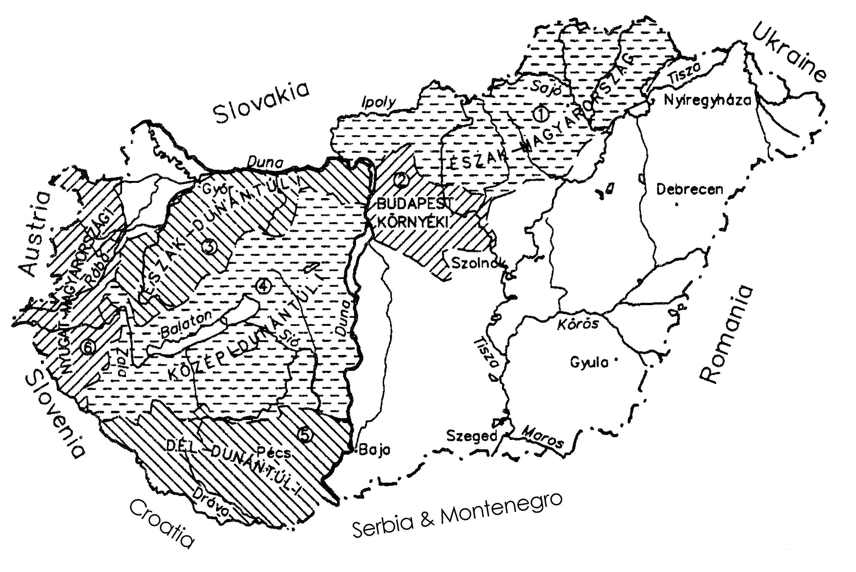
Figure 1. The mountainous and hilly runoff regions of Hungary

The relations q_{5%} [m³s⁻¹ km⁻²] = f(A) [km²] were determined for six regions, out of which the one for North-Hungarian region is going to be demonstrated. (Figure 2.).
The choice of runoff region is followed by the determination q_{5%} [m³s⁻¹ km⁻²] specific flood flow of p = 5% occurrence probability using Figure 2. The interrelations give us the line of mean ratio and its surrounding zone. The upper region should be used in case of flashy runoffs, whereas the lower one should be used in case of balanced flow regimes.
Values can be considered by balancing the hydrological conditions within the whole region. (Value that is out-of-region can be considered as well.) For the analysis of the runoff conditions the geographical and covering data, and other parameters that affect the characteristics of the runoff are needed.

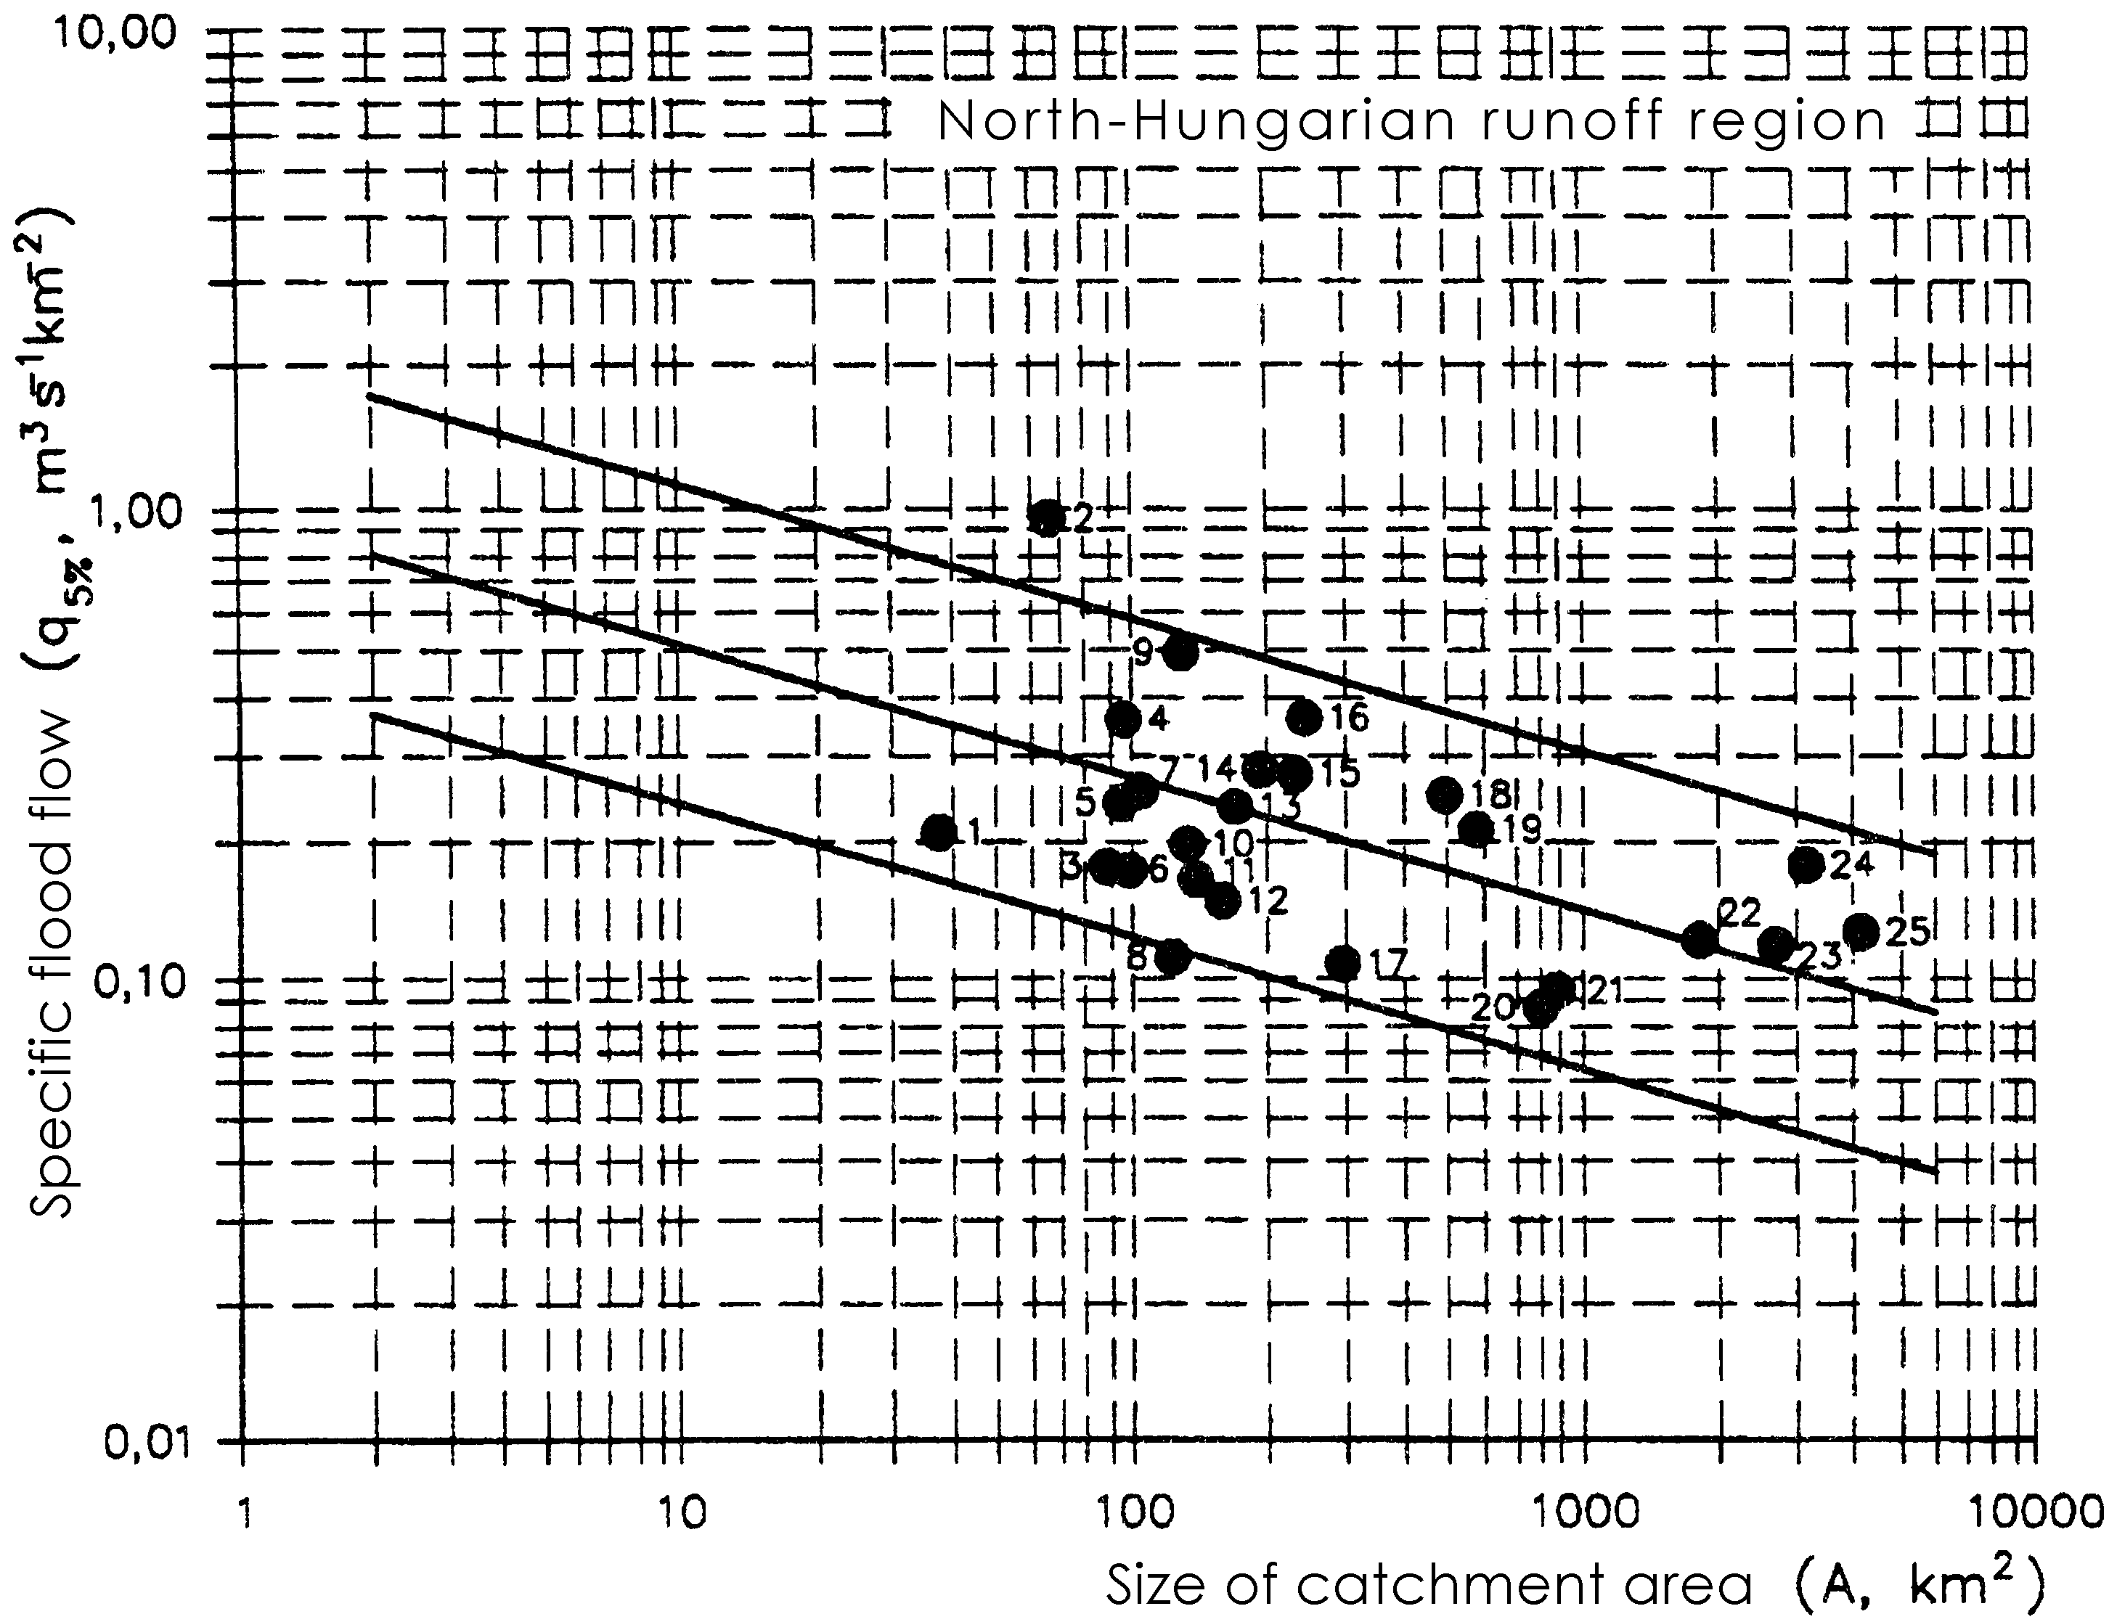

Figure 2. The functions q_{5%} = f(A) of the specific flood flow

The application of the calculable geographical parameters of the examined catchment provides one of the methods for the characterization of runoff relations. The parameters taken into account and their interpretation:

- size of the catchment area (A km²),
- size of the wooded part of the catchment area (A_{e} km²),
- size of the karstic part of the catchment area (A_{k} km²),
- size of the part of the catchment area covered with lakes and reservoirs (belonging to maximum water level) (A_{t} km²),
- sum of volume of lakes and reservoirs (belonging to maximum water level) of the catchment (V_{t} 10⁶m³),
- length of the catchment (B km),
- width of the catchment (C km),
- length-width ratio of the catchment (B/C),
- lowest point of the catchment ( point “0” of the erosion base) (H₀ m B.f.),
- mean height of the catchment area (H_{mean} m B.f.),
- highest point of the catchment (H_{max} m B.f.),
- average slope of the catchment area (I=(H_{max} - H₀)/S ‰),
- length of the main valley (according to M=1:100000 map) (S km),

Table 3. Values of parameters affecting the high water runoff by regions.
Parameter |  | A  [km²] | A_{e} | A_{k} | A_{t} | V_{t}  [10⁶m³] | B | C | B/C  [-] | H₀ | H_{mean} | H_{max.} | I  [‰] | S  [km] | (S’+ΣS_{m})/A  [km/km²] | P_{aa}  [mm]
Region |  | A  [km²] | [%] |  |  | V_{t}  [10⁶m³] | [km] |  | B/C  [-] | [m B.f.]
North-Hungarian | min. | 36 | 16,7 | 0 | 0 | 0 | 12 | 4,2 | 0,55 | 89 | 180 | 388 | 6,3 | 8,3 | 0,14 | 550
North-Hungarian | max. | 4167 | 100 | 100 | 0,34 | 6,8 | 78 | 85 | 3,14 | 316 | 580 | 1384 | 59,4 | 148 | 1,99 | 800
Budapest district | min. | 80 | 15 | 0 | 0 | 0,34 | 17,5 | 9 | 0,93 | 87 | 146 | 302 | 6 | 17,7 | 0,16 | 550
Budapest district | max. | 4207 | 35 | 6,25 | 0,34 | 31,9 | 75 | 81 | 3,08 | 156 | 300 | 1015 | 15 | 115,1 | 0,38 | 600
North-Transdanubian | min. | 56 | 16,6 | 3,5 | 0 | 0 | 11 | 4 | 0,80 | 109 | 195 | 343 | 6 | 13,7 | 0,18 | 560
North-Transdanubian | max. | 2710 | 42,6 | 50 | 0,7 | 4,34 | 70 | 69 | 4,50 | 184 | 320 | 704 | 28,9 | 105 | 0,66 | 750
Central-Transdanubian | min. | 16,7 | 6,6 | 0 | 0 | 0 | 7 | 3 | 0,80 | 92 | 130 | 175 | 2 | 1,5 | 0,08 | 550
Central-Transdanubian | max. | 3210 | 57,8 | 75 | 1,9 | 60 | 83 | 86 | 6,25 | 298 | 279 | 645 | 136,7 | 119,5 | 0,65 | 740
South-Transdanubian | min. | 2,4 | 20 | 0 | 0 | 0 | 2,3 | 1,3 | 0,83 | 93 | 132 | 154 | 0,9 | 1,7 | 0,23 | 640
South-Transdanubian | max. | 940 | 100 | 2,9 | 1,6 | 26,5 | 59,9 | 45,9 | 2,89 | 205 | 250 | 681 | 70,6 | 71,4 | 0,94 | 750
West-Hungarian | min. | 15,8 | 3,6 | 0 | 0 | 0 | 7 | 2 | 1,02 | 110 | 180 | 270 | 2,9 | 7 | 0,38 | 660
West-Hungarian | max. | 4734 | 88,5 | 0 | 0,27 | 7,18 | 98 | 73 | 3,50 | 263 | 395 | 1783 | 28,8 | 169 | 0,95 | 880

- density of drainage network (according to M=1:100000 map), if S’ is the length of the main creek, ΣS_{m} is the total length of side creeks in km [(S’+ΣS_{m})/A km/km²],
- average annual rainfall (of many years) (P_{aa} mm),
- type of soil (clay, adobe clay, sand and the transitions of these),
- geological type (carbonate, anemolastic, volcanic).

Table 3 gives the extreme values (that is, the maximum and minimum) of the parameters by runoff regions. The table was made based on the data of the catchments that constitute the hydrological database of the work-help.
The parameters that influence the high-water flow and the data of Table 3. are very important factors in the applicability of the work-help, just as in the existence of the hydrological analogy. (Hydrological analogy is interpreted between the observed catchment and the applied catchment base.) If the parameters of the observed catchment are between the minimal and maximal limits of Table 3., we consider the hydrological analogy existing, and the work-help can be applied by all means. (Naturally, the work-helps can also be applied if the parameters of the observed catchment are not between the limits, but in this case the runoff ratios should be analysed from several sides.) At the same time based on the comparison of the calculated parameters and the limits of Table 3. the hydrological-runoff ratios are classifiable, that is, it can be decided if the runoff ratios are flashy, average or balanced. There are numerous other ways of the determination, classification of the runoff ratios, one of the most important ones of these is the site inspection and the conclusions that can be drawn from that.
After the analyses of the runoff ratios based on the above the q_{5%} specific flood flow can be applied, according to Figure 2. - or other graphs of similar figures. With these relations the p=5% (occurring once in every 20 years on average) flood flow can be calculated with the formula Q_{5%}=q_{5%}·A [m³s⁻¹]. Flood flows of arbitrary probability could be relocated by the a_{p} - dimensionless transference numbers of Table 4.

Table 4. Probability factors of flood calculation work-help.
Probability factor | $$a_{1}=\frac{Q_{1\text{\%}}}{Q_{5\text{\%}}}$$ | $$a_{3}=\frac{Q_{3\text{\%}}}{Q_{5\text{\%}}}$$ | $$a_{\text{10}}=\frac{Q_{\text{10}\text{\%}}}{Q_{5\text{\%}}}$$ | $$a_{\text{20}}=\frac{Q_{\text{20}\text{\%}}}{Q_{5\text{\%}}}$$
a_{p} [-] | 1,7 | 1,2 | 0,8 | 0,6

In general, flood flows of p% occurrence probability can be calculated according to:

Q_{p%}[m³s⁻¹]=a_{p}· q_{5%} [m³s⁻¹ km⁻²] ·A[km²]

In case we want to compare the results of our calculations with the results of other previous procedures, then it should be done first and foremost with the results of the empirical flood flow calculation procedures of the Csermák-formula.

5. Example for the calculation with the work-help

A catchment of A = 156 km² size is given in the Northern-Hungarian region. The task is the determination of the flood flow of p=1% probability, Q_{1%}. First, the runoff ratios should be classified. Based on a site inspection it was determined that the runoff ratios are flashy. For that reason, using the border line of the upper zone of Figure 2., the value of the specific runoff is: q_{5%} = 0,45 m³s⁻¹ km⁻²
According to the related table, the probability factor is: a_{p}= Q_{1%}/Q_{5%}=1,7

The flood flow of p=1% probability is: Q_{1%} = a_{p}·q_{5%} ·A = 1,7·0,45·156 = 119 m³s⁻¹

(Only the technique of the calculation was introduced in the example, there were no comparisons, since it was a fictitious catchment.)

6. Examination of flood functions

Based on the antecedents the q_{5%} [m³s⁻¹ km⁻²] = f(A) [km²]^{-b} relations could be given by the following functions:
q_{5%} [m³s⁻¹ km⁻²] = a A [km²]^{-b}

furthermore: Q_{5%} = q_{5%} A = a A^{-b} A = a A^{1-b}

that is: Q_{5%} [m³s⁻¹] = a A [km²]^{1-b}

The equations have been calculated to all regions, and parameters a, (-b), (1-b) have been given according to Table 5.

Table 5. Parameters of flood functions
Region | Parameter
Region | a | -b | 1-b
North-Hungarian | 0,95 | -0,28 | 0,72
Budapest district | 0,25 | -0,20 | 0,80
North-Transdanubian | 0,72 | -0,30 | 0,70
Central-Transdanubian | 0,46 | -0,36 | 0,64
South-Transdanubian | 1,30 | -0,42 | 0,58
West-Hungarian | 1,10 | -0,23 | 0,77

It is difficult to calculate a global average from the parameters of equations, but the parameters of average function approximately calculated according the database are the following values: a = 0,80; (1-b) = 0,70. In this case the equation for flood function of p = 5% probability is: Q_{5%} [m³s⁻¹] = 0,8 A [km²]^{0,7}.
The flood function of p = 1% probability is:

Q_{1%} [m³s⁻¹] = 1,7⋅0,8 A [km²]^{0,7} = 1,36 A [km²]^{0,7}

This equation emphasizes that the floods of small Hungarian mountainous and hilly catchments are in function with 0,7th power of the catchment size instead of 0,5th power as assumed earlier (Wundt, Bárdossy, Szilágyi).

7. References

Bergmann, H.-Domokos M.: A Felső-Rába vízgyűjtőjének hidrológiai monográfiája. Technische Universitat Graz. Graz-Budapest, 1996.
Csermák B.: Kisvízfolyások árvízhozamának számítása. Beszámoló a VITUKI 1954. évi munkájáról. VÍZDOK, Budapest, 1957.
Dombvidéki Munkabizottság: A dombvidéki vízrendezés hidrológiájának fejlesztése. (A nagyvízhozamok új számítási módszerének kidolgozása.) Témafelelős: Koris K. Budapest 1998.
Dombvidéki Munkabizottság: A dombvidéki vízrendezés hidrológiájának fejlesztése. (A nagyvízhozamok új számítási módszerének kidolgozása.) Témafelelős: Koris K. I-V. kötetek. Budapest,1999.
Dombvidéki Munkabizottság: A dombvidéki vízrendezés hidrológiájának fejlesztése. (A nagyvízhozamok új számítási módszerének kidolgozása.) Témafelelős: Koris K. Budapest 2000.
EDINEX Consulting: Árvízi adatgyűjtemény. (Magyarország kisvízfolyásainak árvizei és azok statisztikai feldolgozása az észlelések kezdetétől 2000-ig.) Témafelelős: Koris K. Budapest, 2000.
Koris K. (szerk.): Hidrológiai számítások. Linográf Kiadó. Budapest, 2001.
Koris K.: Új hazai árvízszámítási módszer hegy- és dombvidéki vízgyűjtőkre. Magyar Hidrológiai Társaság XIX. Országos Vándorgyűlése. Gyula, 2001.
Kovács Gy.-Domokos M.: Segédletek a dunántúli kisvízfolyások szélsőséges vízhoza-mainak becslésére. Vízügyi Közlemények, LXVI. évfolyam 4. füzet, 1984.
Országos Vízügyi Főigazgatóság: Árvízszámítási segédlet a hazai hegy- és dombvidéki kisvízgyűjtők árvízhozamainak meghatározásához. EDINEX. Budapest, 2001.
Stanescu, V.A.-Ungureanu, V.-Domokos M.: A Duna-vízgyűjtők regionalizálása az évi nagyvízhozamok eloszlásfüggvényeinek becsléséhez. Vízügyi Közlemények, LXXXI. évfolyam 2. füzet, 1999.
Zsuffa I.: Műszaki hidrológia I.-IV. Műegyetemi Kiadó. Budapest, 1999.
Zsuffa I.: Vízfolyások árvízhozamának számítása. VITUKI. Vízügyi Műszaki Tájékoztató Iroda. 13. szám. Budapest, 1968.

