CHARACTERISATION OF THE RUNOFF REGIME AND ITS STABILITY
IN THE TISZA CATCHMENT

Dipl. Geogr. Péter Kovács¹, Dr. Eng. Béla Nováky²

¹Water Resources Research Centre (VITUKI) Plc., Budapest, Hungary,
e-mail: kovacsp@vituki.hu
²Szent István University, Gödöllő, Hungary, e-mail: novbela@fau.gau.hu

Abstract: Runoff regime is the fluctuation of a certain hydrological event within the year, its stability is the measure of deviation between the runoff regime of individual years and the typical regime pattern. The main goal of our work is to evaluate the runoff regime over the whole Danube Basin, but the aim of this paper is to investigate the hydrological regime in one of the most important subcatchment of the Danube River, the Tisza River Basin.
The runoff regime types of the Tisza Basin – defined by the probability of occurence of the first highest (MAX1) and first lowest (min1) monthly mean discharges – are following well the territorial changes of the climate connected with the elevation. As it is shown on the Figures 5-9, the runoff regime stability of the low flow events is higher than that of the flood events. The most stable part of the basin is the mountainous area around the springs of the Tisza, while the most unstable territory is in the western part, the Zagyva River Basin.
Keywords: Tisza River, runoff regime, characterization, runoff regime stability

KENNZEICHNUNG DES ABFLUSSREGIMES UND SEINER STABILITÄT
IM EINZUGSGEBIET DER THEISS

Zusammenfassung: Unter Abflussregime wird die Fluktuation eines gewissen hydrologischen Elementes während des Jahres verstanden. Unter Stabilität des Abflussregimes wird das Mass der Abweichung der einzelnen Jahre von einem regionalen typischen Gang des Abflussregimes verstanden. Der Hauptzweck des Projektes ist ein Überblick über das Abflussregime im ganzen Donauraum, während sich der vorliegende Beitrag mit der Untersuchung des Einzugsgebietes des Zubringerflusses Theiss begnügt.
Die Abflussregime-Typen werden anhand der Auftrittswahrscheinlichkeit des ersten höchsten (MAX1) sowie des ersten niedrigsten (min1) Wertes der monatlichen Mittlelabflüsse definiert. Im Einzugsgebiet der Theiss folgen diese Typen der von der Seehöhe abhängigen Verteilung der Klimaelemente. Aus den Abbildungen 5 bis 9 geht hervor, dass im Untersuchungsgebiet die Abflussregime-Stabilität der Hochwasser-Ereignisse von derjenigen der Niedrigwasser-Ereignisse übertroffen wird. Der stabilste Teil der Einzugsgebietes ist das bergige Quellgebiet der Theiss, während die niedrigste Stabilität im westlichen Teil, undzwar im Einzugsgebiet des Flusses Zagyva zu verzeichnen ist.
Schlüsselwörter: Theiss, Abflussregime, Kennzeichnung, Stabilität des Abflussregimes

1. Introduction
Runoff regime is the fluctuation of a certain hydrological event within the year. In the characterization of the runoff regime, selected events, first of all the extreme values play an important role. Although the realization of a selected hydrological event within a particular year may differ considerably from that of other years, the typical pattern of the runoff regime over a longer period can be detected. Regime stability is the measure of deviation between the runoff regime of individual years and the typical regime pattern.
Due to spatial variability of climate and prevailing physio-geographical conditions, the regime of the watercourses is also different and has a variability in space. Moreover the regime is influenced also by impacts of anthropogenic activities (e. g. land and water uses). When factors that determine the runoff regime do change in time (climate change, change in anthropogenic activities), both type and stability of runoff regime will change. Thus characteristics of the runoff regime can be used as indicators of climatic changes.
This work is a part of a project of the Hidrological Cooperation of the Danube Countries in the framework of the IHP UNESCO. The main goal is to evaluate the runoff regime over the whole Danube Basin. The aim of this paper is to investigate the hydrological regime in one of the most important subcatchment of the Danube River, namely in Tisza River Basin above the river section Szeged. The selected catchment is able to simulate the problems of an international river like the Danube, because four countries (Ukraine, Slovakia, Romania and Hungary) are sharing on the territory. In this model catchment, we would like to test the investigation methodology before using it on the whole Danube Catchment.

2. Investigations carried out in the past
The Tisza River Basin was investigated in the runoff regime stability study of Stanescu et al. (1997) in the frame of FRIEND-AMHY. As a result of the investigation a regionalization of hydrological regime types and its stability were carried out. Stability investigatoins allowed to determine the very stable, or stable montainous zones, relatively stable zones in medium altitudes and unstable or relatively unstable zones in low territories.
In the framework of a bilateral hydrological cooperation of the Water Resources Research Centre (Budapest) and the Technical University of Graz, 25 dicharge stations of the catchment of the Upper Raab River (belonging to the section of Sárvár) were processed for typifying the runoff regime and to determine its stability (Bergmann et al., 2001).
In the investigation of 52 watercourses of Hungary, also a stability investigation was carried out (Nováky et al., 2001). It was found that the most stable is the runoff regime of watercourses originating from karstic regions and the least one is the runoff regime of watercourses under heavy anthropogenic impacts. As a rule the runoff regime has the highest stability in the western part of the country (Transdanubia) due the most even climate. The Raba River originating from the Alps is the only exception with the lowest stability of runoff regime among all the investigated watercourses.

3. General description of the Tisza River Basin
The roundish shaped catchment of the River Tisza is located in the middle of Europe. The total area of the catchment is 157,200 km². From northwest to southeast the basin is surrounded by the very high ridges of the Carpathian Mountains. The western and southwestern watershed boundary of the Tisza Basin follows the very low plateaus of the Hungarian lowland even though its exact location is unclear in many places. The springs of the river are in the Chornogora Mountains, in the highest range of the Ukrainian Carpathians, and the river reaches the Danube in Serbia after 966 km flow.

3.1. Topography and the river network
The river network can be divided into 8 characteristic subsystems (Zsuffa, 2003): 1) the Upper Tisza system (13173 km²) with the Bila Tysa and Chorna Tysa; 2) the Somes/Szamos river system (15882 km²), with the Somesul Mare and the Somesul Mic sub-river systems; 3) the Bodrog river system (13570 km²), with the Topla, Ondava, Laborec, Uzh and Latoryca sub-river systems; 4) the Slana/Sajó river system (12708 km²), with the Bodva/Bódva and Hornád/Hernád river subsystems; 5) the Zagyva river network (5676 km²), 6) the Cris/Körös river system (27537 km²), with the Barcau/Berettyó, Crisul Repede/Sebes Körös, Crisul Negru/Fekete Körös and the Crisul Alb/Fehér Körös tributary river networks; 7) the Mures/Maros river system (303332 km²), with the Aries and Tarnava tributary river networks and 8) the direct drainage area of the River Tisza, that also consist fairly large tributary systems, such as the Crasna/Kraszna or the Aranca and the Bega in the lower (Serbian) catchment.
The topography of the whole Tisza basin is characterized by high but narrow chains of mountains surrounding huge and flat lowlands. This ‘swimming pool’ feature of the basin is responsible for the serious flood problems that have been encountered on the lowlands many times. That is to say, the rainwater flowing quickly down from the mountains slows down and accumulates on the lowland areas (Figure 1).

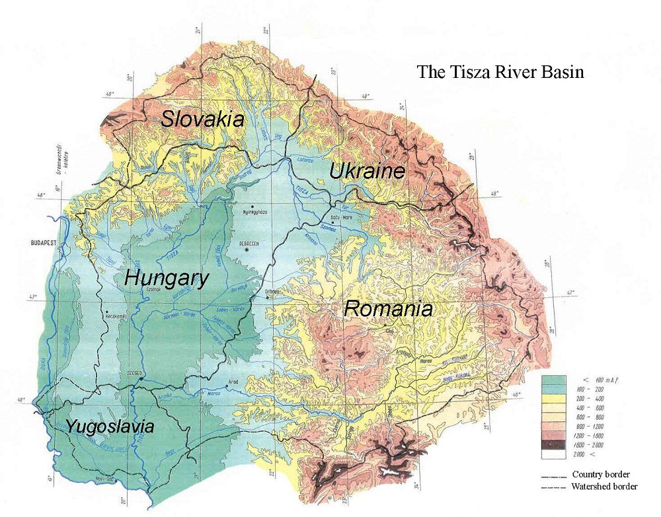
Figure 1. Topographic map of the Tisza River Basin

The closing profile of our investigation is at Szeged, Hungary, because this is the last downstream station on the river we had data serie from. So we were not able to investigate the whole Tisza catchment, so the applied area for the survey was almost 140000 km².

3.2. Climatic conditions, hydrometeorology
Annual precipitation on a continental river basin of the moderate climate is generally proportional to the terrain elevation. Accordingly the precipitation in the Ukrainian Carpathians might exceed 1700 mm, while in the lowland part of the river basin, in the Great Hungarian Lowland, annual precipitation is frequently less than 500 mm (Figure 2). Nevertheless there are significant deviations from this general rule at many places due to the ruling northwestern wind direction. That is to say, the northwestern slopes of the mountains are more exposed to precipitation, e.g. at the Apuseni Mountains, causing severe flood problems in the Cris/Körös river system (Zsuffa, 2003).

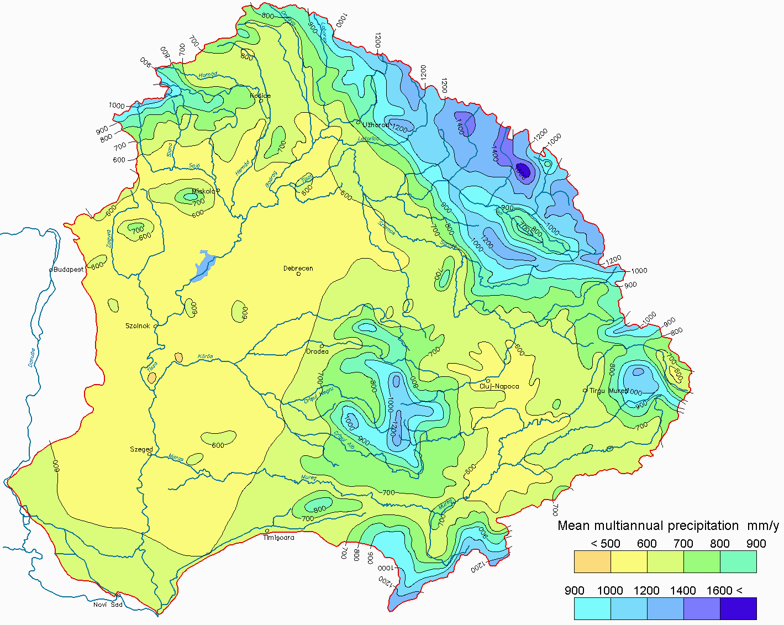 | 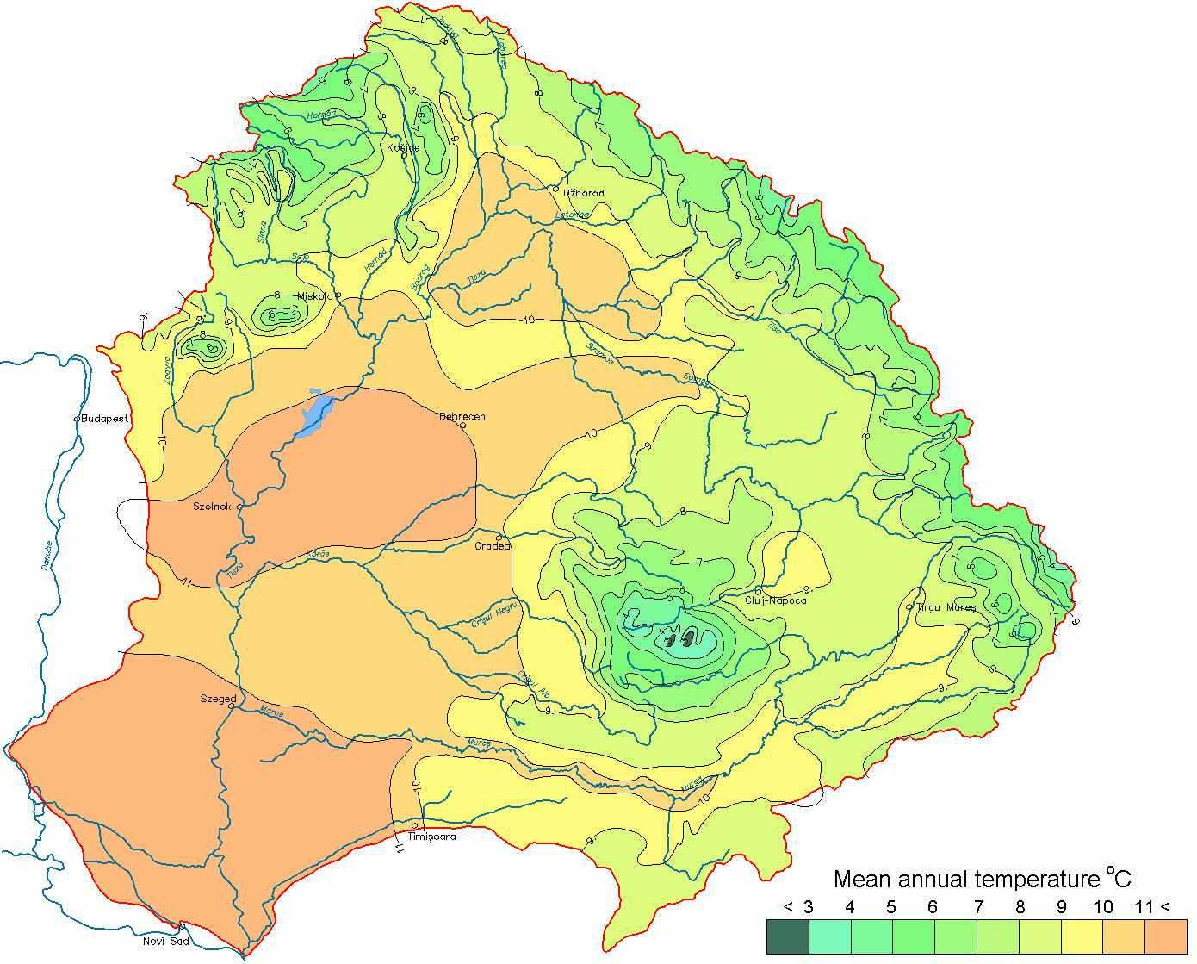
Figure 2. Annual precipitations and mean temperatures within the Tisza catchment

In the Tisza River Basin, the variation of precipitation within the year is characterized by summertime rainstorms, as the peak precipitation events, associated with relatively low wintertime precipitation. In addition, the influence of the mediterranean climate results in a secondary precipitation peak in October and November. In February the snow cover varies between 3 and 40 cm, which equals a water content of about 9-120 mm. Abrupt melting of the snow cover can cause very dangerous floods. Similarly dangerous situation occurs when heavy rainfall hits the still frozen land surface of the higher catchment parts.
Annual average air temperature of the drainage basin (Figure 2) varies mostly with the altitude and thus the areal temperature distribution closely resembles the topographic map. The lower Hungarian parts of the river basin are subject to extreme temperature variations. The summer maximum air temperature can be as high as 40 ºC, while winter temperature at the very same place may drop below -30 ºC. The Hungarian plains are also subject to very abrupt changes, and extreme fluctuations; 40-50 degree Celsius temperature change per month have been observed several times (Zsuffa, 2003).

4. Methodology of determining runoff stability index and of certained stability categories
The method of identifying the runoff regime type is based on the investigation of so-called discriminant periods within the years for six selected hydrological events as the first, second and third highest as well as the first, second and third lowest monthly (mean) discharges (symbolized: MAX1, MAX2, MAX3 and min1, min2, min3). The discriminant period is the time section consisting of a given number of months within which the given hydrological event is occured by the highest probability. In our investigation the discriminant period was chosen as 3 months.
Using the time series of monthly flow the discriminant periods were evaluated for all hydrological stations investigated. Two hydrological stations have the same runoff regime type if the discriminant periods related to all hydrological events are the same or differs with only some limitations. The runoff regime of two stations may be accepted as identical if the discriminant periods of one or two hydrological events, especially of MAX3 or min3, rarely MAX2 or min2, are differ not more than one month.
After having determined the type of runoff regime for all hydrological stations, the runoff regime stabilities of the individual stations (or else of regional station groups) can be investigated.
Stability can be characterized by adopting the following index: the index H, measuring the entropy as defined by Shannon, is the sum H=ΣH(E_{j}) of the index H(E_{j}) characterizing the individual stabilities of the six hydrological event listed above, as defined by the following equation:

$H\left(E_{j}\right)=p_{i}×\text{ln}p_{i}+\left(1−p_{i}\right)×\text{ln}\left(1−p_{i}\right)$ (1)

where p_{i} is the probability of occurence of the given hydrological event within the selected discriminant period of the year and $\left(1−p_{i}\right)$ is the probaility of occurence of the same event within the complementer period. The value of entropy $H(E_{j})$ is depending on the length of the observation period, namely the number of the investigated years, and the place of this period in the absolute time. The entropy is decreasing with the growth of the investigated period if its lenght is at least 30 years or more.
The function (1) is simmetrical, that is $H\left(p_{i}\right)=H\left(1−p_{i}\right)$. Thus the stability index H can be used only in case if $p_{i}>0,5$. This limitation can be lifted by introducing its modified version as it was proposed by Nováky (2001):

$N=−\sum{p_{i}}×\text{ln}p_{i}$ (2)

where p_{i} is the probability of occurence of a given hidrological event within the i ^{th} period, while i ranging from 1 to 4. It means that the whole year is divided into 4 equal periods, consisting of 3-3 months, and the period, where $i=1$ is the discriminant period. Obviously, the equality

$p_{1}+p_{2}+p_{3}+p_{4}=1$ (3)

is valid.
On the basis of the index of the runoff regime stability, the stability can be qualified or categorized. The selection of the category limits depends on decision and may even be modified in the course of the investigation. Not only the yearly runoff regime (runoff regime as a whole) can be qualified, but also individual hydrological events or selected groups (thereof e.g.: the group of maximum monthly flow) as well. The stability of only the high flow regime can be cahracterized by the index

$N_{\text{max}}=N(\text{MAX}1)+N(\text{MAX}2)+N(\text{MAX}3)$, (4)

the stability of only the low flow regime by the index

$N_{\text{min}}=N(\text{min}1)+N(\text{min}2)+N(\text{min}3)$ (5)

and the stability of the yearly flow regime by the index

$N_{R}=N_{\text{MAX}}+N_{\text{min}}$. (6)

On the basis of the N index the stability of a given hydrological event or the flow regime can be classified like Nováky (2001) as it is shown in Table 1.

Table 1. Empirical classes of runoff regime stability on the basis of the Nováky index
N(MAX1),…,N(min3) | N_{MAX}; N_{min} | N_{R} | Stability grade | Symbol
<0,28 | <0,84 | <1,68 | Very stable | VS
0,28-0,92 | 0,84-2,76 | 1,68-5,52 | Stable | S
0,92-1,24 | 2,76-3,72 | 5,52-7,44 | Relatively stable | RS
1,24-1,39 | 3,72-4,17 | 7,44-8,34 | Relatively unstable | RU
>1,39 | >4,17 | >8,34 | unstable | U

The stabilty index can be displayed on a map, on which 1) the isolines of the identical stability indices can be plotted and 2) the regions belonging to the same stabilty categories can be identified. It is proposed to compile isoline maps 1) for all the six events considered (N_{R}), 2) for the three flood events (N_{MAX}), 3) for the three low flow events (N_{min}), 4) for MAX1 and 5) for min1. Both for the identification of discriminant periods and for the computation of stability indices, softwares have been developed.

5. Data collection for the investigation
For the characterization and regionalization of the runoff regime and its stability, we used the data series of 40 discharge gauging stations from the four countries of the Tisza catchment (Figure 4). There are 7 stations from Ukraine, 5 from Slovakia, 11 from Romania and 17 from Hungary. Among the stations, the flat areas are relatively better represented than the mountainous ones. More than the half of the used gauging stages are on the plains. In the mounainous regions, the upstream of the Tisza and the Cris/Körös are in better situation than the headwater regions of Mures/Maros or Bodrog.
We preferred to use rather extended catchments (> 500 km²), which is limiting the resolution of the investigation. It means that some features of smaller catchments are merged into the value of the bigger area. But there are some great basins, which are containing some smaller areas: e.g. the basin of Sajó at Felsőzsolca is including the area of Slana/Lenartovce and Bodva/Turna. Of course the closing profile at Szeged is containing all the investigated areas.
The length of most of the data series are the same, 51 years. The time period is 1950 to 2000, but there are three stations with shorter data series (see Table 2). As it is in the methodology chapter, the selection of the location in time, the starting year and the length of the observation period have an impact on the stability index, so the collation of the results of individual rivers is restricted, while the separation of the discriminant period – the basis of the calculation – is hardly ever influenced by them.

Table 2: The runoff regime types by using the discriminant periods
River | Station | Year | MAX1 | MAX2 | MAX3 | min3 | min2 | min1
Zagyva | Jásztelek | 51 | XII-II | I-III | II-IV | VIII-X | VIII-X | VIII-X
Fehér-Körös | Gyula | 51 | XII-II | I-III | III-V | VIII-X | IX-XI | IX-XI
Crisul Negru | Tinca | 51 | I-III | II-IV | II-IV | VI-VIII | VIII-X | IX-XI
Fekete-Körös | Sarkad | 51 | I-III | II-IV | II-IV | VII-IX | IX-XI | IX-XI
Bodva | Turna n. Bodvou | 35 | II-IV | I-III | III-V | VII-IX | VII-IX | VIII-X
Berettyó | Berettyóújfalu | 51 | II-IV | I-III | III-V | IX-XI | VIII-X | VIII-X
Latoryca | Chop | 44 | II-IV | II-IV | II-IV | VI-VIII | VIII-X | VIII-X
Tur | Turulung | 51 | II-IV | II-IV | III-V | VIII-X | VIII-X | VIII-X
Sajó | Felsőzsolca | 51 | II-IV | II-IV | III-V | IX-XI | VIII-X | VIII-X
Szamos | Csenger | 51 | II-IV | II-IV | II-IV | IX-XI | IX-XI | VIII-X
Uzh (Uh) | Zarichevo | 51 | II-IV | II-IV | III-V | VI-VIII | IX-XI | VIII-X
Lapus | Lapusel | 51 | II-IV | II-IV | III-V | VIII-X | IX-XI | VIII-X
Uzh (Uh) | Uzhhorod | 51 | II-IV | II-IV | IV-VI | VIII-X | IX-XI | VIII-X
Crisul Alb | Gurahont | 51 | II-IV | II-IV | XI-I | VIII-X | IX-XI | VIII-X
Bodrog | Felsőberecki | 51 | II-IV | III-V | II-IV | IX-XI | VIII-X | VIII-X
Kraszna | Ágerdőmajor | 51 | II-IV | II-IV | I-III | XI-I | IX-XI | IX-XI
Somes | Satu Mare | 51 | II-IV | II-IV | II-IV | VIII-X | IX-XI | IX-XI
Ondava | Horovce | 51 | II-IV | II-IV | IV-VI | VIII-X | IX-XI | IX-XI
Rika | Mizhhirya | 51 | II-IV | II-IV | III-V | IX-XI | IX-XI | XII-II
Latoryca | Mucachove | 51 | III-V | II-IV | II-IV | VII-IX | IX-XI | VIII-X
Slana | Lenartovce | 51 | III-V | III-V | III-V | VIII-X | VII-IX | VIII-X
Tisza | Tiszapalkonya | 51 | III-V | III-V | II-IV | IX-XI | IX-XI | VIII-X
Somesul Mare | Beclean | 51 | III-V | III-V | III-V | VIII-X | IX-XI | VIII-X
Hernád | Gesztely | 51 | III-V | III-V | V-VII | VIII-X | IX-XI | VIII-X
Tarnava Mare | Medias | 51 | III-V | III-V | II-IV | IX-XI | VIII-X | IX-XI
Mures | Alba Iulia | 51 | III-V | III-V | I-III | IX-XI | IX-XI | IX-XI
Aries | Turda | 51 | III-V | III-V | IV-VI | VIII-X | IX-XI | IX-XI
Hornád | Ždana | 43 | III-V | III-V | IV-VI | XI-I | IX-XI | IX-XI
Tisza | Szolnok | 51 | III-V | III-V | IV-VI | IX-XI | VIII-X | X-XII
Viseu | Bistra | 51 | IV-VI | III-V | III-V | IX-XI | IX-XI | XII-II
Tysa | Rahiv | 51 | IV-VI | IV-VI | III-V | X-XII | XII-II | XII-II
Teresva | Ust Chorna | 51 | IV-VI | IV-VI | III-V | I-III | I-III | I-III
Tisza | Szeged | 51 | IV-VI | II-IV | IV-VI | VIII-X | VIII-X | IX-XI
Hármas-Körös | Gyoma | 51 | IV-VI | II-IV | II-IV | X-XII | IX-XI | IX-XI
Tisza | Tivadar | 51 | IV-VI | II-IV | III-V | VIII-X | IX-XI | IX-XI
Tisza | Záhony | 51 | IV-VI | II-IV | III-V | VIII-X | IX-XI | IX-XI
Sebes-Körös | Körösszakál | 51 | IV-VI | II-IV | IV-VI | VII-IX | IX-XI | IX-XI
Maros | Makó | 51 | IV-VI | IV-VI | III-V | IX-XI | IX-XI | IX-XI
Crisul Repede | Vadu Crisului | 51 | IV-VI | V-VII | IV-VI | IX-XI | IX-XI | IX-XI
Hnilec | Jaklovce | 51 | IV-VI | VI-VIII | V-VII | XII-II | IX-XI | IX-XI
6. Characterization and regionalization of the runoff regime
The characterization of the runoff regime was executed by using the discriminant periods, selected as a basis for computing the Nováky-index (Table 2). The discriminant periods are in accordance with the statement, according to which the highest monthly runoff usually occures during the period between the end of the winter to the dawn of the summer, and the lowest monthly runoff falls between the end of the summer to the end of the autumn.
The investigation was executed by using the so called „closest neigbourhood” principle. This means that the catchments are graded by the discriminant periods to get an order, where the basins with identical discriminant period come close together by using a chosen power sequence of the six hidrological events. This settelement insures that the discriminant periods of the directly neigboured catchmnets would be the closest together. Our chosen power sequence of the discriminant periods – as it is used by Nováky et al. (2001) – is:

MAX1→ min1→MAX2→min2→MAX3 →min3

In this case we try to grade the rivers on the way of setting together the stations with similar discriminant periods of MAX1 event. In the group of similar discriminant period of MAX1 event the order is defined by the identity of the discriminant periods of min1 event. The principle of alignment hereafter is based on the similarity of the discriminant periods of events in order: MAX2, min2, MAX3, min3. The ranged catchments are in Table 2.
The grouping of the catchmnets comes together with the changing of the discriminant period of a given group and event. The increase of the period is as big as the length of the time space between the earliest and latest discriminant periods of that event in a given group. So the new discriminant period is covering all the individual periods of the catchments belonging to the group.
There are some catchmetns in the contracted runoff regime types, which are hanging out from their group. In these cases the obligate increase of the discriminant period at the designation to a given type is at least 2 months. Stations with less accomodation to their groups are: Latoryca/Chop, Crisul Alb/Gurahont, Kraszna/Ágerdőmajor, Hornád/Zdana, Hármas-Körös/Gyoma and Hnilec/Jaklovce. The considerable deviation of the periods of the station Rika/Mizhirya caused that we had to create an individual regime type for it. The possible reason of these discrepancies can be found at the smaller length of the given data series, in some cases the anthropogenic modifying effects or the limits of the characterization methodology.

Table 3: The runoff regime types of the Tisza river Basin
Type | MAX1 | MAX2 | MAX3 | min3 | min2 | min1 | Catchments
I. | XII-II | I-III | II-V | VIII-X | VIII-XI | VIII-XI | Zagyva, Fehér-Körös/Gyula
II. | I-III | II-IV | II-IV | VI-IX | VIII-XI | IX-XI | Crisul Negru/Fekete-Körös
III/1. | II-IV | I-V | XI-V | VI-XI | VII-XI | VIII-X | Bodva, Barcau/Berettyó, Latoryca/Chop, Tur/Túr, Sajó/Felsőzsolca, Szamos/Csenger, Uzh, Lapus, Crisul Alb/Gurahont, Bodrog/Felsőberecki
III/2. | II-IV | II-IV | I-VI | VIII-I | IX-XI | IX-XI | Crasna/Kraszna, Somes/Satu Mare, Ondava
III/3. | II-IV | II-IV | III-V | IX-XI | IX-XI | XII-II | Rika
IV/1. | III-V | II-V | II-VII | VII-XI | VII-XI | VIII-X | Latoryca/Mucachove, Slana/Lenartovce, Tisza/Tiszapalkonya, Somesul Mare, Hernád/Gesztely
IV/2. | III-V | III-V | I-VI | VIII-XI | VIII-XI | IX-XII | Tarnava Mare, Aries, Mures/Alba Iulia, Hornád/Zdana, Tisza/Szolnok
V/1. | IV-VI | III-VI | III-V | IX-III | IX-III | XII-III | Viseu, Tysa/Rahiv, Teresva
V/2. | IV-VI | II-VIII | II-VII | VII-II | VIII-XI | IX-XI | Tisa upsteram, Tisza/Szeged, Hármas-Körös, Crisul Repede/Sebes-Körös, Maros/Makó, Hnilec

Considering the above mentioned observations – more or less subjectively – the 40 sations of the Tisza River Basin are classified by their runoff regimes. As seen in Table 3, 5 main types were defined, together with the sub-types totally there are 9 runoff regime types identified within the Tisza River Basin.

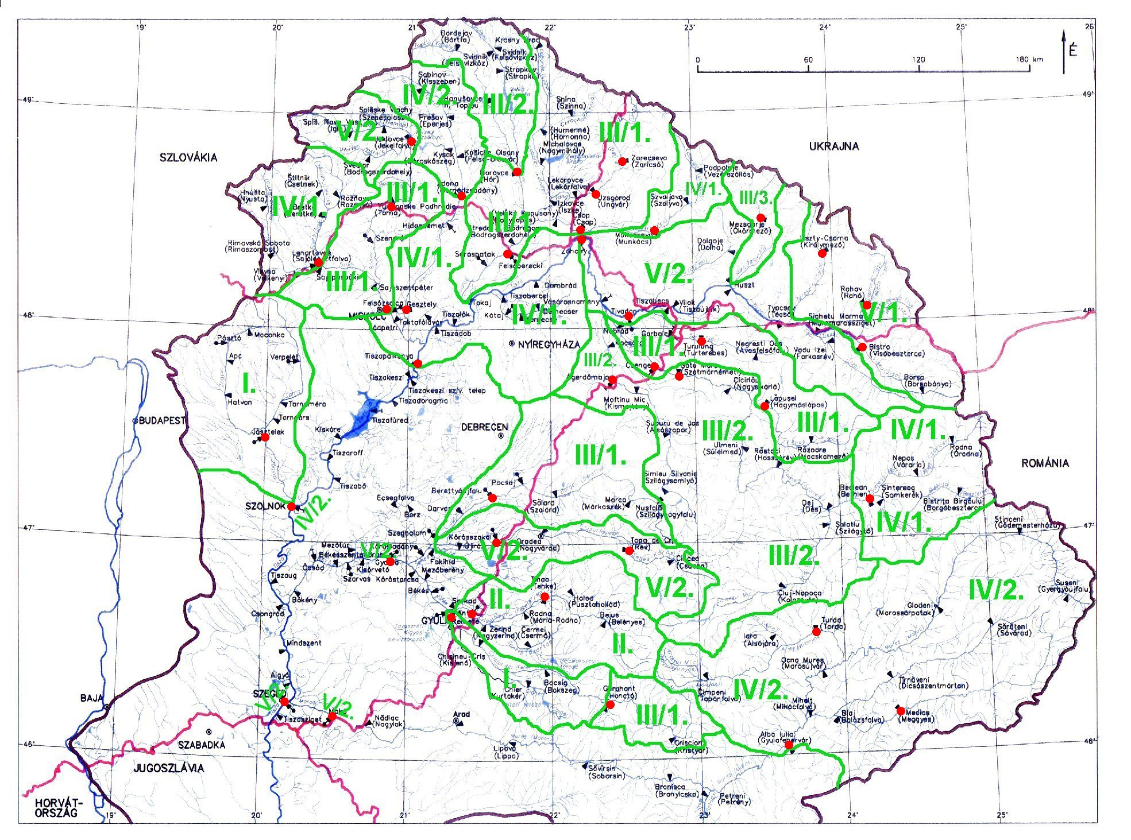
Figure 4: The runoff regime types of the Tisza River Basin

The territorial delimination of the runoff regime types displayed by Figure 4 in accordance with Table 3. On the map in the headwater regions of the rivers, the types belonging to the catchment, but at the downstream of the main rivers (Tisza, Mures/Maros and Crisul/Körös) the runoff regime classes belonging to the rivers, because of the complex influences. The evaluation of the runoff regime types defined above:
The River Zagyva and the downstream of Crisul Alb/Fehér-Körös are belonging to the Runoff Regime Type I. At these catchments, the first maximum of the monthly mean discharge is the earliest on the whole Basin, it is already between December and February. The second maximum is usually comes from January to March, but the third maximum can drag out until May. The least monthly mean discharges arrive together between August and November. The two catchments are in the same type, but probably with different reasons. The catchment of Zagyva is opened to south, it can be reached without any difficulty by the mediterranian effects and this is one of the warmest and driest part of the Tisza catchment (see Figure 2 and 3). The values of the downstream station of Crisul Alb/Fehér-Körös are possibly disturbed by the runoff regime of its receiver stream.
In the Runoff Regime Type II. there is the whole Crisul Negru/Fekete-Körös. Here the first maximum arrives usually between January and March, the other two maxima are from February to April. The possible reason of these early maxima is that tis river gets its water from the western slopes of the Apuseni Mountains. This area eralier gets its more precipitation from the clouds of the northwestern wind direction than the ambient lower territories (see Figure 2). The minima arrives between August and November, but the catchment sometimes has dry summer too – the third minimum is from June to September.
The highest number of the catchments are belonging to the Runoff Regime Type III. This is a very complex group with basins from the northern part of the Great Hungarian Plains to the mountainous territories. The common feature of all the basins of this type, that the first maximum discharge comes in the term between February and April, but the other two maxima are observed usually until the end of May. The differences between the three sub-types are at the minimum values. At Sub-type III/1. the lowest monthly mean discharges arriving from August to October, the second and third minima are generally coming around October, but at sometimes and some places they can be detected much more earlier, in the middle of summer. Mostly the lower transitional areas belonging to this sub-type. The Sub-type III/2. consisting the central territory of the Transylvanian Basin (the catchments of the Somes/Szamos and Crasna/Kraszna) and the northest part of the Tisza Basin (the Topla-Ondava catchment). The minimum values are about a month later than at the pevious sub-type. In the Sub-type III/3. is only one catchment, the river Rika, the most mountainous territory in this regime type. Here the only difference is at the first minimum discharge: the delay is more than three months than the other sub-types – like other higher territories.
At the Runoff Regime Type IV. the highest discharges (MAX1) arriving between March and May and the other two maxima are usually detected almost in the same time, until June. The main difference between the two sub-types is at the minimium values again: there is an almost two-months delay for the Sub-type IV/2. The two sub-types have a specific territorial disposition: the northern located catchments of this type are in the Sub-type IV/1. (Slana/Sajó, Latoryca, Hornad/Hernád, Somesul Mare and the middle part of Tisza above Tiszapalkonya); the southern located Upper-Mures/Maros and Tisza at Szolnok belonging to the Sub-type IV/2. The only exception from this sequence the upper part of Hornad/Hernád in the second sub-type on the north possibly bescause of the significant anthropogenic interferences.
The Runoff Regime Type V. is the most extreme group, because „the two ends”, the spring and the nethermost areas of the River Tisza are pertaining to it. Still this high geographical distance, the MAX1 values are observed in the same time, between April and June. The other two maxima are in the same time period too, but they have unfortunately a so wide duration. The extemity is revealed at the minimum values and of course at the two sub-types too. The rivers of the Chornogora and Maramures Mountains (Teresva, Bila and Chorna Tisa and Viseau) have the low discharges in the winter part of the year (Sub-type V/1.), while the downstream parts, where the runoff regime types belonging to the rivers (Tisza at Szeged, Maros at Makó, Hármas-Körös), have most of their minimal values before November (Sub-type V/2.). Besides this system, in Sub-type V/2. there are high geographical differences which are probably caused by the complexition of the runoff regime or the exposition of that given catchment.

7. The stability of the runoff regime
The stability of the runoff regime was computed for 40 catchments of the Tisza River Basin by using the Nováky stability index of Eq. (2). The results are in Table 4.
By the whole runoff regime stability (N_{R}), all of the rivers belonging to the relatively stable (RS) category, except the uppermost part of Tisza (Tysa/Rahiv), which has a stable (S) runoff regime. The more unstable parts of the area are mainly in the western, lower side of the Tisza Catchment, but the most unstable river, the Rika is at the mountainous region (Figure 5). This is the only place with a value above N_{R} = 7 – but the regime stability is remaining relatively stable.
At the maximum events (N_{MAX}), 4 rivers of 40 are in the stable (S) category, the others are relatively stable (RS). Notice the mountainous territory of regime sub-type V/1., the rivers of the Maramures Mountains and Ukrainian Carpathinas have stable runoff regime. The most unstable regimes are again at the Hungarian Great plain, in the Zagyva catchment and at the conjunction of the tributaries of Crisul/Körös (Figure 6). Investigating the stability of MAX1 event, we can establish that the uppermost part of the Tisza (Tysa/Rahiv) has a very stable (VS) runoff regime, the only one point in the catchment. 10 othe stations have got stable (S) values, which are in the surrounding Carpathian Mountains as we can see it on Figure 7. The more unstable territories are in the lowland part, again on the catchments of Zagyva and Crisul/Körös.

Table 4: Stability indices characterizing the runoff regime at selected gauging staions
of the Tisza River Basin
River | Station | N(MAX1) | N(MAX2) | N(MAX3) | N(min3) | N(min2) | N(min1) | N_{MAX} | N_{min} | N_{R}
Slana | Lenartovce | 1,166 | 1,132 | 0,985 | 1,153 | 1,046 | 0,955 | 3,283 | 3,154 | 6,437
Bodva | Turňa n. Bodvou | 1,004 | 1,115 | 1,098 | 1,220 | 1,028 | 1,019 | 3,217 | 3,267 | 6,484
Hnilec | Jaklovce | 0,916 | 1,129 | 1,151 | 1,206 | 0,976 | 0,959 | 3,196 | 3,141 | 6,337
Hornád | Ždaňa | 1,055 | 0,810 | 1,138 | 1,073 | 0,979 | 0,930 | 3,003 | 2,982 | 5,985
Ondava | Horovce | 0,814 | 1,192 | 1,168 | 1,226 | 1,069 | 0,775 | 3,174 | 3,070 | 6,244
Viseu | Bistra | 0,546 | 0,889 | 1,217 | 1,203 | 0,836 | 0,968 | 2,652 | 3,007 | 5,659
Tur | Turulung | 1,022 | 1,118 | 1,095 | 1,079 | 1,021 | 0,888 | 3,235 | 2,988 | 6,223
Somesul Mare | Beclean | 0,973 | 1,062 | 1,009 | 1,018 | 0,940 | 0,870 | 3,044 | 2,828 | 5,872
Lapus | Lapusel | 0,984 | 1,075 | 1,000 | 1,021 | 1,062 | 0,864 | 3,059 | 2,947 | 6,006
Somes | Satu Mare | 0,952 | 1,058 | 0,911 | 1,006 | 0,999 | 0,911 | 2,921 | 2,916 | 5,837
Crisul Repede | Vadu Crisului | 0,970 | 1,133 | 1,057 | 1,213 | 1,140 | 0,851 | 3,160 | 3,204 | 6,364
Crisul Negru | Tinca | 1,083 | 1,142 | 1,109 | 1,144 | 0,796 | 0,905 | 3,334 | 2,845 | 6,179
Crisul Alb | Gurahont | 0,948 | 1,112 | 0,945 | 1,142 | 0,948 | 0,732 | 3,005 | 2,822 | 5,827
Mures | Alba Iulia | 0,716 | 1,016 | 1,157 | 1,054 | 0,732 | 0,883 | 2,889 | 2,669 | 5,558
Aries | Turda | 0,759 | 0,992 | 1,031 | 0,999 | 0,951 | 0,952 | 2,782 | 2,902 | 5,684
Tarnava Mare | Medias | 0,752 | 0,876 | 1,225 | 0,991 | 0,907 | 0,868 | 2,853 | 2,766 | 5,619
Tysa | Rahiv | 0,227 | 0,973 | 1,100 | 1,137 | 0,779 | 0,856 | 2,300 | 2,772 | 5,072
Teresva | Ust Chorna | 0,450 | 0,843 | 1,290 | 1,208 | 1,073 | 0,901 | 2,583 | 3,182 | 5,765
Rika | Mizhirya | 1,161 | 1,183 | 1,281 | 1,121 | 1,218 | 1,053 | 3,625 | 3,392 | 7,017
Latoryca | Mucachove | 1,022 | 0,982 | 1,160 | 1,124 | 1,197 | 0,989 | 3,164 | 3,310 | 6,474
Latoryca | Chop | 1,010 | 0,987 | 0,947 | 1,129 | 1,194 | 0,956 | 2,944 | 3,279 | 6,223
Uzh (Uh) | Uzhhorod | 0,994 | 0,760 | 1,267 | 1,119 | 1,146 | 1,052 | 3,021 | 3,317 | 6,338
Uzh (Uh) | Zarichevo | 0,864 | 0,849 | 1,203 | 1,074 | 1,200 | 0,925 | 2,916 | 3,199 | 6,115
Tisza | Tivadar | 1,046 | 1,160 | 1,181 | 1,172 | 1,092 | 0,916 | 3,387 | 3,180 | 6,567
Tisza | Záhony | 0,981 | 1,075 | 1,053 | 1,135 | 1,021 | 0,796 | 3,109 | 2,952 | 6,061
Tisza | Tiszapalkonya | 0,978 | 1,084 | 0,903 | 1,105 | 1,059 | 0,829 | 2,965 | 2,993 | 5,958
Tisza | Szolnok | 0,972 | 0,977 | 1,091 | 1,124 | 1,029 | 1,001 | 3,040 | 3,154 | 6,194
Tisza | Szeged | 0,989 | 0,877 | 1,035 | 1,066 | 1,071 | 0,883 | 2,901 | 3,020 | 5,921
Szamos | Csenger | 0,960 | 1,070 | 0,959 | 1,083 | 1,013 | 0,875 | 2,989 | 2,971 | 5,960
Kraszna | Ágerdőmajor | 0,894 | 1,202 | 1,196 | 0,995 | 1,042 | 0,993 | 3,292 | 3,030 | 6,322
Bodrog | Felsőberecki | 0,916 | 1,020 | 0,921 | 1,102 | 1,105 | 0,960 | 2,857 | 3,167 | 6,024
Hernád | Gesztely | 1,141 | 1,001 | 1,188 | 1,110 | 0,908 | 0,966 | 3,330 | 2,984 | 6,314
Sajó | Felsőzsolca | 1,192 | 1,120 | 1,133 | 1,114 | 1,028 | 1,074 | 3,445 | 3,216 | 6,661
Zagyva | Jásztelek | 1,109 | 1,184 | 1,180 | 1,038 | 0,801 | 0,375 | 3,473 | 2,214 | 5,687
Berettyó | Berettyóújfalu | 1,025 | 1,065 | 1,128 | 1,043 | 0,849 | 0,718 | 3,218 | 2,610 | 5,828
Sebes-Körös | Körösszakál | 1,157 | 1,128 | 1,098 | 1,143 | 1,062 | 0,796 | 3,383 | 3,001 | 6,384
Fekete-Körös | Sarkad | 1,123 | 1,117 | 1,142 | 1,142 | 1,027 | 0,830 | 3,382 | 2,999 | 6,381
Fehér-Körös | Gyula | 1,082 | 1,085 | 1,218 | 1,069 | 1,003 | 0,779 | 3,385 | 2,851 | 6,236
Hármas-Körös | Gyoma | 1,045 | 1,102 | 1,189 | 1,094 | 1,226 | 1,078 | 3,336 | 3,398 | 6,734
Maros | Makó | 0,694 | 0,883 | 1,126 | 1,048 | 0,998 | 0,938 | 2,703 | 2,984 | 5,687
Indication of categories of runoff regime stability according to Table 1:
0,275 – very stable, 0,526 – stable, 1,111 – relatively stable, 1,285 – relatively unstable

At the minimum events (N_{min}), only 3 rivers belonging to the stable (S) category, the others are relatively stable (RS). The stable parts of the catchment are the Zagyva on the western and the southeastern part of the Mures/Maros Basin (Figure 8). The more unstable is the downstream of Crisul/Körös, the Bodva/Bódva and Latoryca catchmnets. At min1 event, 22 stations out of 40 is in the stable (S) category (Figure 9). The relatively stable (RS) areas are the Slana/Sajó and Hornád/Hernád catchments, the dovnstream of Crisul/Körös and the rivers of the Northeastern Carpathian Mountains (Uzh, Latoryca, Rika).

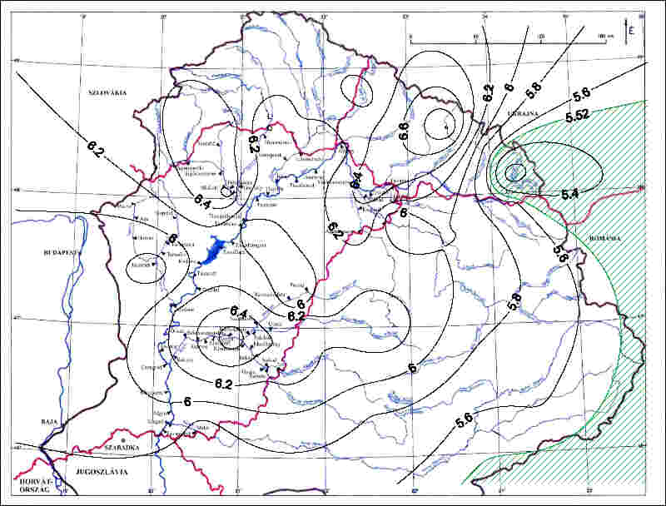
Figure 5: The regional variation of N_{R}
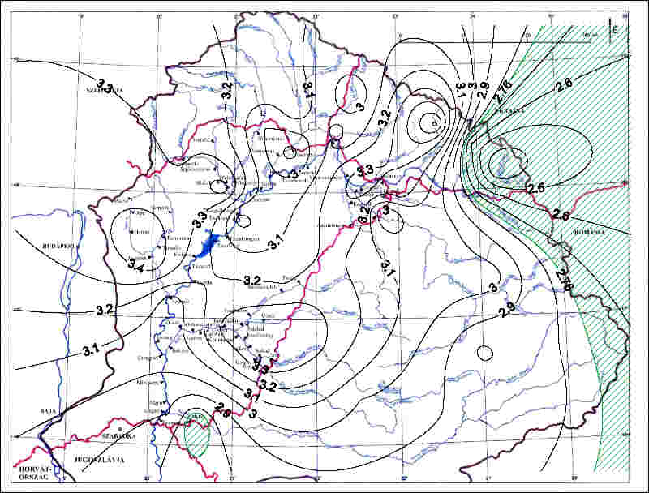 |  | 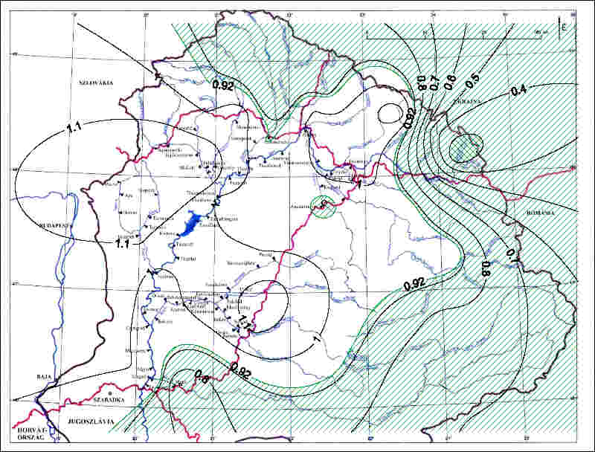
Figure 6: The regional variation of N_{MAX} |  | Figure 7: The regional variation of N(MAX1)
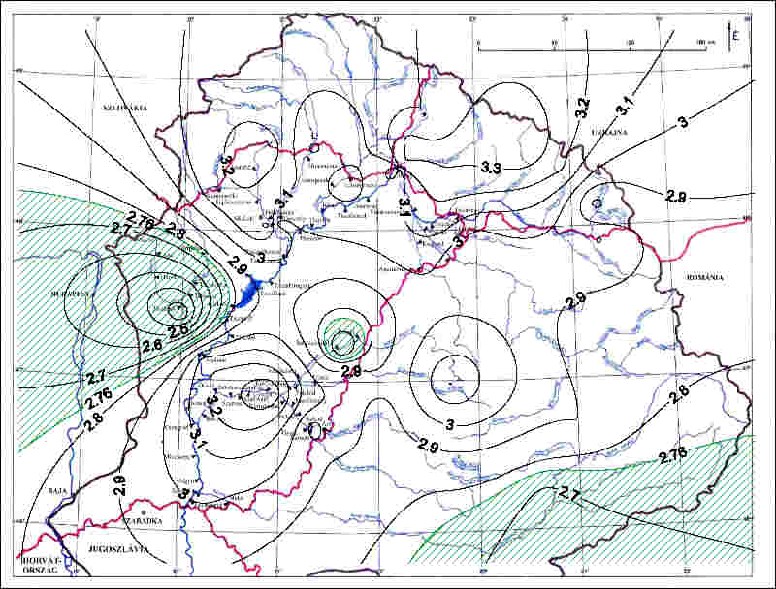 |  | 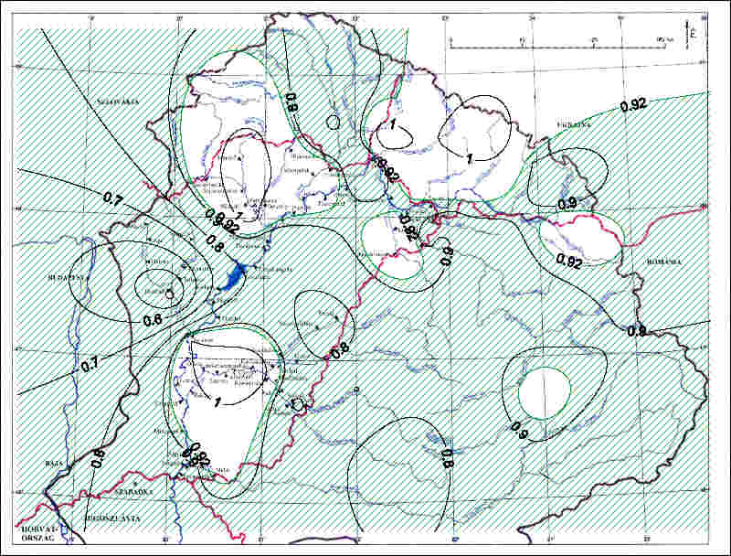
Figure 8: The regional variation of N_{min} |  | Figure 9: The regional variation of N(min1)
8. Conclusions
It can be declared that the runoff regime types – basically defined by using the MAX1 and min1 values – are following well the territorial changes of the climate connected with the elevation, which system in some places may be modified by heavy aerial impacts, mainly the delay effects of the underground storage basins or the anthropogenic interferences.
On some rivers the longitudinal changing of the runoff regime type can also be investigated. The regime type of the main stream may be modified by the incoming tributaries, like at the Slana/Sajó and its tributaries: Bodva/Bódva and Hornád/Hernád, or of course at River Tisza.
It is to note, that the runoff regime stability of the minimum events is larger than that of the maximum events. This is especially true at the first minimum (min1) and maximum (MAX1) events, where the difference is spectacular (see Figure 7 and 9 and Table 4). It is to see on the maps that the regime stability of the flood events is more influenced by the geographical conditions than at the minima. Mainly at the individual flood events, the stability is larger in the mountainous areas, while at the low flow events this effect does not appear.
The most stable part of the Tisza River Basin is the area close to the springs of the main stream, Tisza, in the territory of runoff regime Sub-type V/1. Here the runoff regime is stable or very stable at all the flood and almost at all the low flow events. The possible reason – together with the high elevation – is climatic, this is the wettest area of the catchment. In the western part of the Tisza Catchment, there is the most unstable section of the territory, the Zagyva River Basin. Here the low flow events are stable, but the flood events are very close to the relatively unstable category. This is possibly because of climatical and geological reasons.
The results of this investigation are accomodating well to the outcomes of the preliminary researches (Stanescu et al., 1997, Nováky et al., 2001). The present work will be extended to the whole Danube Catchment to enlarge our knowledge about this internatonal river.

9. References
Bergmann, H., Domokos, M., Krainer, R., Krall, E., Goda, L., Hamza, I., Neppel, F., Nováky, B. (2001): Untersuchungen im Einzugsgebiet der oberen Raab über hydrologische Folgen einer möglichen Klimaänderung. Schriftenreihe zur Wasserwirtschaft No. 36., Technische Universität Graz, Graz – Budapest
Nováky, B., Goda, L., Domokos, M., Bergmann, H. (2001): Looking for the impacts of climate change on the hydrometeorological data series of the Upper Raab Catchment. Vízügyi Közlemények, LXXXIII. volume, No. 3., pp. 393. Hungarian National Water Authority, Budapest
Nováky, B., Szalay, M. (2001): The runoff regime stability of the Hungarian rivers. Szent István University, Gödöllő
Stanescu, V.A., Ungureanu, V. (1997): Hydrological regimes in the FRIEND-AMHY area: space variability and stability. FRIEND ’97 – Regional hydrology: Concepts and Models for Sustainable Water Resource Management, IAHS Publ. No. 246. pp. 67.
Zsuffa, I., jr. (2003): Hydrological and flood issues of the River Tisza. Manuscript in Tisza River Basin Project (under preparation)

Both names of transboundary rivers are given in the order of flow from the spring to the mouth. When the stations are mentioned, the name of the stream is given only in the language of the given country.

