HYDROMORPHOLOGY, RIVERINE LANDSCAPE AND RIVER MANAGEMENT STRATEGY

Milan Lehotský, Anna Grešková

Institute of Geography, Slovak Academy of Sciences, Bratislava, Slovak Republic,
e-mail: geogleho@savba.sk, greskova@savba.sk

Abstract: The River Morphology Hierarchical Classification (RMHC) framework with seven taxonomic levels; catchment, zone, segment, channel-floodplain unit, river reach, geomorphic unit and facies (morphohydraulical unit) has been presented. The RMHC framework shows good potential as a standardised method for classifying riverine landscape over a range from catchment scale to channel and discharge and suspended load scale. It represents a good research tool for assessment as well as for river management applications.
Keywords: river, geomorphology, hierarchy, classification, riverine landscape, management.

HYDROGEOMORPHOLOGIE, FlUßLANDSCHAFT UND Fluß Management sTRATEGIE

Zusammenfassung: Der Beitrag präsentieren ein neues Zutritt zur hierarchische Klassifikation der Flußmorphologie. Die hierarchische Klassifikation der Flußmorphologie dargestellt standarde Methode fűr die Erkenntnis und Untersuchung der Flußlandschaft in einheitliche Auffassung von der Einzugsgebiet Skale zur Flußabschnitt Skale. Diese Methode ergibt anwendbares Mittel fűr die Bewertungen und Applikationen in Fliessgewässer Management.
Schlűsselworte: Fluß, geomorphologie, hierarchische Klassifikation, Flußlandschaf, Management

1. Introduction
Rivers throughout the world have suffered a long history of degradation through direct and indirect human influence. Channel modification has been both widespread and intensive as stream and rivers have been aligned for farming convenience, to aid navigation, to achieve the engineering objectives of flood alleviation and agricultural drainage or straightened adjacent to roads and railways. As a consequence, many rivers have a channelized nature with straight, trapezoidal channel section, clear of river bank trees and hedges and with uniform bed morphology. Flow regulation and modification have also been widespread. The combined effects of pollution, channelization and river regulation mean that rivers that could be considered natural are indeed a rare phenomenon. Recently, recognition of the adverse effects of human impacts on river systems, coupled with a rise in environmental awareness, has driven initiatives for river restoration as a part of river management scheme. The aim of this article is to present how the principles from fluvial geomorphology can be applied to derive a template with which to explain the hierarchy of structures and the interaction of various biophysical processes along river course - riverine landscape.

2. Conceptual framework
Over the “modern” time scale, channel morphology can be conceived as dependant upon representative catchment hydrological conditions, relief, vegetation, sedimentology and so on. However, as time and space scale are reduced, channel morphology switches from being dependant to being independent; from being product, to being a control on the contemporary varying, within-reach patterns of flow and sediment transport (Lane, 1995). In investigation of hydrological cycle of water movement the synthesised, holistic approach is now emphasised while water is interpreted as the landscape element and the environment, as the product but also the factor determining the origin of specific spatial structures located in the lowest bottom parts of valleys genetically and positionally linked to the surface stream. This comprehensive “product of water stream” is first of all formed by the specific geomorphologic-substrate base - channel-floodplain geosystem as the natural slightly unilaterally inclined dynamic flat valley bottom differentiated transversally and longitudinally with inserted banks and bottom delimited by three-dimensional linear object formed by permanent or periodic water flow which recurrently flows out, inundates and forms the microrelief of the valley bottom. The channel-floodplain geosystem simultaneously represents the taxon of hierarchic system of fluvial geosystems (Lehotský, 2002). This base is linked to the habitat structure and that of land cover. Together these components form a specific, genetically interlinked and interacting spatial geosystem of riverine landscape in the bottom parts of the river basins. Thus riverine landscape is understood to consist of channel zone and adjacent riparian zone, extended to the limit of influence of contemporary fluvial processes. This includes the entire active floodplain of the river (Church, 2002). In the past research of riverine landscape has focused largely on ecological and water quality consideration. Thus, the tradition distinction in geoecology and landscape ecology between whether something is happening on land or in water environment is of minor importance in the context of geosystems – it is the spatial pattern, relationships and processes that are important, not substrate or the medium (Wiens, 2002).
Geographers are ideally placed to work at interface between scientific understanding of biophysical processes and direct management applications, through the provision of tools and techniques for catchment planning and on-the-ground applications in conservation and rehabilitation programmes. Understanding of geomorphic processes, and determination of appropriate river structure and function at differing position in catchment, are critical components in sustainable rehabilitation of riverine landscape. The geomorphic structure and function of many, especially middle and small-size rivers are tied innately to vegetation cover and composition, and loading of large woody debris. These interactions induce direct controls on the distribution of flow energy, dictating local-scale patterns of erosion and deposition at differing flow stage. When tied to sediment availability and flow variability, geomorphic structure dictates the diversity of hydraulic units and associated habitats along river courses, and many other facets of riverine landscape functioning. In our articles (Lehotský, Grešková, 2003, Lehotský, Grešková, in press) we have dealt with the methodology of the investigation of the fluvial geosystems as the base of the riverine landscape. We have presented the holistic geomorphic classification system of fluvial geosystems and five geomorphically oriented concepts of the riverine landscape. The concept of river connectivity and river continuum, hierarchy concept, flood-pulse and related telescoping concepts as well as channel sensitivity and natural capital value concepts have been discussed.
According to Haigh (1987) principles of hierarchy when applying the systemic holistic approach in physical geography and landscape ecology are used in three areas: in delimitation of landscape unit and their classification, classification of river networks and in determination of age of landscape systems. Similar to all spatial entities, landforms are also organised in certain ways. First of all, every form of georelief developed, passes from one state into another, it has its age, it is getting older and determine the development of young form. In accord with Davis' theory of geomorphic cycles it reflects the temporal dimension of organisations. As all landforms are associated with our planet, they must be organised in positionally, in choric way (they always possess a neighbour), in other words they are places in something and a larger and normally older form contains a younger one or vice versa. Dimension of hierarchic organisation of landforms determines the basic features of their taxonomic system, while each of its levels is defined by a set of classification criteria on base of which it was formed. Similarly to other disciplines, there also are many approaches to hierarchic classification of geosystems. If we take into account the there are geosystem taxon presented as areas and representing cells of the geomorphological network, then hierarchisation can be applied to the level of picture analysis expressed in simplified way by the relationship between texture (granularity) and structure (pattern). Texture at a higher hierarchic level represent the structure at a lower level and vice versa. Expressed by geographer's language analysis of area at one scale represents wholes, systems which become subholes or subsystems at another level. The origin, location, spatial distribution, functioning and disappearance of forms is not at all accidental. A specific choric organisation responds to differentiated action of endogenous and exogenous agents at every hierarchic level. Parameters of organisation of higher taxon or taxons simultaneously form the matrix for organisation of lower taxon. Organisation of lower taxons inserted into the matrix of higher taxon or taxons and it more ore less agrees with it. It is used for parametrisation and description of higher taxon.
As rivers demonstrate remarkably different characters, behaviours and evolutionary traits (both between and within catchments), individual catchment need to be managed in flexible manner, recognizing what forms and processes occur where, why and how often, and how these processes have changed over time. According Frissel et. al (1986) we need to answer the questions. How do we select representative or comparable sampling sites in streams? How we can interpret in the broader context, or how far can we reasonably extrapolate information gathered at specific sites? How do we assess past and possible future states of a stream? To achieve this, a physical template is required upon which to assimilate and order information, identify gaps and, most importantly, highlights linkages of river biophysical processes and their management applications. Without this template, management programmes are applied ad hoc manner. It is not unduly cynical to ask how management strategies can work within a sustainable framework if the principles adopted do not “work with nature”, building on catchment-framed understanding of river character and behaviour (Brierly et al. 2002). A number of hierarchical classifications which link the catchment and channel have been proposed as tool for effective river investigation and management. The approach used widely by river ecologists is that advanced by Frissell et al. (1986). The latter has been developed specifically for floodplain (alluvial) rivers and emphasizes the role of lateral and vertical connectivity in explaining ecological pattern. Such approaches are also seen to be valuable for advancing river management and conservation because they allow scientific and socio-economic questions to be addressed simultaneously (Gregory, Gurnell, Petts, 2002). The aim of article is to present a general approach for hierarchically classifying stream geosystems in the context of the catchment that surround them. The hierarchy is based on spatially levels (taxons) of resolution which recognise that the structure and dynamics of the river-floodplain geosystems are determined by the surrounding catchment. The presented concept of fluvial geosystems hierarchy methodologically comes out from the ideas of hierarchical composition of geosystems (patches) generally spreads in geoecology and landscape ecology and from the work of Pool (2002) dealing with the river hierarchical patch dynamics. As to the description of main taxons and criteria of their delimitation the Frissell`s model (1986), the classification scheme of instream habitats of Rowentree, Wadeson (1998), Wadeson, Rowentree (1998), Maddock (1999), Thomson et al. (2001), River style framework (Brierly et al. 2002) and ideas concerning classification of river channels presented in the book of Krzemień et al. (1999) have been used as good conceptual guides. The result is simple complete framework how to understand a river.

3. River Morphology Hierarchical Classification framework (RMHC)
The identification and characterization of riverine landscape hierarchy is a summary understanding of how river operates or behaves within its valley setting. The RMHC framework endeavours to more beyond visual and mechanical approaches to river classification to provide a more process-based procedure for analysing river character and behaviour. Perspective and regionally specific river classification procedures provide little sense of river process, river change, river condition or trajectory and restoration measure. Unlike these schemes the RMHC framework is:
- Catchmet-based. Linkage of biophysical processes in catchment, such as water and sediment fluxes and vegetation dispersal can be analysed.
- Process-based. Understanding of the character and behaviour of both channel and floodplain zones provides the process-based knowledge to manage rivers in a way that “works with nature”.
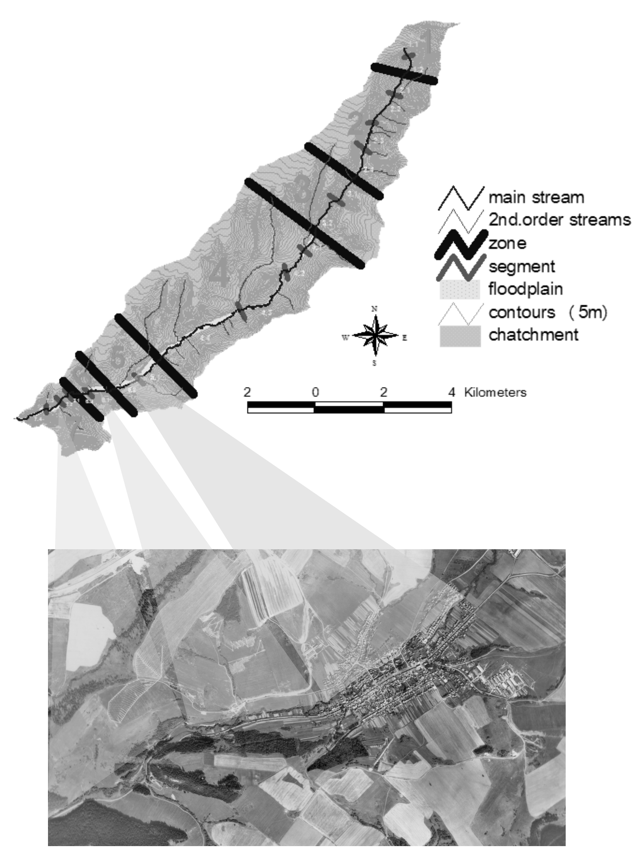
- Structured hierachically. Processes occurring at finer scale can be explained by those occurring at higher levels-taxons in the hierarchy.
- Set within the context of river evolution. Understanding a river`s capacity to adjust within its valley setting provides the basis for assessing how far from its natural conditions the river sits, and why that type of the river has changed. Only then can the contemporary condition of river be realistically assessed.
- Directly linked to assessment of the trajectory of future river condition. Analysis of river change provides a basis to predict how river will be adjust in the future. This provides a geomorphic basis for determination future target conditions for river rehabilitation and creating a catchment-framed visions (cf. Brierly et. al., 2002),
Figure 1. Zone taxons

- Directly linked to restoration measure. Understanding of the character and behaviour of river provides the ability to influence river engineering.
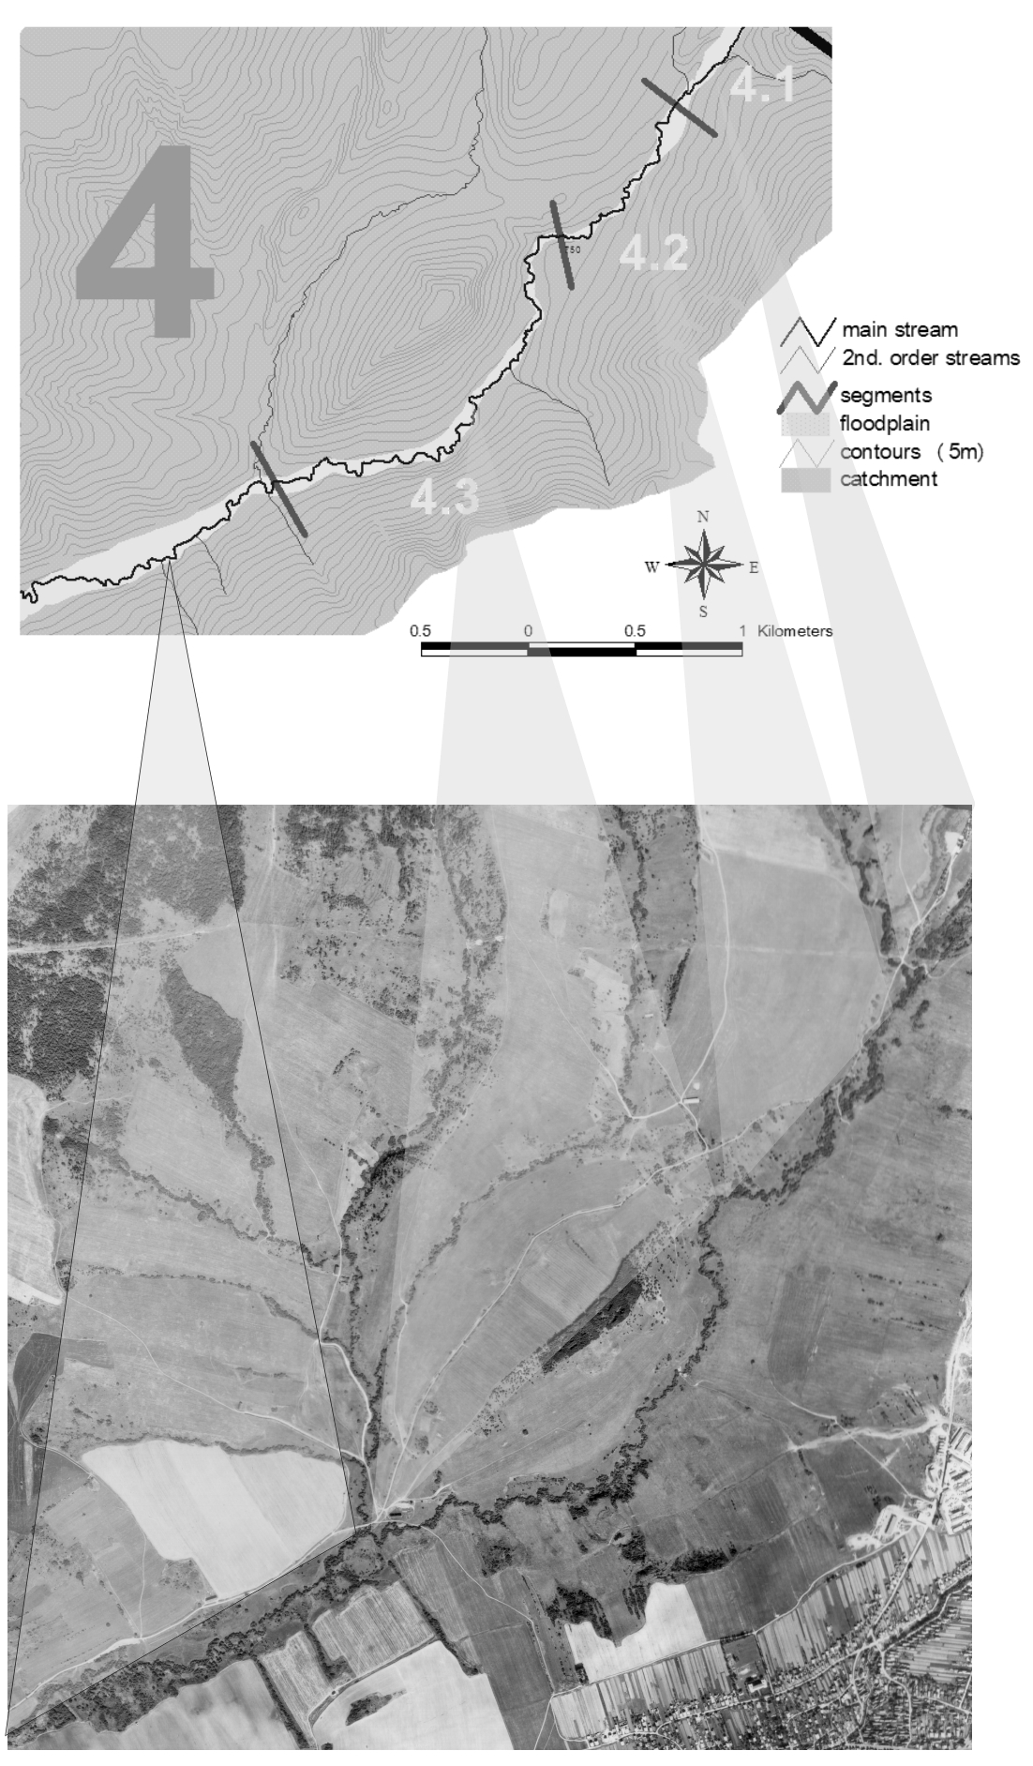
From the top to bottom we identified following seven taxons of riverine landscape: 1. catchment, 2. zone, 3. segment, 4. channel-floodplain unit (riverine landscape unit), 5. river reach, 6. geomorphic unit (landform, habitat) and 7. facies-morphohydraulic unit (microhabitat).

1. Catchment represent the land surface which contributes water and sediments to any given stream network at given river profile. Surface elements boundaries of catchment are determined by dividing catchment into dominated either by hillslope or fluvial processes. Channel-floodplain systems are determined by variability of:
- type of stream network,
- general genetic geomorphological and geological setting with respect to its position of surrounding large morfotectonic and climatic geographical position.
2. Zone (Fig. 1) is area within a catchment adjacent to river which can be considered as homogenous with respect to:
- morphostructural and morphosculptural conditions, i. e. homogeneous from the viewpoint of the altitude, relief energy, slope and horizontal differentiation and tectonic features,
Figure 2. Segments with the
distinct planform differences

- conditions defined by chemical and granulometric composition, percolation, water transmission and soil properties,
- runoff properties and the potential of sediment production,
- hydrological regime of river.
The compact settlement of relevant size to the river is considered as the specific type of zone. The comparison among stream network might focus network efficiency, sediment transport, etc. Restoration measure in catchment and zone level can be significant in the removal or modification of man-made obstruction to sediment transport and aquatic animal migration (dams, torrent control device, etc.).
3. Segment (Fig. 2) is the part of zone, a length of valley bottom where is no significant change in the drainage network, i. e a part of river upstream or downstream to next bigger tributary and in the imposed flow discharge or sediment load. Classified is in terms of:
- bed slope,
- valley confinement ratio,
- degree of sinuosidy (measured along valley thalweg),
- discharge,
- index of the sediment/discharge ratio in relation to long profile,
- specific drainage network.
Widening of the river bed in order to initiate braided or meandering and large scale excavation of floodplain alluvium along severely entrenched river channels can be consider as appropriate restoration measures on the segment and the next - channel-floodplain level.
4. Channel-floodplain unit - riverine landscape unit (Fig. 3) represents the channel, riparian zone, floodplain, and alluvial aquifer. It is viewed as a single, integrated corridor distinct from, but interacting with, the remaining catchment. Water residence time in the aquifer determines aquifer elements boundaries. Comparison among units might focus on water routing, relatively importance of longitudinal, lateral and vertical connectivity, etc. Unit boundaries are determined by:
- planform,
- coarse-scale geomorphological features such as islands, side-channels, cut-banks, bank breaks, etc..
- inundation frequency,
- channel abut index,
- degree of sinuosidy (measured along local thalweg),
- meander belt index,
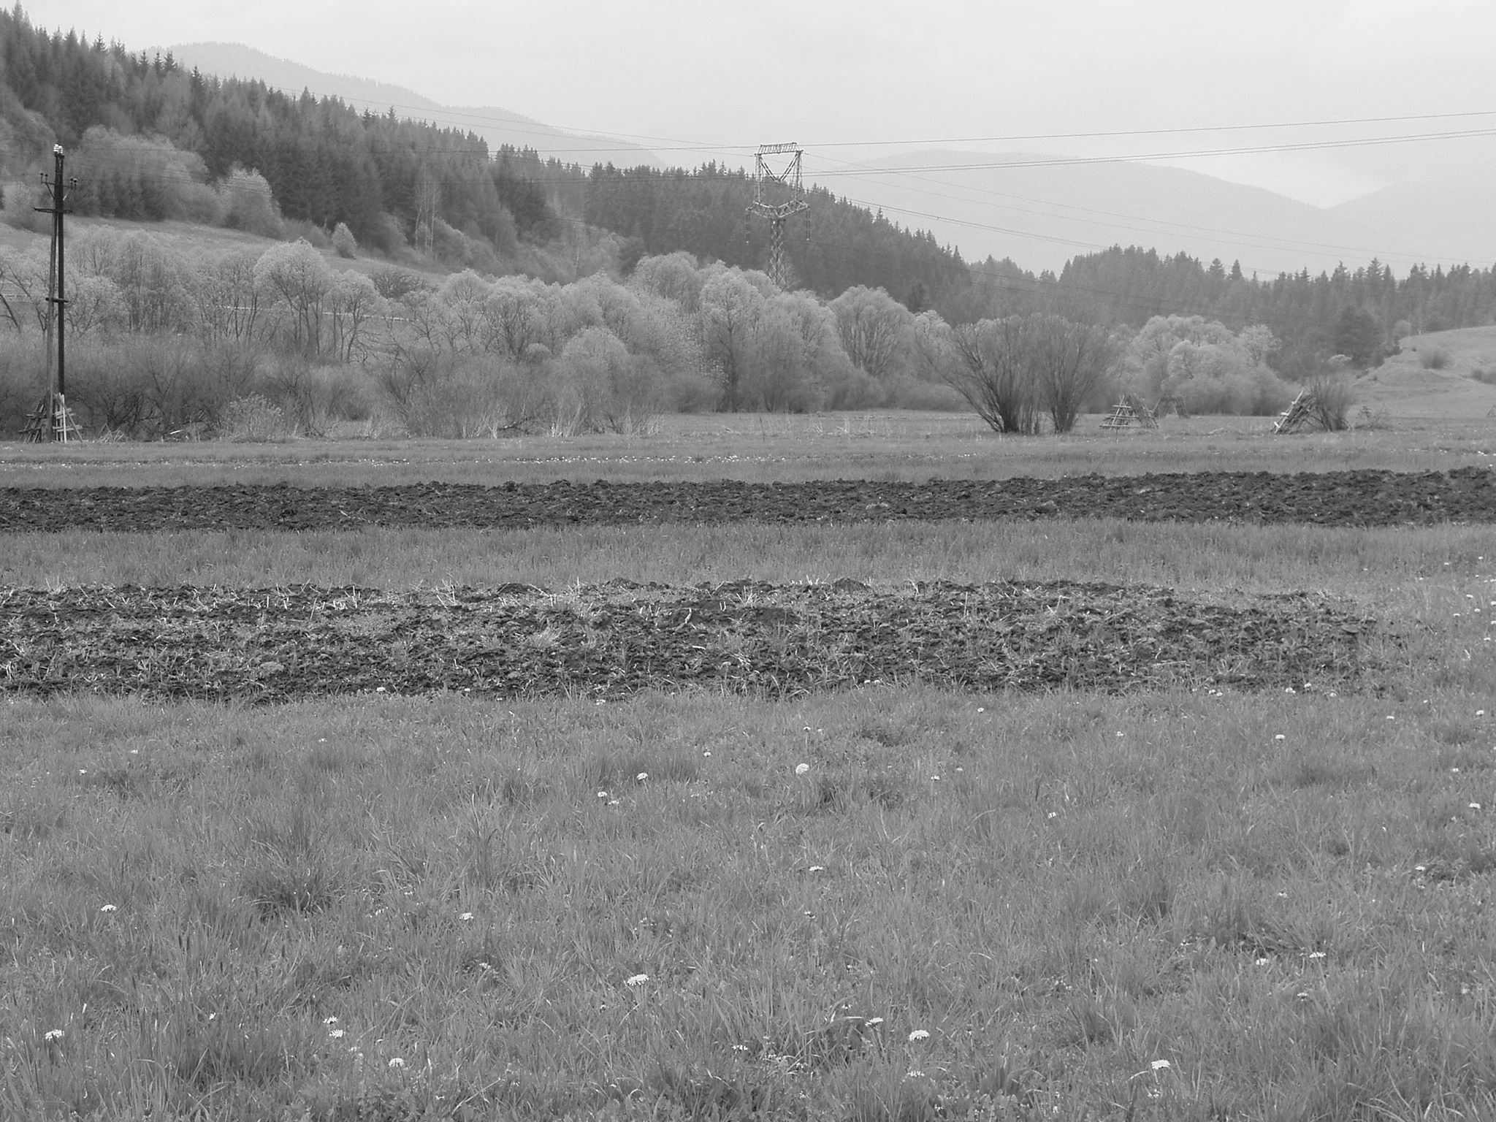
- structure of floodplain geomorphic units,
- position of stream into floodplain,
5. River reach (Fig. 4) is understands as a length of channel within which the constrains on channel form
are uniform so that a characteristic assemblage of morphological units or landforms occurs. Taxon boundaries are determined by:
- morphometric and morphografic features of geomorphological units,

Figure 3. Riverine landscape unit with sinuous stream,
riparian vegetation zone and agricultural land use.

- substratum properties of riverbed and banks determining lateral movement of stream,
- amount and forms of wood debris.
Comparisons among reaches might focus on pattern and dynamics, habitat stability, etc. of river.
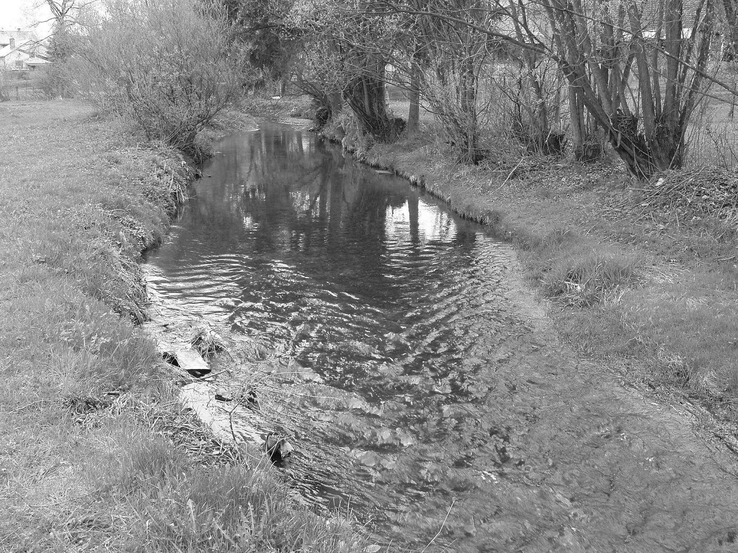
6. Geomorphic unit (landform, macrohabitat) is the basic structures recognised by fluvial geomorphologists as comprising the channel and floodplain morphology, formed from the erosion of bedrock (waterfall, rapids, etc.) or from the deposition of alluvium ( sand and gravel bars, riffles, pools, etc.). Taxon boundaries are determined by:
- fine-scale geomorphic features, recognized in the field (Fig. 5),
- name of generally accepted geomorphological terminology (Lehotský, Grešková, 2004)
They are studied as individual, but interactive features of landscape.
7. Facies - morphohydraulic unit (microhabitat) represents a spatially distinct instream
Figure 4. Straight river reach

environment determined by the temporally variable hydraulic and substrate characteristics associated with each morphological unit. Nanorelief, individual habitat features (rocks, logs, gravel sediments, etc.) and hydraulic properties represent that the lowest instream hierarchical level (Fig. 5). Its assessment provides important tools for space of river health monitoring. Taxon boundaries are determined by:
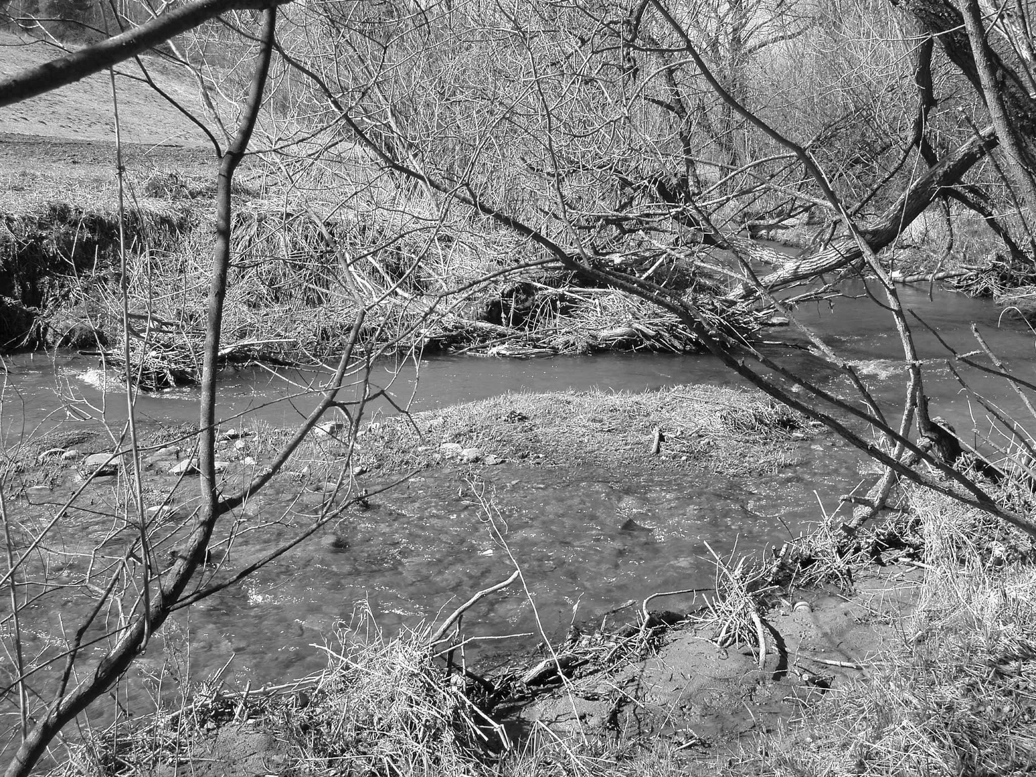
- position in stream,
- substratum type through geomorphic unit (mean phi, sorting, packing),
- flow type (fall, chute, broken or unbroken standing waves, ripples, upwelling, smooth surface flow, scarcely perceptible flow, standing water),
- flow velocity,
- water depth,
- mean high of roughness elements above stream bed,
vertical spacing as
Figure 5. Geomorphic unit (central bar) and morphohydraulic units
(flow and water depth differences)
mean distance between the highest points of two clasts measured parallel flow,
- horizontal spacing as mean distance between the highest points of two clasts measured perpendicular flow,
- groove width, bank morphology (bank shape expressed as concave, convex, straight or undercut and bank slope),
- organic matter (wood debris, logs, twigs, leaves, detritus, roots character),
- Froude and Reynolds numbers.
On the reach, landform a morfohydraulic level the creation of stream bends, initiation of channel widening or riffle-pool sequences, installation of single structures (boulders, tree stumps, pilings, groynes) in order to create substrate and velocity diversity represent restoration measures.

4. Conclusions
The article presents the classification scheme of channel-floodplain geosystems. River Morphology Hierarchical Classification (RHMC) framework represents a research tool developed on the basis of geomorphological understanding of river. It is is applicable on every river system. The recent trends towards fine-scale studies in geomorphology have been described as shift from description to explanation, thereby under-scoring the importance of bottom-up and top-down trans-taxon (trans-scale) linkages provides a foundation for understanding geomorphical dynamics of riverine landscapes and their interactions with biological communities. Thus, the procedure provides a rigorous scientific basis for assessing a range of biophysical processes and provides consistently applied template upon with effective management decision-making can take place.

The authors are grateful to the Slovak Grant Agency for Sciences (VEGA) – Grant No. 2/3084/23 for supporting this work.

5. References
Brierley, G., Fryirs, K., Outhet, D., Massey, C. (2002): Application of the River Styles framework as a basis for river management in New South Wales, Australia. Applied Geography, 22, 91-122.
Church, M. (2002): Geomorphic thresholds in riverine landscape. Freshwater Biology, 47, 541-557.
Frissell, C. A., Liss, W. J., Warren, C. E., Hurley, M. D. (1986): A hierarchical framework for stream habitat classification: viewing stream in watershed context. Environmental Management, 10, 199-124.
Gregory, K. J., Gurnell, A., M., Petts, G. E. (2002): Restructuring physical geography. Transaction of the Institute of British Geographers. NS 27, 136-154.
Haigh, M. J. (1987): The Holon: Hierarchy Theory and Landscape Research. Catena Supplement 10, 181-192.
Krzemień, k. ed. (1999): River channels: pattern, structure and dynamics. Prace Geograficzne, zeszyt 104, Instytut Geografii Uniwersytetu Jagellońskiego, Krakow.
Lane, S. (1995): The Dynamics of Dynamic River Channels. Geography, Vol. 80(2), Physical Geography Now, 147-162.
Lehotský, M. (2002): Korytovo-nivný geosystém - terra incognita v slovenskej geomorfológii. Geomorphologia Slovaca, 2, 23-30.
Lehotský, M., Grešková, A. (2003): Geomorphology, fluvial geosystems and riverine landscape (methodological aspects). Geomorphologia Slovaca, 2, 2003. 46 – 59.
Lehotský, M., Grešková, A. (2004): Hydromorfologický slovensko-anglický výkladový slovník. SHMÚ, Bratislava.
Lehotský, M., Grešková, A.: Riverine landscape and geomorphology: ecological implications and river management strategy, Ekológia (Bratislava). (in print)
Maddock, I. (1999): The importance of physical habitat assessment for evaluation river health. Freshwater Biology, 41, 373-391.
Pool, G. C. (2002): Fluvial landscape ecology: addressing uniqueness within the river discontinuum. Freshwater Biology, 47, 641-660.
Rowntree, K. M., Wadeson, R. A. (1998): A geomorphological framework for the assessment of instream flow requirements. Aquatic Ecosystems Health and Management, 1, 125-141.
Thomson, J. R., Taylor, M. P., Fryirs, K. A., Brierly, G. J. (2001): A geomorphological framework for river characterization and habitat assessment. Aqutic Conservation: Marine and Freshwater Ecosystems, 11, 373-389.
Wadeson, R. A., Rowntree, K. M. (1998): Application of the hydraulic biotope concept to the classification of instream habitats. Aquatic Ecosystems Health and Management, 1, 143-157.
Wiens, J. A. (2002): Riverine landscape: taking landscape ecology into water. Freshwater Biology, 47, 501-515.

