VICAIRE : “VIrtual CAmpus In hydrology and water REsources”

André Musy¹, Radu Drobot²

¹EPFL, ISTE – HYDRAM, Lausanne, Schwitzerland, e-mail: andre.musy@epfl.ch
²UTCB, Bucharest, Romania, e-mail: drobot@utcb.ro

Abstract: The VICAIRE project proposed within the framework of "SCOPES 2000-2003 Scientific Cooperation between Eastern Europe and Switzerland” gathered a Swiss partner, and a selection of seven Eastern European institutions from Bulgaria, Republic of Moldova, Romania and Ukraine. The project's main objectives were to elaborate and develop an international and competitive distance learning programme in the field of hydrology and water resources and to modernise the existing teaching systems of higher education in the partner's institutes by adding web-based courses. A number of 5 modules were elaborated in the frame of the project: Basic Hydrology, Engineering Hydrology, Qualitative Hydrology, Groundwater Hydrology and Water Management. The results of the project are presented in a computerized version, based on the templates currently used at EPFL for the distance-teaching policy. Each module consists in 10-12 chapters, presenting the basic theory, exercises and solutions, simply questions and questions with multiple answers.
Keywords: Distance learning, hydrology, water resources, environmental engineering.

Zusammenfassung: Das im Rahmen von „SCOPES 2000 – 2003 Scientific Cooperation between Eastern Europe and Switzerland“ vorgeschlagene Projekt VICAIRE brachte einen Schweizer Partner und sieben Osteuropäische Institute aus Bulgarien, der Republik Moldawien, Rumänien und der Ukraine zusammen. Das Hauptziel des Projektes war die Erarbeitung und Entwicklung eines internationalen und wettbewerbsfähigen Distance Learning Programms im Bereich der Hydrologie und der Wasserressourcen. Eine andere Zielsetzung war aber auch die Modernisierung der bestehenden Unterrichtssysteme im höheren Bildungswesen der Partnerinstitute durch das Einfügen von web-basierten Kursen. Insgesamt wurden im Rahmen des Projektes 5 Module entwickelt: Grundlagen der Hydrologie, Hydrologie für Ingenieure, qualitative Hydrologie, Grundwasserhydrologie und Wasserwirtschaft. Jedes Modul besteht aus 10 bis 12 Kapiteln, die das Basiswissen präsentieren und Übungen mit Lösungen, einige einfache Fragen aber auch Multiple Choice Fragen beinhalten. Die Resultate des Projektes werden in einer Computerversion vorgestellt, basierend auf den Vorlagen die gegenwärtig an der EPFL in Distance Learning Kursen eingesetzt werden.
Schlüsselworte: Distance Learning, Hydrologie, Wasserressourcen, Umweltingenieurwissenschaften

1. Introduction
The VICAIRE project proposed within the framework of "SCOPES 2000-2003 Scientific Cooperation between Eastern Europe and Switzerland" is an institutional partnership. It gatheres a Swiss partner, EPF Lausanne under the coordination of the Laboratory "Hydrology and Land Improvement (HYDRAM)", and a selection of seven Eastern European institutions placed under the local coordination of the Technical University of Civil Engineering Bucharest (Romania). The Eastern partners are: Sofia University "St Kliment Ohridski" (Bulgaria), Politehnica" University Timisoara (Romania), Kharkiv State Technical University of Civil Engineering and Architecture (Ukraine), Ukrainian Scientific Research Institute of Ecological Problems, Kharkiv (Ukraine), Technical University "Gh. Asachi" of Iasi (Romania), Technical University of Moldova, Chisinau (Republic of Moldova).

2. Main objectives of the project
The VICAIRE project concerns the thematic orientations in hydrology, water resources, water quality and water management. Its main objectives are:
- to elaborate and develop an international and competitive distance learning programme in the field of hydrology and water resources for Eastern European countries
- to train specialists in the above-mentioned field, capable of managing surface and groundwater resources in countries worldwide, whatever their geographical and socio-economical situation
- to improve and modernise the existing teaching systems of higher education in the partner's institutes by adding web-based courses
Various modules were developed in the frame of the project: Basic Hydrology, Engineering Hydrology, Water Quality, Groundwater Hydrology and Water Management. The distribution of the tasks between partners and within each module was as shown in Table 1.

Table 1: Tasks distribution

Module 1  "Quantitative Hydrology" |  | Module 2  "Qualitative Hydrology" | Module 3  "Hydrogeology" | Module 4  "Water Resources Management"
A. Basic Hydrology  *Uni Timisoara*  Uni Iasi  (Uni Moldova) | B. Engineering Hydrology  (including Urban Hydrology)  *TUCEB*  Uni Politehnica  Bucarest | *Uni Sofia* | *TUCEB*  Uni Bucarest  Uni Iasi | *KSTUCA*  USRIEP

Legend: bold type: co-ordinator of the module
in brackets: partial contribution

Each module is composed of 8-12 chapters; every chapter contains the objectives of the chapter, an abstract, the text presentation, simply questions, questions with multiple choice, exercises and solutions.
Several tasks have therefore to be defined:
- set up and develop a common curricula including the general subjects and the main chapters to be treated according to a commonly defined content
- develop textbooks for each chosen curricula
- realise didactical and pedagogical tools related to the course chapters in order to better illustrate and explain the content presented within each chapter
- develop and establish appropriate exercises presented on the Website, including keys of resolutions as well as the final solutions
- identify and test several types of distance self-evaluation tests, both efficient and reliable aiming at a better and stronger valorisation of such distance courses on the basis of a systems of credits still to be defined together
- validate and evaluate the products developed within this framework, to test it with students concerned within each institution of the partner countries.
The results of the projects are presented in a computerized version, based on the templates currently used at EPFL today for the distance-teaching policy.

3. Developments and actions within the project

3.1. Common curricula
A common curricula including the main topics and/or chapters with related sub-chapters (Figure 1) was elaborated according to the concerned fields of training. This part is aimed at both undergraduate (third and fourth years of study) and postgraduate students of the partner institutions who need to improve and/or update their knowledge.

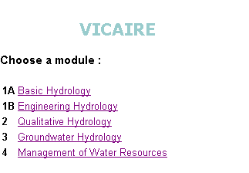
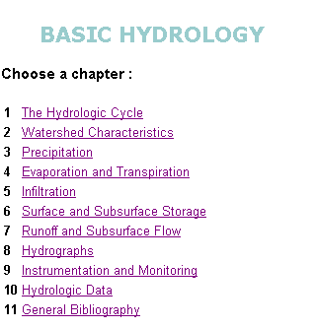
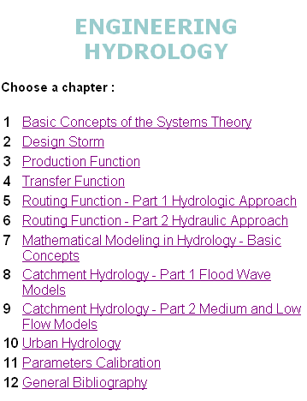
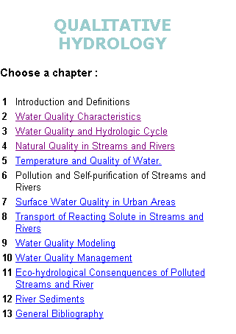
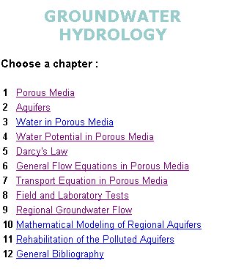

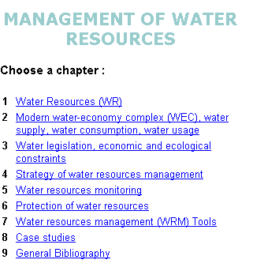

Figure 1: General overview of the VICAIRE topics and subtopics

However, each module was developed in accordance with its main topic, including essential basics of concepts, methods and theoretical aspects as well as their applications in certain specific engineering fields.
Courses on Quantitative Hydrology concern:
- Basic Hydrology: from the water cycle to the hydrological processes, hydrological
data,
- Principles of Engineering Hydrology: from production to estimations of floods and low
flows,
- Basic in Hydraulics and Applied Statistics,
- Hydrology in urban zones as well as urban water system management.
Courses on Qualitative Hydrology concern:
- Water chemical quality in non-saturated fields and in streams,
- Water biological quality in streams,
- Water diffuse and punctual pollution: origin and transport processes,
Courses on Groundwater Hydrology concern:
- Flow in non-saturated and in saturated media (soil hydrology),
- Questions on solutes transport in porous media,
- Rehabilitation of polluted aquifers.
Courses on Management of Water resources concern:
- Hydro-systems: general description and presentation,
- Formulation of the demand,
- Management strategies and constraints,
- Methods of management and optimisation principles,
- Decision-making systems (special emphasis for costal zones might be taken into
consideration).

3.2. Textbook, exercises and questions
Swiss and Eastern European partners according to their field of expertise developed reference textbooks. For each textbook, several exercises and examinations placed under the coordination of one Eastern European partner have been prepared.
The Swiss partner's experience concerning the conceptual aspects, tools and their integration within this virtual campus was shared to Eastern partners.
To ensure the proper understanding of the main subjects of each chapter proposed in the VICAIRE project, a number of appropriate exercises were created and put at disposal on the Web, together with relevant keys for resolutions and possible final solutions (Figures 2, 3 and 4).
These exercises take into account the specificities and particularities existing in each of the partners country and, consequently, the problem that has to be or (in certain cases) is already solved. However, a close contact between students and teachers either by the electronic mail, the Web forum of discussion and/or sometimes directly "online" has shown to be of importance.
Each module represents a maximum of 26 hours of teaching corresponding to 2 hours/course per semester and per week (14 weeks / semester). Module 0 “Overview and guide” was placed under the responsibility of EPFL and meant as a presentation and introduction to the e-learning facility.
Important actions to validate such a new teaching method have been carried out and will be improved. Each institution has tested and validated this distance learning facility through courses, exercises and self-evaluation tests.
In what concerns the implementation of this distance learning facility within the higher education systems in the partner countries, a particular and further attention should be brought especially for the evaluation of such a method.
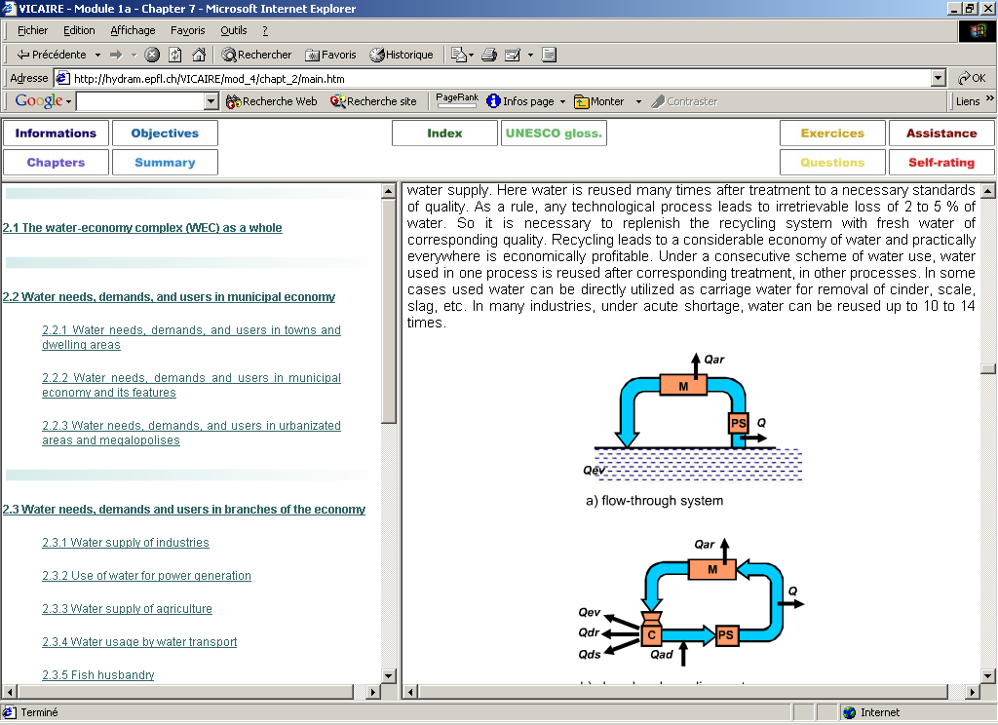
Figure 2: Example of textbook

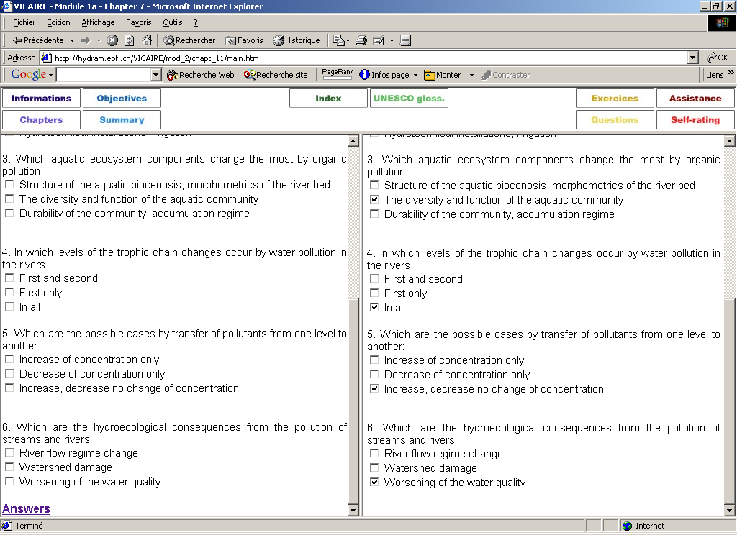
Figure 3: Examples with multiple-choice questions (self-evaluation)

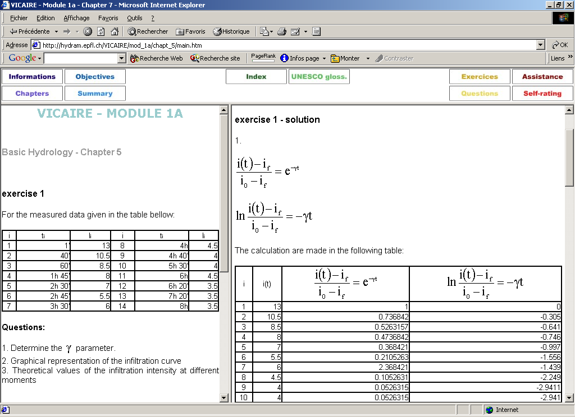
Figure 4: Example of exercises with corrections

4. Coordination and management

The Swiss partner's contribution was based on its own expertise with the advice of the Pedagogical Chair and the Distance Learning Laboratory at EPF Lausanne. However, to ensure a better and more efficient communication between the project's partners, basic rules were defined:
- Each module was placed under the responsibility of its co-ordinator
- Each course (chapters and subchapters) was under the responsibility of its authors.
- All the partners, who give their permission for its use, validate the final version.
- Each institution was responsible for its final courses
- The Swiss partner, represented by Prof. André Musy, worked in close collaboration with the East-European co-ordinator and, when necessary, with the other partners of the project as well.
- Several coordination meetings took place during the years 2001 and 2002 in each of the Eastern European partner countries, except Ukraine.

4. Valorisation and future activities
To increase the promotion and the development of such a new teaching method and technique, the following actions should be foreseen:
- improve the courses developed within this context, namely by:
- preparing additional exercises; simple and multiple-choice questions,
- improving the figures and tables,
- including animations or short movies on specific topics,
- standardising the symbols (at least in the frame of each module),
- re-reading of each module's text to eliminate redundancies, check and fill-in gaps and/or eliminate mistakes, if any,
- improving the written English language,
- introducing new chapters, when required.
- organise a forum of discussion and chat sessions.
- organise a viable structure with self-financing rules, if possible.

5. Problems encountered
As a general observation, all the partners involved within this project invested lots of time and energy. Few problems were encountered and arose mainly because of the partners had no specific experience in the approach, methodology and implementation of distance learning as a whole. For example:
- huge amount of work and its complexity. For one chapter, evaluation in man-hours: an average of 120-150 hours per chapter.
- implementation of various courses still has to be accepted within each institution (academic acceptance, computational means, tutoring facility and capacity, languages, etc.)
However, one has to note that the numerous "small" problems that appeared during the project, were resolved thanks to the existing excellent collaboration and motivation in setting up this project.

6. Main results

The main result was the development of a computing support teaching system of a basic course in the field of hydrology. This work led to the production of:
- 52 chapters, divided in 5 modules;
- more than 5000 files (.htm, .pdf, .gif, .jpeg and .swf) representing about 25MB of numerical data.
In the past five years, computer technologies have duly evolved and therefore, any distance-learning programme, should have the ability to adapt "quickly" to these new technologies.
Enhancing soft and hardware supports, implementing, adapting and updating the content of educational programmes will be one of the challenges of the future. Therefore, the various partners of the VICAIRE project have decided to keep in touch to be able to implement this distance learning facility.
As a conclusion, the project was ambitious, fruitful, interesting and its results and outcomes successful.

Acknoledgements: Special thanks to modules co-ordinators and to all authors and contributors from Romania, Bulgaria, Republic of Moldova and Ukraine.

