Temporal and spatial change of selected hydrogeological characteristics in the Lower Hron basin

Mgr. Zora Papánková

Department of Land and Water Resources Management, Civil Engineering Faculty, Slovak University of Technology Bratislava, Slovak republic, e-mail: papankova@svf.stuba.sk

Abstract: The article deals with characterizing temporal and spatial change of relevant hydrogeological information regarding the water-bearing quaternary sediments around Lower Hron. A map of hydraulic permeability coefficient value distribution and a map showing the depths of underlying impermeable underbed were constructed in GIS using the inverse distance weighted interpolation method. Also the decreasing trend of groundwater table level and its causes are discussed.
Keywords: permeability coefficient, depth of impermeable underbed, quaternary, inverse distance weighted interpolation method

Zeitliche und räumliche veränderung von ausgewählten hydrogeologischen parametern in flussgebiet von unterem hron

Zusammenfassung: Diese Arbeit beschäftigt sich mit der charakterisierung von zeitlicher und räumlicher Variation wichtiger hydrogeologischer Informationen, die die wasserführende quartäre Sedimente in dem Flussgebiet von unterem Hron betreffen. Eine Wasserdurchlässigkeitkarte und eine Karte mit der Abbildung von den Tiefen von der wasserdichten Schicht, die unter der quartären Schicht liegt, wurde konstruiert. Beide Karten wurden im GIS mit der Interpolationsmethode invertiert gewichteter Abstand gemacht. Auch die fallende Tendenz des Grunwasserspiegels und deren Ursachen wurden diskutiert.
Schlüsselworte: Wasserdurchlässigkeitkoeffizient, Tiefen von undurchlässiger Unterschicht, Quartär, Interpolationsmethode invertiert gewichteter Abstand

1. Introduction
Hydrogeological unit Lower Hron Basin is an important water resources area because of the groundwater storage found in its quaternary aquifers. This plane area stretching southwards is clearly bordered by surrounding elevated geomorphologic units. This basin is characterized by a mostly uniform geological composition dominated by quaternary alluvial material sedimented on mostly impermeable neogene underbed. In water resources, the groundwater found in the deep neogene layers plays only a little role – they make out only 10% of the total drinking water resources used (Kertész, 1984) compared to 90% drinking water coming from quaternary groundwater resources. This article deals with the upper quaternary aquifer horizon and characterization of the medium, where the groundwater is found. This groundwater is tied to the fluvial deposits of the River Hron building the Hron Pane and the Hron Terraces. It is hydraulically connected to the Hron River and its tributaries and besides serving as a source of drinking water to the population it is also used extensively by agriculture.
The aim of the work is a hydrogeological representation of the basin showing a spatial and temporal change in selected hydrogeological characteristics, thus serving as a possible input for some further hydrogeological research and modeling. Effective water resources management in the area requires defining the stress of the water resources system, water balance of the catchment, predicting the storage volume development and the regime of the replenishment of the groundwater resources. For predicting the groundwater storage change, creating a hydraulic model for groundwater flow is necessary, and for this a spatial characterization of the basin is crucial.
Therefore the aim of the first part of the work was to create maps showing the spatial variability of impermeable layer depth and permeability coefficient variation using interpolation in a GIS environment. Spatial delimitation of the quaternary sediments and spatial variability of its permeability defines the extent and capacity of the water bearing layers.
For designing and maintaining ecological limits for groundwater exploitation, it is necessary to predict the trends of development of hydrological and climatic variables. Second part of the work was dedicated to evaluating the causes and relations between long-term groundwater-level decline, observed on the whole territory, subsiding Hron River base and the steady precipitation regime.
It is necessary to mention, that when discussing the cause of the depressing groundwater-level, the geological-tectonical development of this area has to be taken into account as it is an important influencing factor.

2. Natural settings
Lower Hron Basin is a natural geologically and morphologically outlined area within the Danube Lowland, created in the Quaternary due to the development of the fluvial sedimentation basin (Vaškovský et al., 1982). Lower Hron Basin begins at Kozárovská brána narrow, where the river Hron flows out of the Štiavnické Mountains, into the Hron Flat and the Hron Plain and finally flows into Danube River in the south. The area comprises large Hron terraces on the right bank and smaller terraces and the Hron Flat on the left, bordered on the East by Ipeľ Downs.
The area has an elongated south northern shape following the direction of the river and the tectonic fault. The tectonically subsided parts of the territory were filled by the river with gravel material, some places up to 30m depths. In this type of area found mainly in the north – so called Kozmálovská Depression, the groundwater is found in pressured artesian horizons due to the occurrence of less permeable clayey layers.
River Hron in its lower section is 77 km long, with a 70m difference in height, which makes it a lowland type of river. In the last decades, Hron has been continually corrected and straightened.

3. Extent of the quaternary layers
Quaternary layers here are mainly gravelly fluvial and proluvial terraced accumulations, or tectonic depression fills and some fluvial cone deposits, created by the river and it’s tributaries in Pleistocene and Holocene. These sediments are in the most part, especially the Hron terraces, covered by recent loess and loess loam, up to 30m thick. The fluvial deposits are generally in the reverse terraced development, but in the northern part with the subsiding depressions are deposited in the normal, superposed development.
These main terrace units are found in Lower Hron Basin (Nagy et al., 1998, Vaškovský et al., 1982): In the northern part right bank side Lipnicke Terraces with a typical inverse development – oldest sediments lying on the more recent ones; fluvial sandy gravel layers in the subsiding zones of Kozmalovska depression developed in the normal superposed order – where recent deposits are at the top. The composition of this area is depicted in the schematic profile A (Figure 1). The numbering from I to VI in the Figures 1, 2 represent the geological age of the various terrace units using the terraces classification by Halouzka (1986), where “I” means the most recent – upper Pleistocene to Holocene and “VI” the oldest – lower Pleistocene age.
Characteristic for the central and southern part of the territory are right bank side terraces, starting with the older - Ludinsko – brutská, Lužansko – brutská, following into the more recent – Lokská terrace, Kalnianska accumulation, Želiezovská and Hron settlement terraces towards the current Hron River location and on the left bank side smaller Žemliarska and Kamenická terraces. This composition is represented by the Profile B (Figure 2) created using stratigraphy and morphometry data listed in Nagy et al. (1998) a Vaškovský et al. (1982).
Figure 1: Schematic profile A – northern part

Figure 2: Schematic profile B – southern part
The largest part of the area is covered by Lužansko – brutská terrace, the lesser parts belonging to Lokská, Želiezovská and settlement terraces and the Kozmalovska depression fill. The outlines of the various terraces are shown in Figure 3.

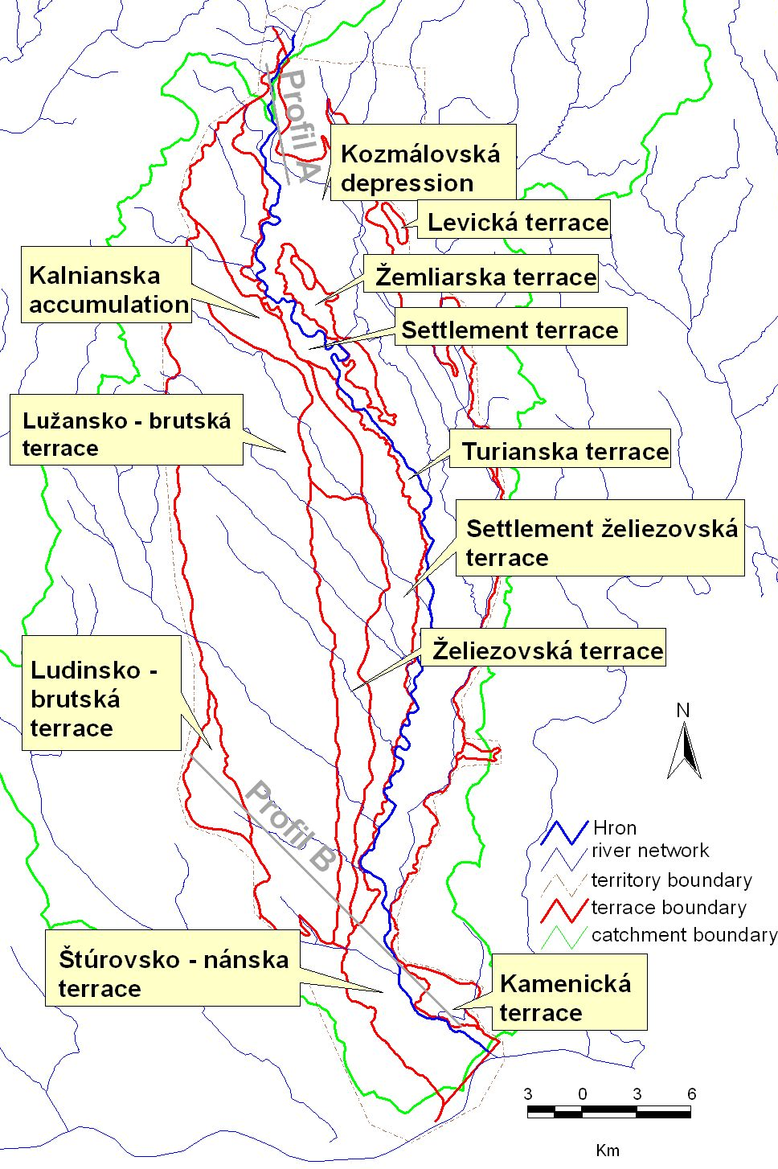

Figure 3: Extent of the various units
The delineation of the different terrace units is important for the hydrogeological characterization of the territory since the permeability is changing also due to the age and type of sediments. The spatial distribution of the varying impermeable underbed depth as well as the change in the other characteristic – permeability coefficient, was determined using measured point data and applying interpolation methods with map algebra in the GIS environment.

4. Methodology
The basis for the calculation was spatial interpolation into nods or grid points of a raster network, where the variable was unknown, using the information form known measured values. Generally, interpolation is defined by relation (1):
$z_{0}=\sum_{i=1}^{n}{w_{i}z_{i}}$, | (1)
Where the value of the examined variable z_{0,} located by planar coordinates x₀ and y₀, is expressed by weighted linear combination of known values z_{i} with coordinates x_{i}, y_{i} and weights w_{i}, determined for each measurement.
The deterministic approach is based on overlaying surfaces of different shapes through the data set defined by coordinates x, y (Meijerink et al., 1994). Weights of the point measurements are determined based on their geometrical position.
For this case, the interpolation method inverse distance weighted was used. Basic principle for all inverse distance weighted methods is assigning stronger weights to the point measurements that are closer to the point searched (Lam, 1983). The weights of the intrepolation function w_{i} are therefore depending only by the distance between the calculated point x₀, y₀ and the discreet measured points x_{i}, y_{i}. Generally, this relation can be expressed as (2) (Tabios, Salas, 1985):
$w_{i}=\frac{f\left(d_{0i}\right)}{\sum_{i=1}^{n}{f\left(d_{0i}\right)}}$, | (2)
Where d_{0i} is the distance between the point to be calculated x₀, y₀ and the known value x_{i}, y_{i}. For the inverse distance weighted method, the function f(d_{0i}) is defined as (3) (Surfer, 1995), where parameter β represents the exponent coefficient of the weight.
$f\left(d_{0i}\right)=\frac{1}{d_{0i}^{β}}$, | (3)

5. Depth of impermeable underbed
The spatial variability of the impermeable underbed (in meters under surface) is shown on the map in Figure 4. Different depths are differentiated by color scheme. The surface of the underbed was created by interpolating known values using GIS. The Database serving as the resource for the measured data was filled with information on the captured geological boundary depths from the Registry of hydrogeology boreholes and wells at the Geofond institution. The geography coordinates defining an exact location were geodetically measured only for the recent boreholes, the locations of the older ones had to be digitized from 1:25 000 maps. In this way, 523 boreholes that were deeper than the impermeable layer boundary were used. These boreholes were unevenly distributed in the territory, most of them concentrated in the vicinity of the Hron River. Beside this, in the narrow strip along the river, geophysical measurements (using vertical electrical probing) of the quaternary fluvial sediment depths were conducted, in the framework of “Hydromorphological research of Slovak rivers – part Lower Hron” (Water Research Institute report, 1986). These 1446 measurements were also used to construct the underbed depths map. On top of that, from the above mentioned report another 602 data for wells not listed in the geological registry, were used. All the source data and the map and the full database are a part of the work by Papánková (2003).
The territory is mainly consisting of thrust tectonic blocks and in the geological past was modeled by neotectonic movements, resulting in uplifting and dividing of some sedimentation basins according to the active faults direction. Therefore also the depths of impermeable layers change apparently with the displacement of blocks. The most relevant faults were digitized in GIS as can be seen in Figure 4, using general geological maps in the scale 1:25 000 and compared with the generalized information on tectonics from a geological map of the territory in the scale 1: 50 000. In addition to the interpolation method, to the computation was added the option to stop the calculation at barriers, in this case the lines representing the faults, in order to interpolate values within thus defined smaller areas.

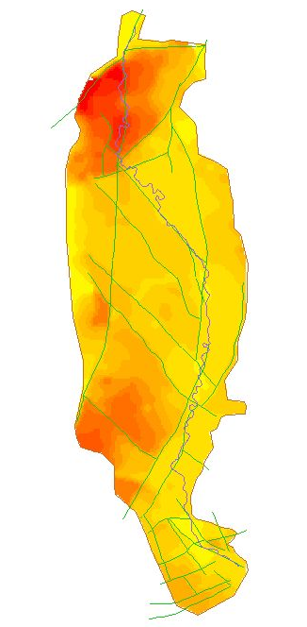
5.1 Results
The values of the impermeable layer depths for the subsiding area of Kozmálovská Depression are according to the depth lines up to 26 – 28m. These values are slightly underestimated, because the depths found in boreholes were up to 35 – 40 m. The underestimated values are caused by averaging the extreme values, with the less extreme values that were more frequent in the quite large interpolated territory. The used method discards possible error values, and therefore the information of the extreme values measured is partly lost. Towards south in this subsiding structure the impermeable layer can be found less deep – around 20m in Kalnianska accumulation.
In the smaller left bank Žemliarska terrace, to the south from Horna Sec, the depths decrease rapidly from 18 to 8 m. The left bank Hron alluvial plain, extending up to 8 km width by the town Levice, has quaternary sediments of depths from 6 to 8 m. The left bank Hron alluvial plain in its southern part has depths of mostly 8 m, sometimes 6 m and towards the Ipeľ Downs increases up to 10 m due to deluvium coverage.
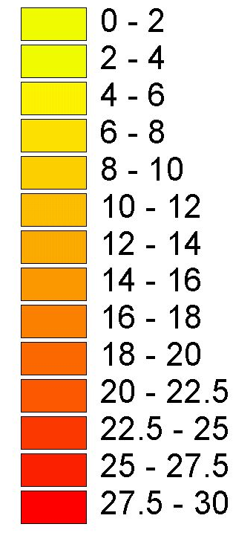
The southern part around the river course yields depths of fluvial deposits around 6 m, increasing to 8 m on the eastern borders. On the southeast stretch of the territory, there is the buried Kamenická terrace located near the foothills of Kováčovské Hills that together with the covering sediments has depths of up to 12 m. On the southern border of the territory where the Hron fluvial deposits join the Danube fluvial accumulations, the depths increase up to 10–12m.
Figure 4: Impermeable layer depths in m

For the right bank terraces, the northern part of the Lužansko-brutská terrace has an average quaternary sediments depth of 10 m, occasionally only 8 m, westwards decreasing to 6 m. The area of Lokská and Želiezovská terraces has in general smaller depth, around 8 m. In the area surrounding the Hron River the depths are also 8 m. Towards the south in the area of Lužansko-brutská terrace, the depths are higher – around 14 to 18 m, back towards the Horn River slowly decreasing to 12 – 10 m. Located on the southern border of the territory, the covered Ludinsko-brutská terrace yields quaternary depths around 20 m, towards Hron again decreasing to 8 m.
In general, the right bank terrace shows higher depths of quaternary, which are due to the covering recent loess and loess loamy sediments that are lacking in the Hron Plain around the river.
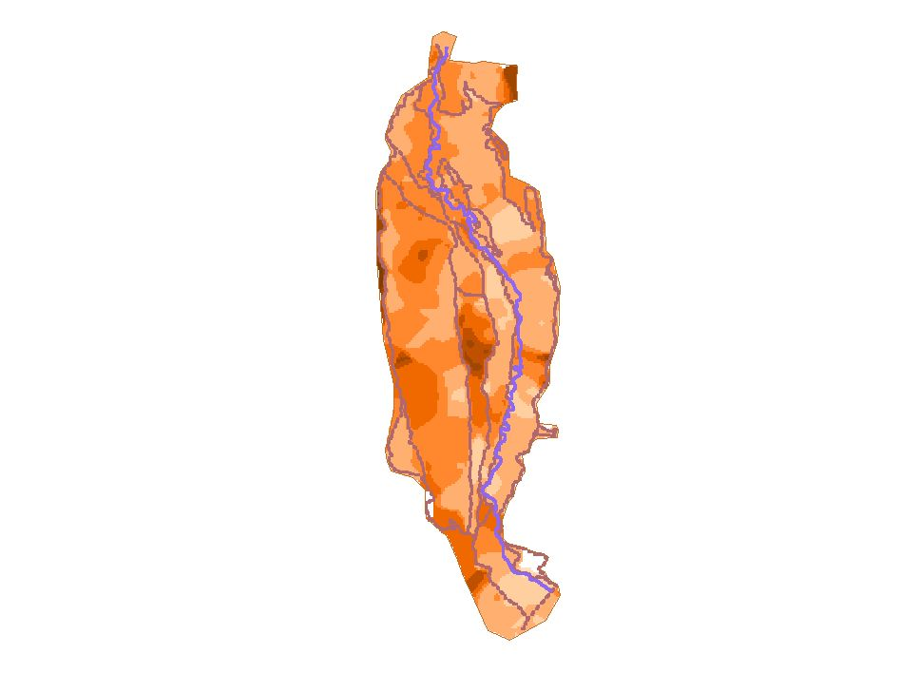
6. Hydraulic parameter - permeability coefficient
For evaluating the spatial variability of the aquifer permeability represented by the permeability coefficient k_{f}, data used were from the same above mentioned database containing information from boreholes listed in the geological archive Geofond. From the total amount of boreholes existing in this territory, 279 were deep enough to contain the information about the quaternary depth. Into the evaluation included were only permeability coefficients that were obtained from pumping tests, not those calculated from gradation curves.
The spatial variability of the permeability coefficient can be seen on the map Figure 5. This map was created using the same interpolation method – inverse distance weighted - as before. The data was also irregularly scattered throughout the territory and the values strongly variated within small distance.
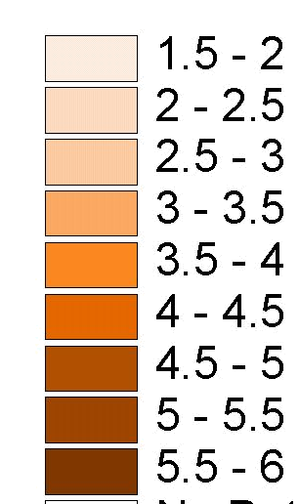
According to the assumption that the sediment composition and therefore also its permeability changes with the age and type of the fluvial depositions (e.g. recent nival, proluvial or older terraces), to the computation were added barriers (boundaries restricting the interpolated area). In this case the barriers were formed by the boundaries of the different terraces as in Figure 2.

6.1 Results
A complex characterization of Lower Hron quaternary sediments is given in Malík et al. (1999), but only as an estimation of geometrical average of the transmissivity coefficient T in m²/s.
Figure 5: Variation of k_{f}

The comparison of these values with the average values of permeability coefficient in m/s, evaluated in this thesis for the given geological units, is given in the Table 1, where n is the number of data evaluated for the respective geological unit, for which the value k_{f} is the arithmetical average.

Table 1: Average values of k_{f} and T for selected units
Evaluated quaternary unit of Lower Hron | n | k_{f} [m/s] | G(T) [m²/s]  (Malík et al., 1999)
Fluvial sediments of the Hron Flat and Hron’s left tributaries | 65 | 1,01.10⁻³ | 2,15.10⁻³
Proluvial sediments of the Hron’s northern leftsided tributaries (pleistocene – holocene) | 20 | 1,3.10⁻³ | 2,4.10⁻³
Sediments of the lower terraces (sídelná, žemliarska, turianska, sediments of kozmálovská depression - würm) | 28 | 5,15.10⁻⁴ | 1,9.10⁻³
Sediments of the middle terraces (lokská, kalnianska acumulation, želiezovská, sídelná želiezovská) | 47 | 2,2.10⁻³ | 3,0.10⁻³
Sediments of the upper terraces (lužansko-brutská, ludinsko-brutská, levická) | 59 | 3,84.10⁻⁴ | 8,1.10⁻⁴

In general it can be seen, that the permeability of the sediments is the highest in the fluvial deposits of the Hron Flat, on the map clearly visible on the left side of Hron. So-called higher Hron terraces – such as Lužansko – brutská and Ludinsko – brutská terrace on the left side and small left-overs of Levická terrace on the right – yield smaller values of permeability coefficient than the more recent middle and lower terraces that are found closer to the river course or in the direct link to the Hron Flat. The lower permeability in the higher units is caused by clayey material found there.
Using the inverse distance weighted interpolation method, same as in the case of quaternary depths, the extreme values are somewhat averaged out by the lower values found in the same location.
For a better comprehensivity of the coefficient values and view on the map, the values of the coefficient were reclassified as – log of the given value, according to which it is able to distinguish more permeable (smaller values) and less permeable (higher values) – see the conversion table in Figure 5.

7. Hydrological a climatological indicators
According to various authors conducting research of this area (e.g Kertész, 1984) the water in the aquifers of the Hron Flat originates from the surface waters of the Hron River. This can be also seen on the comparison of the oscillation of the groundwater level and the discharge in the Hron River, measured in 2 profiles – Psiare in the upper part and Kamenín in the lower part of Hron. In the Figure 6, there is compared the discharge measured in the river – measuring profile Psiare, with the groundwater level development in a measuring well situated in the Hron Flat near the river course. A strong dependence of the groundwater level on the discharge in the river can be seen on the graph. The local peaks and lows of the groundwater level follow the pattern of the river discharge only with a small delay.
The explored relationship was also evaluated statistically – by estimating the correlation coefficient. For the set of data Psiare – measuring well 599 this coefficient is 0,53; for the data set Kamenín – measuring well 556 correlation coefficient was 0,34. Both these values are highly meaningful on the statistical level of substantiality P < 0.01 (N=417), tested according to the Student’s t-distribution.

Figure 6: comparison of discharge and groundwater level
The geology-stratigraphy and geomorphology of the territory suggests (Halouzka, 1982) that already in the geological history the basis of Hron was subsiding. Today, the cutting of the River into its own older sediments can be observed by the washing out of the older fluvial, even river base material. The recent trend of the river subsiding can be also linked to the continuous long-term decrease in the groundwater level in the wells close to the river (Figure 7).
Figure 7: Decreasing trend in groundwater level near the river
Groundwater level is hydraulically linked to the river and therefore the river base subsiding, which is measurable (Krčmář, 2003), will also have the effect on groundwater level decreasing. This decrease cannot be caused only by the hydrological factors, because climatology and hydrology of the area, such as precipitation and water consumption, wasn’t changing relevantly. This assumption is further supported by the groundwater level development in a measuring well near Starý Tekov, situated in the north of the territory, where the groundwater level has a stable development and isn’t decreasing. This is caused by the geological / tectonical development in the Kozmálovská depression in the northern part of the territory, where the subsiding in the river base is complemented by the sedimentation process in this tectonical subsiding structure. In this part, the river isn’t cutting into its sediments. But in the rest of the territory, the river compensates this subsiding by cutting into its sediments.
Climatology indicators don’t have an effect on this different development - the precipitation doesn’t show the same pattern. Long-term measurements of precipitation in 3 selected measuring stations located close to the river - Želiezovce in the south, Jur nad Hronom in the center and northern Nový Tekov – have a balanced precipitation regime represented by trend-lines with minimum to zero slope (Figure 8).
Figure 8: Time series of monthly precipitation sums in the years 1961 - 2002

8. Conclusion
In this paper, hydrogeological characteristics for the territory of Lower Hron basin are listed and evaluated, in a summarizing way using existing data and thus creating a geographical output in GIS. A map of depths of the impermeable layer underlying the permeable quaternary sediments was created, representing one of the boundary conditions for groundwater modeling and a map of territorial distribution of permeability of sediments, characterized by values of permeability coefficient. These maps were created using existing measurement data from a database and interpolating these using the inverse distance weighted method. Other boundary conditions for modeling can be obtained from the spatial delineation of the given terrace units, whose borders were digitized into GIS from geological maps scaled 1:25 000.
For the need of groundwater resources management, discussed were some aspects of the problem with the groundwater level regime that is hydraulically linked to the surface water regime. The dependency of the groundwater regime on the regime of the river discharge was evaluated graphically and statistically. Discussed was also the possible geological/tectonical cause for the decreasing tendency of the groundwater-level in the territory, independent of the balanced precipitation regime, but linked to the subsiding Hron River base.
The work thank to the GIS processing of the data can be further added and extended by the continuing research, or be a source of input data for further research in this territory or its parts.

9. References:
Halouzka, R. (1982): Lower Hron Basin – kvartér a morfológia. Kandidátska dizertačná práca. Manuskript – archív GS SR, Bratislava, SR.
Halouzka, R. (1986): Z nových poznatkov o stratigrafii kvartéru terasových náplavov riek Západných Karpát (stredné Pohronie, Orava a Turiec). Region. geol. Západ. Karpát, Spr. o výsk., 21, 167-175, GÚDŠ, Bratislava, SR.

Kertész, A. (1984): Dolný Hron – pravostranné terasy. IGHP Bratislava, SR.

Krčmář, D. (2003): personal information
Lam, N. S. (1983): Spatial interpolation methods: A Review. The American Cartographer, Vol. 10, No. 2, 129 - 149.
Malík, P. et al. (1999): Hydrogoelogická a hydrogeochemická mapa severovýchodnej časti Podunajskej nížiny. Manuskript, 253pg., archive ŠGÚDŠ, Bratislava, SR.
Meijerink, A. M. J. & et al. (1994): Introduction to the use of geographic information systems for practical hydrology. ITC publication no. 23, 243 pg., The Netherlands.
Nagy, A. et al. (1998): Vysvetlivky ku geologickej mape Podunajskej nížiny - východná časť 1 : 50 000. 187pg., Vydavateľstvo Dionýza Štúra, Bratislava, SR.
Papánková, Z. (2003): Hydrogeologická charakteristika kvartéru na území dolného toku Hrona. Diplomová práca. Geofond, Bratislava, SR.
Surfer for Windows (1995): Version 6 User’s Guide. Golden software, USA.
Tabios, G. Q. & Salas, J. D. (1985): A comparative analysis of techniques for spatial interpolation of precipitation. Water Resources Bulletin, 21, 365 - 380.
Vaškovský, I. et al. (1982): Vysvetlivky ku geologickej mape jv. časti Podunajskej nížiny. 115pg., Bratislava, GÚDŠ, SR.
Water Research Institute report, team of authors, (1986): Hron – hydromorfologický výskum slovenských riek. VÚVH Bratislava, SR.

