Examination of the excess water problems utilize the excess water information systém

Gábor Balla

Szent István University Gödöllő, Hungary, Department of Water Management and Land Reclamation, Hungary, e-mail: balla.gabor@mkk.szie.hu

Abstract: The average 500-600 mm rain is shortly enough for the requirements of the agriculture. This reason can’t cause excess water problem but with the changes of hydrological status of soil, excess water causing lots of problems for agriculture, industry and population.
Excess water has two main reasons. There are natural reasons (climate, surface, soil hydrological reasons and natural vegetation) and human reasons (land use, water management, land reclamation and other changes in water system).
The extreme conditions were the results of the combined effects of several excess water generating factors, of which each one reached an extreme value, in the 90s. The changes in the ownership system increased the sensitivity of excess water. Excess water appeared where it had not been before.
These problems require to create a complex database system. The database allows a wide range of utilization for agricultural practice, research and work of water management, and helps make decisions. The database system gives a chance to use agricultural plans, meteorological plans, groundwater plans etc. in different combinations at the same time. We can link product values, meteorological data to different digital plans.
In my work I used the Excess Water Information Database which is being made by the Department of Water Management Faculty Gödöllő. I examined the excess water problems in the 1990s on the area of Körös Circuit Water Conservancy (KCWC) considering the changes of the ownership system. The digital plan combinations with attached information were the base of my work and the information system made possible to examine the area from several perspectives.
The Excess Water Information System made possible to find areas which are more endangered by excess water.
Keywords: excess-water, GIS, land reclamation, water management.

1. Introduction
Hungary is situated in Central-Eastern Europe in the Carpathian-basin. The surface of the country is about 93.000 km2. The climate is defined by the alternation of dry and wet periods. The average 500-600mm yearly precipitation is not completely enough for the requirements of the agriculture. This amount is hardly sufficient for sustaining production without irrigation considering the water consumption of plants and requirement of agricultural practice. However this value of precipitation causes excess-water problems when its yearly distribution is unequal. So excess-water problem appears every year.
About half of Hungary’s territory (40.000 km2) has plain characteristics. 19.000 km2 suffers periodically excess-water damage in wet years. Problems appear primarily in agricultural practice but also in industrial and residential areas.
Sensitivity of territories to inland water is closely related to the soil and topographic conditions. The sustainable development in agricultural practice means greater intensity, wider diversity of plant cultivation and higher quality of products.
Excess-water problem appears in water management in connection with the flood protection and the river control. The additional water entailed by precipitation moved by gravitation, could not course to rivers because of bunds. The additional inland water which generates agricultural damage or delays growth of plants is called excess-water in Hungary. During the last century, Hungarian engineers built drainage systems which drive the excess-water from fields into receiver streams during the last century.
Before 1990, the State and Collective Farms owned and controlled the drainage systems but today the channel system has four individual owners: the State, the authorities, the water-management associations and the farmers. The change which started at the beginning of the 1990s and which is still in progress, affects 58.000 km2 of agricultural land and about 2.5 million people (i.e. one fourth of the population of Hungary). Very heterogeneous farming structure has been formed. About 50% of the agricultural lands consist of farms smaller than 10 ha (0.1 km2), in addition, about 80% of the landowner families possess a land which is smaller than 1 ha (0.01 km2). The farm-sizes of Collective properties were ten times bigger, about 3000-5000 ha (30-50 km2), than now. Thus the same expanse of inland water on a Collective property made smaller damage, because after 1990, a 0,5 ha (0.005 km2) big excess-water area inhibits families from producing enough agricultural products for their living on small private farms and often led them to their financial ruin.
Besides, there is another problem which proceeds from the shared control over drainage systems. The State controls the channels above 3m3/s capacity, the authorities control the channels which run trough their property, the water-management associations control common channel structures which are not under the control of the State, other channels are owned and controlled by farmers. Every owner has demands and problems but statutes do not separate properly the owner’s rights and duties.
Due to the political, social and economical changes at the end of the 1980s, the State and the Collective property decreased while private owners' responsibility became more prevalent. The agricultural practice has become more sensitive to excess-water damage.
Thus, the development of surface drainage will coincide with the future expectations (suspected today) only if it corresponds with ecological conditions and the changes of the production system.
The focus of the development of surface water drainage will shift away from higher/central control to lower/local control. Especially, because it has become more evident to us, that there is only limited chance to control the appearance and presence of excess-water with the main waterworks at the operational unit of agricultural land, i.e. at the field. The importance of the drainage systems in smaller regions, at field level, has been increasing for years because fault of the drain-channel density in catchments.
The development of the surface water drainage should be definitely based on the needs of the agriculture, after all the objective is to release farming from the harmful effects of excess-water. The last few springs have shown us the importance of inland surface excess-water drainage (Forgoné, 1999).

2. Examination of the excess water problems
The system filled with the data from a particular region of Hungary. This area was the Körös Circuit Water Conservancy (KCWC) which is situated in the south-eastern part of Hungary (Figure 1).
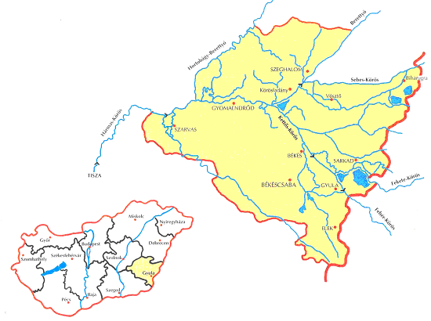
Figure 1. Working area of Körös Circuit Water Conservancy

Excess-water has two main reasons. There are natural reasons (climate, surface, soil, hydrological reasons and natural vegetation) and human reasons (land use, water management, land reclamation.
The extreme conditions were the results of the combined effects of several excess-water generating factors, of which each one reached an extreme value, in the 1990s. The changes in the ownership system increased the sensitivity of excess-water. Excess-water appeared where it had not been before.

2.1. Methodology
These problems require to create a complex database system. The database allows a wide range of utilization for agricultural practice, research and work of water management, and helps make decisions. the database system gives a chance to use agricultural plans, meteorological plans, groundwater plans etc. in different combinations at the same time. We can link product values, meteorological data to different digital plans.
Data are essential to project and to realize the excess-water management. Our Excess Water Databank contains information from maps (hydrological, meteorological, agricultural, soil-information etc.) and databases (temperature, ground-water, irrigation, radiation, plant production etc.) for plans of water-works, for implementation, for operations and maintenance of surface drainage systems. This data collected from various sources such as Hungarian Meteorological Service (HMS), Hungarian Central Statistic Office (HCSO), Ministry of Agriculture and Urban Development (MAUD), Water Resources Research Center Plc. (WRRC) etc.

2.2. Main steps
1st step: We collect and attached to the system graphical (maps, pictures, plans etc.) and statistical data (tables, documents etc.).
2nd step: We convert this information to digital form (raster map to vector map, picture to digital picture, data to excel or document files etc.). If there were any absence we searched it and we linked to the database.
3rd step: We prepared data for agricultural practice, for research and for planning.
4th step: We made representational data combination for examination of excess water problems in the KCWC. We recombined the collected data and defined the territories from excess water problem point of view.
5th step: We find out the effects which caused excess water problem.
The flow chart of our work made for a better understanding the main stream of our examination (Figure 2.).
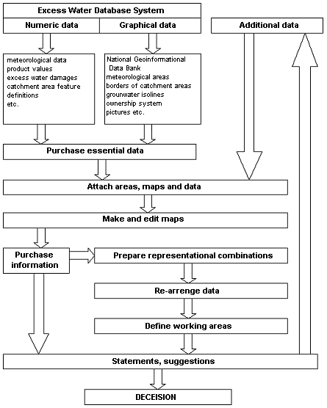
Figure 2. Process flow chart

The main reasons of extreme excess-water problem are the following:
- the drainage systems water driving ability reduced;
- the extreme conditions were the results of the combined effects of several excess-water generating factors;
- the changes in the ownership system increased the sensitivity of excess-water;
- the owner’s rights and duties were not separate properly;
- the channels reception capacity reduced because of alluvial material;
- where the soil has extreme water management condition the excess-water appears (Várallyay, 1980) (Figure 3.);
- the excess water appears on areas where had not been excess-water before (Pálfai, 2000) (Figure 4.);
- the extreme high value of precipitation with the high-water of recipient rivers both made inland water problems.
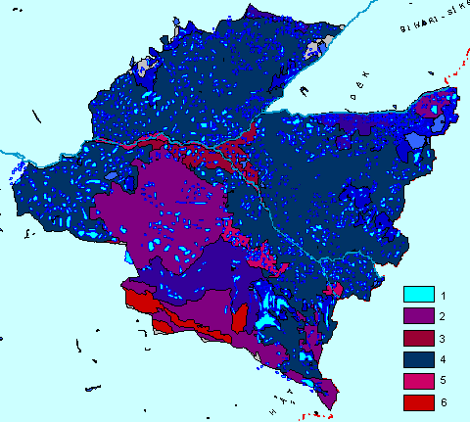
Figure 3. Excess-water areas and soil water management character
1. excess-water, 2. very good, 3. good, 4. medium, 5. bad, 6. very bad soil water management character
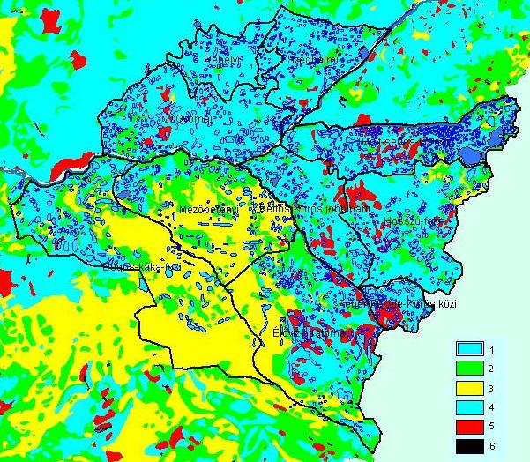
Figure 4. Excess-water sensitivity map by Pálfai and excess-water areas
1. excess-water spot, 2. no sensitivity, 3. low sensitive area, 4. sensitive area, 5 very sensitive area for excess-water, 6. borders
In my work I used the Excess Water Information Database which is being made by the Department of Water Management Faculty. I examined the excess water problems in 1999 on the area of KCWC considering the changes of the ownership system. The digital plan combinations with attached information were the base of may work and the information system made possible to examine the area from several perspectives.
The Excess Water Information System made possible to find areas which are more endangered by excess water. This research and databank system will be the base of my future examinations where I am trying to ascertain the changes in agricultural practice can reduce the appearance of excess water, and decrease its damage.

3. Summing
The objective of our research was to establish such a system which give easy access to information collected and therefore provide a wide range service for planning and for making decision about agricultural operations, research and water management duties.
During our research we find out more problems which have great data requirement such as to change land usage, to determine territories excluded from cultivation, to give alternatives for the possibilities of drainage, for storage-utilization of excess water, for the regulation of the water balance, to follow the results of irrigation at dry plough-land etc. The database system can give the basic information to a great number of problems so we started to make some procedure in some question listed above in consideration of the Water Framework of the European Union.

4. References
Forgóné Dr. Nemcsics, M. (1999): Methodology for the Agricultural Foundation of Surface Drainage System Development with Geographical Information System. II. International Scientific Days of Land Management in the Great Hungarian Plain, Vol. I, 84-89. pages, Mezőtúr, Hungary
Pálfai, I. (2000): Az 1998/99. évi téli és tavaszi belvizek kialakulása, sajátosságai és összehasonlítása a korábbi nagy belvizekkel. Hidrológiai Közlöny Vol. 2000/3, 141-144. pages, Budapest, Hungary.
Várallyay, Gy. et.al. (1980): Magyarországi talajok vízgazdálkodási tulajdonságainak kategóriarendszere és 1:100 000 méretarányú térképe. Agrokémia és talajtan. Tom. 29. No. 1-2, 77-112 pages, Budapest, Hungary.

