MORPHODYNAMIC OF THE DANUBE BED BETWEEN 440 AND 487 KM

F. Ploscaru, M. Petrus

The paper is centered upon two objectives: the first one is to assess the morphodynamic evolution of the Danube bed, extended between Giurgiu and Oltenita localities (440 – 487 km), on the two planes, vertical and horizontal, on a relatively long time interval (1980-2000), and the second one is to trace the bathymetry maps for the same bed sector, corresponding to three big measurements campaigns, 1980, 1990 and 2000 respectively.
Thus, for accomplishing the first objective, there were available three cross profiles sets, resulted from the measurements campaigns enunciated in 7 reference sections that cover the entire studied bed extension (Figure 1).

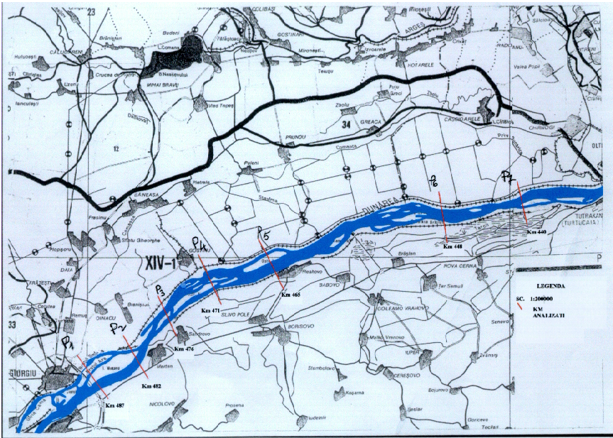

Figure 1

Achieving a critical analysis of the profiles succession in all the seven sections (Figures 2), we retain the relative moderate degree of the bed deformability in vertical plane (with an average of 1 – 3 m), specifying that the aggradation-degradation processes alternate during the intervals between the three topobathymetry raisings, these alternations being normal, and determined by the facies types drained with areal disposal, by the consistence of the alohton materials deposed on the bed, but insufficiently rammed, the hydraulic of the flow influenced by reservoirs presence: Iron Gates 1 and 2, situated in the upstream etc.

Cross profile on danube river

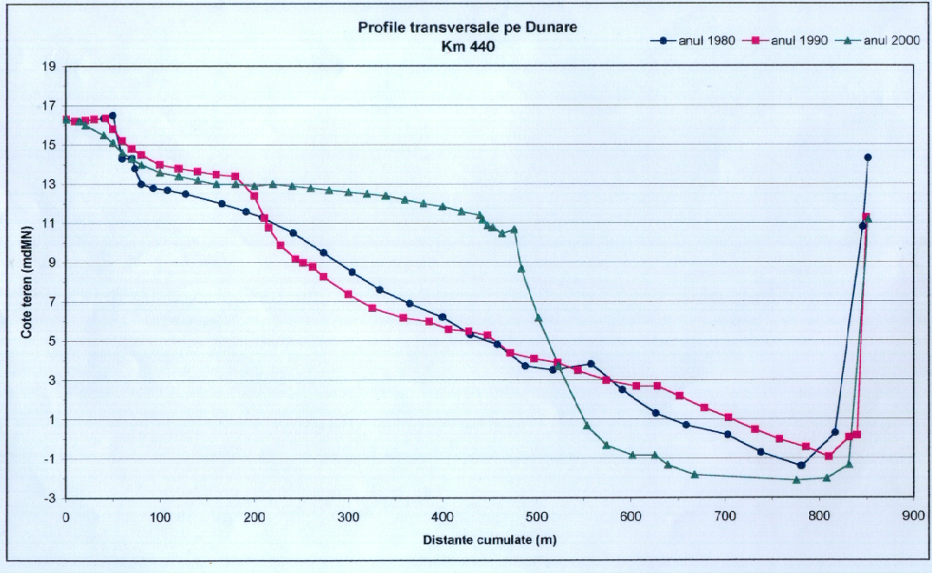
Figure 2

Thus, the maximum deformability is emphasized on the sectors imminent to the 1, 2 and 5 sections, from 440 km; 448 km and 476 km. In detail, for the sections 1 and 2 there are distinguished aggradations comprised between 2 and 6 m; and for the section 5, degradations with extensions on the whole profile, comprised between 1 and 3 m.
Regarding the deformations amplitude for the two banks of the Danube River, it results that the Romanian bank is perceptibly marked by a more active morphodynamic, where the erosion process is dominant. The causes are connected to the weak cohesion of the bank subbasement and the lack of dykes, comparing to the right bank (of Bulgaria R.), which is mostly constituted by calcareous rocks and extended protections, especially by concrete. But we also retain that the navigable channel generally preserve their route, without migrating from a bank to another.
The analysis of the bed morphodynamic in longitudinal profile on the same studies sector (Figure 3), it has been found a lent but continuous erosion process, except of an extended sector, between 448 and 465 km, where the contribution of Potoka of Bulgaria R. is more consistent in alluvia.

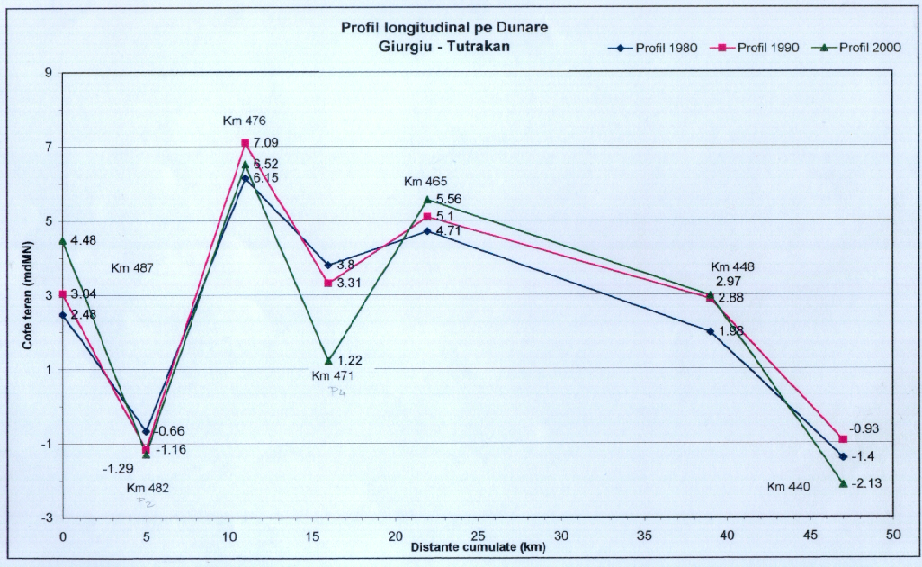

Figure 3. LONGITUDINAL PROFILE ON DANUBE RIVER

We mention that this erosion morphological process is generated by the more and more drastic diminishing of the alluvia concentration, both of the Danube River and of Olt, main tributary, through the building on stages of numerous reservoirs.
Concerning the second objective, namely the bathymetry representation of the studied sector, it has the role of indicating suggestively the variation of the depths in the area. Thus, as a result of the three measurements campaigns, 1980, 1990 and 2000, three bathymetry maps were accomplished, which offer comparing possibilities, including the evolution tendency.
Examining these maps, accompanied by graphical 3D representations (Figure 4), the aggradation-degradation processes can be easier distinguished through the isobaths displaying, including the channel configuration.

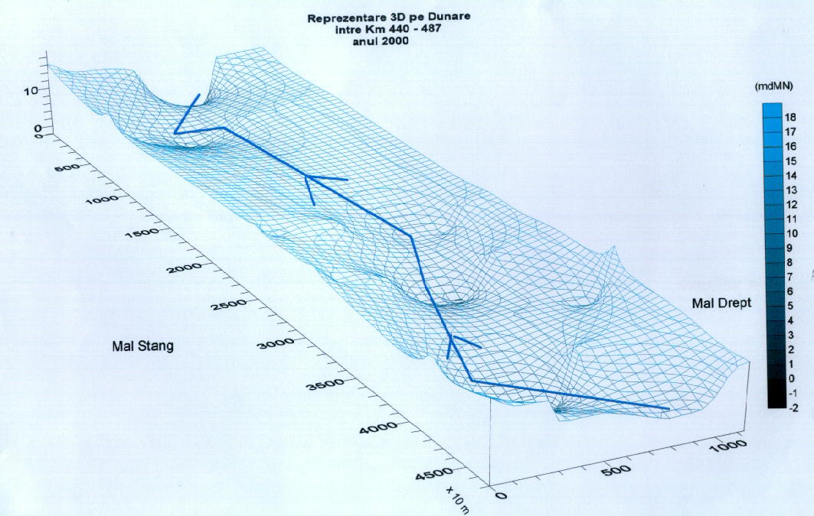

Figure 4. 3D REPRESENTATION ON DANUBE RIVER BETWEEN KM 440 – 487 (2000)

In the future, a multiplication of the topobathymetry sections on this sector, quite extended (50 km) will increase the knowledge degree till the level of the present morphodynamic nonascale, at which is submitted the Danube bed, with advantages for the local navigation security.
Therefore, the Danube sector comprised between 440 and 487 km is in a moderate morphological evolution, resulted from approximately balanced alternatives of aggradation-degradation processes, with weak tendencies of increasing of the last process type, especially in longitudinal profile. The causes are already known, namely the gradually diminishing of the alluvia contribution from the upstream, because of the numerous hydroenergetic buildings.
The analysis revealed also the fact that it is necessary to increase the sections number, in order to improve the monitoring of the present morphodynamic.

