Susceptibility of basins to floods – regional typification of small basins of Slovakia from the point of view of soil permeability

Ľubomír Solín

Institute of Geography, Slovak Academy of Sciences, Bratislava, Slovak Republic,
e-mail: solin@savba.sk

Abstract: The aim of the paper is grouping of small basins of Slovakia into regional units regarding permeability of soil units, which they are composed of. Differentiation of soils as far as permeability is concerned is mainly the consequence of soil texture and structure. Small basins of Slovakia were classified into seven regional units of permeability with regard to soil texture and into the same number of classes to soil structure. By mutual combination of both types of regional units of permeability 38 regional units of overall permeability of small basins in Slovakia were delimited. Because of lack of hydrological data the analysis of hydrological consequences was expressed only with respect to regional units of permeability identified from the point of view of soil texture. Differentiations of arithmetic means of coefficient of variation, skewness, kurtosis and base flow index showed of the mean daily discharges values between regional types showed that it is justified to group seven regional units of permeability into three regional hydrological units.
Key words: soil texture, soil structure, permeability regional units, hydrological regional units.

1. Introduction
The cause of floods lies in extreme values of the determining factors: extremely high intensity and volume of precipitation, insufficient storage space, slow or no infiltration, high speed of water movement in basin, etc. Some of the quoted factors change in time, for instance intensity and volume of precipitation. On the other side, there are factors, for instance, physical properties of rocks and soil, character of land cover, which are relatively stable in time, but different in space. These factors induce regional differences in way of transformation of precipitation into runoff, which later manifests in certain differentiation of basins in terms of their susceptibility to floods. Substrate-soil properties greatly influence soil capacity to transmit water from surface into deeper soil horizons. As far as hydrological consequences are concerned, basins with permeable soils compared to basins with less permeable soil are characterized by smaller range of hydrological values and higher share of basic runoff in the total runoff. In relation to maximum discharges it means that, for instance, the maximum discharges in permeable basins are lower and occur less frequently and consequently the damage caused by floods are minor than in basins with less permeable surface.
In the 1990s Gustard (1992), Demuth, Hagemann (1992), Gustard, Irving (1992) dealt with to the issue of hydrological soil evaluation (substrate-soil complex) in the framework of the FRIEND Projects. In Slovakia, Solín (2001) was involved in hydrological evaluation of the substrate complex of small basins. Differentiation of soils from the point of view permeability is the result of two basic physical soil properties – texture and structure that determine the size, shape and geometric arrangement of soil pores. In this paper emphasis is laid on the regional typification of small basins of Slovakia (almost 5,000 small basins) regarding their permeability and subsequent evaluation of the identified regional types from the point of view of certain hydrological consequences.

2. Permeability of small basins of Slovakia in terms of soil texture
Evaluation of permeability of small basins in Slovakia in terms of soil texture was worked out in connection with the database of physical characteristics of small basins of Slovakia (Solín et al. 2000). Soil pores are classified into two basic groups as far as size is concerned (cf. Bedrna et al. 1989): a) capillary pores with capillary movement of water and b) non-capillary pores with gravitational movement of water. In relation to soil texture, the percentage of non-capillary pores decreases from coarse grain categories to fine grain categories. In the consequence, the permeability decreases from coarse grain categories to fine grain categories (Table 1)

Table 1. Permeability of soil texture categories
soil texture  category |  | share of particles smaller than 0.01mm | category of  permeability | index of  permeability
sandy | 0 - 10% |  | absolutely permeable | 7
loam-sandy | 10 - 20 |  | very well permeable | 6
sand-loamy | 20 - 30 |  | well permeable | 5
loamy | 30 - 45 |  | permeable | 4
clay-loamy | 45 - 60 |  | poorly permeable | 3
clayey very | 60 - 75 |  | very poorly permeable | 2
clay | > 75 |  | no permeable | 1

Based on the relationship between the rock and soil texture (Table 2) by Šály (1992, 1986) and the hydrogeological map of Slovakia at scale 1:500 000 (Porubský 1980), the map of spatial distribution of the soil texture categories was compiled (Figure 1).

Table 2 Relationship between soil texture and the rock (Šály 1962, 1986)
soil texture | rock
sandy | sand deposits
loam-sandy | quartzite, granite, granodiorite
sand-loamy | melaphyre, granodiorite, gneiss, porphyroid, flysh-sandstone
loamy | andesite rocks, porphyroid, gneiss, amphibolite, loess, dolomite
clay-loamy | andesite rocks, phylites, loess, limestone, flysh-clayey shale
clayey | marlite, marly shale, marly limestone
clay | neogenic formations of clay and marl

Overlaying the thematic layer by that of small basins of the SR (Solín, Grešková 1999) the percentage of the individual soil texture categories in each basin was assessed. Permeability index of the basin as the whole was set afterwards by:
$I_{p}=\frac{\sum{P_{\text{pj}}\text{.}I_{\text{pj}}}}{\text{100}}$ (1)
where I_{p} is the permeability index of basin, P_{pj} is percentage of soil texture category of the total basin area and I_{pj} is the corresponding permeability index. Basins were then grouped into interval classes (Table 3), which fulfilled the function of regional classes of basins from the point of view of soil texture permeability. Their spatial delimitation is in Figure 2.

3. Permeability of small basins of Slovakia with regards to soil structure
The second basic characteristics, which determines soil permeability is soil structure. Geometric arrangement of pores, as well as their resistance to outer forces depends on shape of soil aggregates, their size and arrangement. Soil aggregates are classified into three groups depending on their shape and development of their edges after Nemeček et al.(1966):
i) structural elements developed in three dimensions (surfaces and edges are not distinctly developed – granular, surfaces and edges distinctly developed – angular, polyhedron),
ii) structural elements vertically elongated (lacking the rounded upper part – prismatic, with the rounded upper part – columnar).
iii) structural elements horizontally elongated – (platy).

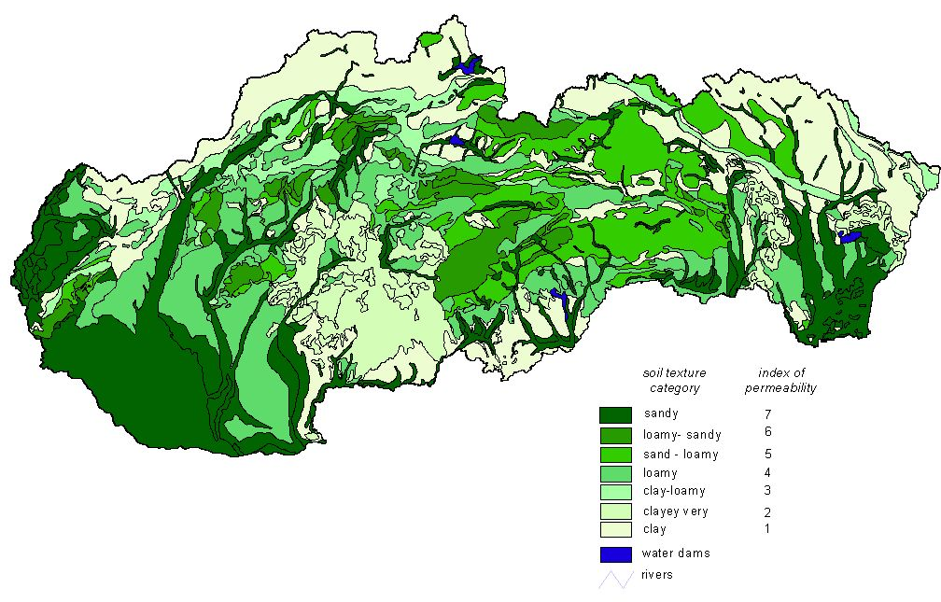
Figure 1. Regional types of soil texture categories

Depending on size of structural elements these basic three groups are divided into several subgroups. For instance, in the framework of granular shape of structural elements, depending on their size there are the following structures: very coarse granular –coarse granular – medium granular –fine granular– very fine granular (Nemeček et al. 1966, Bedrna et al. 1989).

Table 3 Regional classes of permeability index
permeability index | regional class of permeability index
1,00 - 1,50 | 1
1,51 - 2,50 | 2
2,51 - 3,50 | 3
3,51 - 4,50 | 4
4,51 - 5,50 | 5
5,51 - 6,50 | 6
6,51 - 7,00 | 7

With respect to shape and arrangement of structural aggregates porosity diminished from structural aggregates uniformly developed in three directions towards horizontally elon
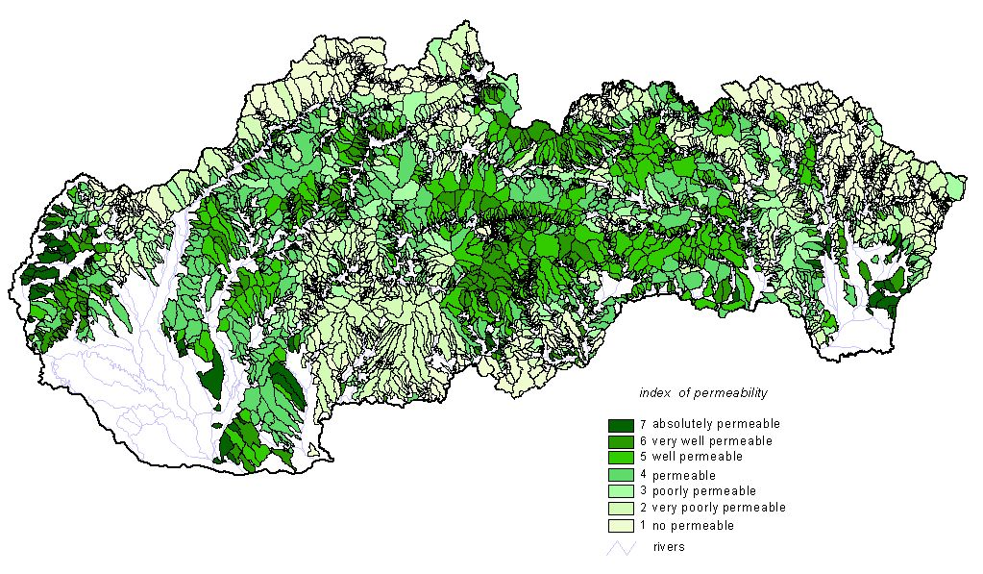
Figure 2. Index of permeability of small basins with respect to soil texture

gated structural aggregates. Permeability also diminishes in this direction. The fact that the shape and arrangement of soil structural aggregates is linked to soil horizons is also very important (Bedrna, Hraško, Sotáková 1968). Structure of humus horizon is fine granular if the reserves of calcium, humus and biological activity are sufficient. Eluvial horizons are characterized by unstable platelike structure. Iluvial horizon of above all solonetz soils is characterized by distinct prismatic to columnar structure. Permeability evaluation of soil horizons based on structure of soil aggregates which are linked to them (Table 4) became the basis for expression of structural permeabilty of soils of Slovakia.

Table 4. Permeability of soil horizons
soil horizon | soil structure | permeability index
layer of loose-sandy material | structureless - loose | 7
weathered substrate | structureless - stone | 6
humus | granular | 5
metamorphic | polyhedron | 4
iluvial | prismatic, columnar | 3
eluvial | platy | 2
gley | structureless - dense | 1

Soils of Slovakia are represented by soil units classified on the map Soils of Slovakia at scale 1:500 000 by Šály and Šurina (2000) according to Morphogenetic classification system of soils of Slovakia (VÚPOP 2000). Each soil unit is characterized by certain grouping of soil horizons and in assessment of the soil unit permeability as a whole the principle of „bottle neck“ was applied. It means that the soil unit was attributed the permeability corresponding to the least permeable soil horizon (Table 5, italic bold numbers in last column).

Table 5. Classification of soil unit permeability
soil unit | soil horizons | soil structure | permeability  index
Leptosols | shallow humus | granular: fine to medium | 6
Leptosols | weathered rock
Arenosols | loose sand | structuruless loose | 7
Rendzic Leptosol and Calcaric Cambisols | humus | granular: fine to medium | 5
Rendzic Leptosol and Calcaric Cambisols | metamorphic | granular: fine to medium | 4
Rendzic Leptosol and Calcaric Cambisols | weathered rock
Chernozems | humus | fine granular | 5
Chernozems | loose loess
Haplic Luvisols | humus | granular: fine to medium | 5
Haplic Luvisols | iluvial | polyhedron to prismatic | 3
Haplic Luvisols | loose substratum
Albic Luvisols | humus | granular: fine to medium | 5
Albic Luvisols | eluvial | platy | 2
Albic Luvisols | iluvial | prismatic | 3
Albic Luvisols | loose substratum
Cambisols and Andosols | humus | granular: fine to medium | 5
Cambisols and Andosols | metamorphic | polyhedron | 3
Cambisols and Andosols | weathered rock
Podzols | humus | medium granular | 5
Podzols | eluvial | structuruless loose | 6
Podzols | iluvial | polyhedron | 3
Podzols | weathered rock
Planosols and Stagnosols | humus | granular: fine to medium | 5
Planosols and Stagnosols | gley | structuruless dense | 1
Planosols and Stagnosols | loess loams deposit
Fluvisols | alluvial deposits | structuruless | 5
Mollic Fluvisols and Mollic Gleysols | humus | fine granular | 4
Mollic Fluvisols and Mollic Gleysols | gley | prismatic to platy | 2
Mollic Fluvisols and Mollic Gleysols | loosse deposit

The map of permeability soil units of Slovakia from the point of view of soil structure is in Figure 3. Overlay these map by layer of small basins of Slovakia, percentage of the each class of permeability index of the total area of basin was expressed. Subsequently total permeability index was assessed for each basin according equation (1). Based on interval classes of permeability index (Table 3) regional classes of permeability index of small basins of the SR were produced with regards to soil structure. Their distribution is in Figure 4.
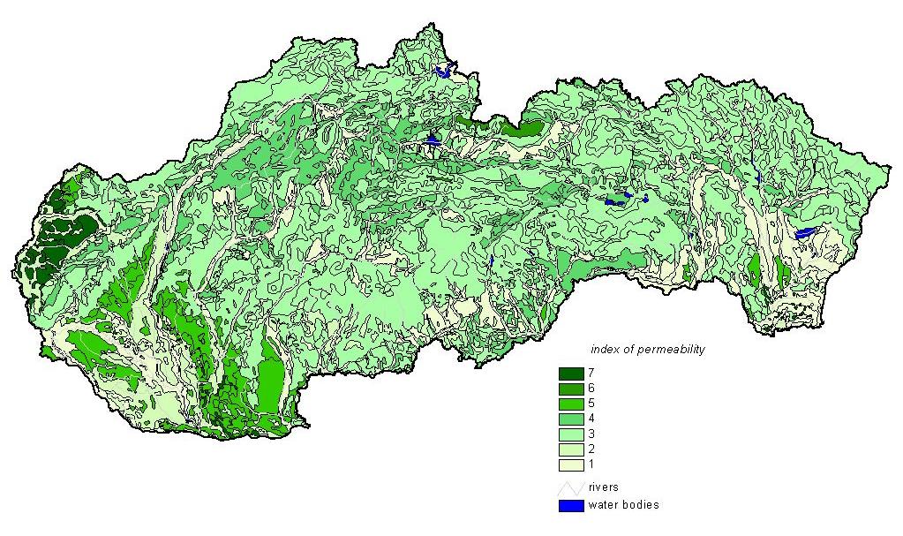Figure 3. Index of permeability of soil units with respect to soil structure.

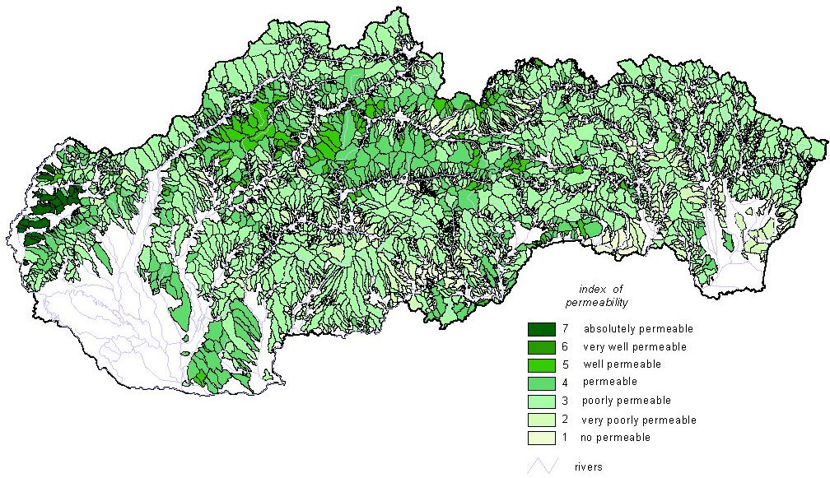
Figure 4. Index of permeability of small basins with respect to soil structure.

Mutual combination of regional classes of soil texture and soil structure permeability index of small basins was used for delimitation of regional types of overall permeability of small basins. In this way the small basins of Slovakia were divided into 38 regional units with regards to permeability of soil-texture and structure (Figure 5). The first index in the legend of map expresses the textural permeability and the second structural permeability of basins.
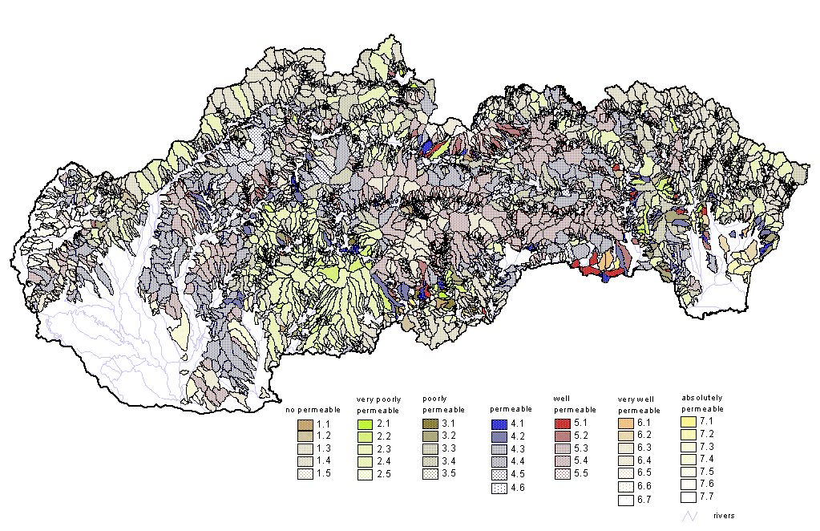
Figure 5. Overall index of permeability of small basins.

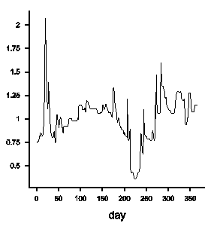
This division of small basins into regional units based on application of certain logically formulated physical differentiation criteria though must be subject of evaluation from the point of view of hydrological consequences. Figure 6 brings hydrographs of normalized values of mean daily discharges for the hydrological year 1980 of three basins: the first (Ladomírka) is one of not permeable basins from the regional unit 1.3, the second (Rimava) is among very well permeable basins of regional unit 6.3 and the third basins (Lábsky brook) is an example of absolutely permeable basin of regional type 7.5. Hydrographs are considerably different, as obvious. Assessment of hydrological consequences of regional units was carried out in the framework of the selective set of 124 basins. However, only 18 out of the delimited regional units have some gauged basins and only in 10 of them there are more than six gauged basins. For this reason only the regional classes delimited by the criterion of soil texture were assessed from the point of view of hydrological consequences.
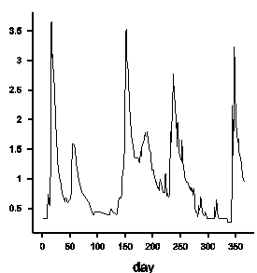
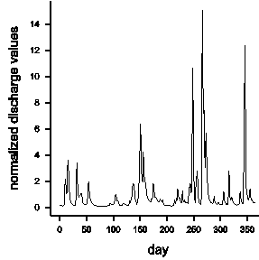
a) Ladomirka b) Rimava c) Lábsky brook

Figure 6. Hydrographs mean daily discharge values

Suitable criteria for comparison of hydrographs are the following statistics of mean daily discharge values: coefficient of variation (Cv), skewness (Cs), kurtosis (Ck) and base flow index (BFI). The IHCRES precipitation model was used for assessment of BFI (IHCRES 2003). The arithmetic means of the quoted statistics represent hydrological consequences of regional units as a whole. Their values are quoted in Figures 7.
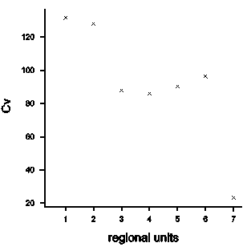
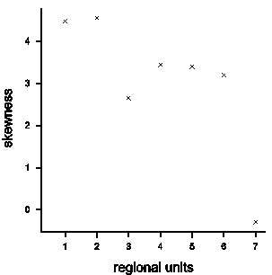
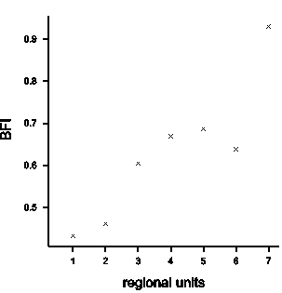
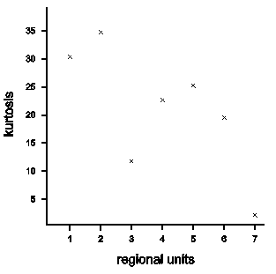

.

Figure 7. Arithmetic mean values of hydrological statistics of regional units

Analysis of graphs shows that from the point of view of differences of arithmetic means coefficient of variation, skewness, kurtosis and BFI between seven regional units it is justified to group them into three hydrological regional units: the first hydrological regional unit (I) covers the regional units of permeability 1 and 2, the second (II) contains the regional units 3, 4, 5, 6, and the third hydrological regional unit (III) is formed by the permeability regional unit 7. Division of small basins of Slovakia into those three hydrological regional units of permeability is in Figure 8. The corresponding arithmetic mean values of hydrological statistics are in Table 6.

Table 6. Arithmetic means of hydrological statistics of hydrological regional units
hydrological regional units | Cv | Cs | Ck | BFI
I | 129,07 | 4,54 | 33,54 | 0,45
II | 89,61 | 3,25 | 20,85 | 0,66
III | 23,44 | -0,29 | 2,17 | 0,93
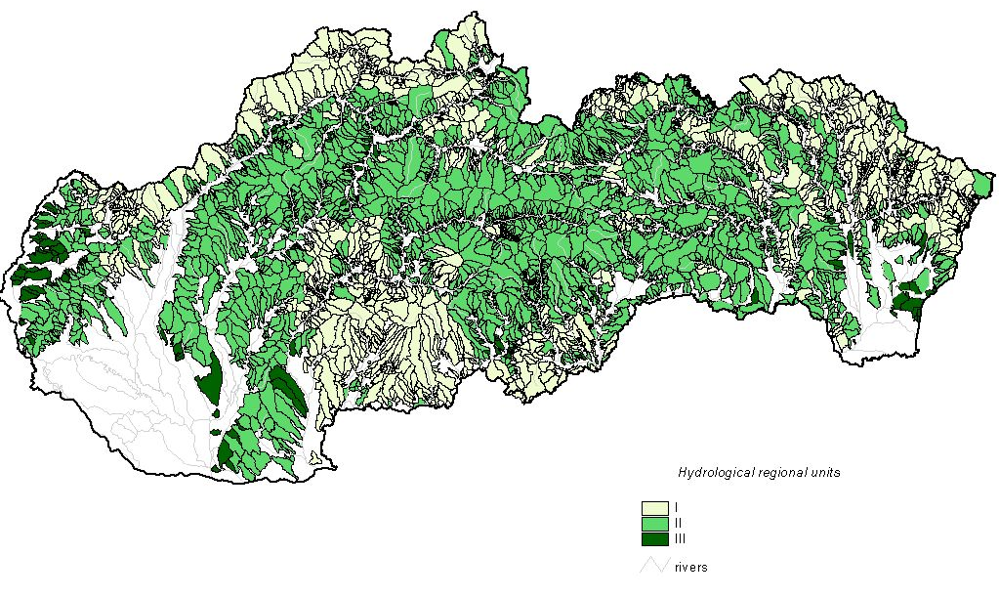
Figure 8. Hydrological regional units

4. Conclusion
Based on logically formulated differentiating criteria small basins of Slovakia were classified into seven regional units of permeability from the point of view of soil texture and the same number of regional units were identified with regards to their soil structure. By their combination 38 regional units of overall basin permeability were classified at the second hierarchic level. However, only 18 out of the 38 delimited regional units are gauged and only in 10 of them have more than six gauged basins. For this reason only the regional units of permeability delimited with regards soil texture were assessed from the point of view of hydrological consequences. They were expressed by four hydrological statistics of the mean daily discharges of hydrological year 1980: coefficient of variation, skewness, kurtosis and base flow index. Analysis of graphs shows that from the point of view of differences of arithmetic means of coefficient of variation, skewness, kurtosis and base flow index between seven regional units of permeability it is justified to group them into three regional hydrological units: the first regional unit (I) covers the regional units 1and 3, the second (II) contains the regional units 3-6, and the third regional unit (III) is formed by the regional unit of permeability number 7.

Acknowledgement
The Slovak Grant Agency VEGA, project no.2/3085/24, supported the research in this paper. The support is gratefully acknowledged.

5. References
Bedrna, Z., Hraško, J., Sotáková, S. (1968): Poľnohospodárske pôdoznalectvo. SVPL, Bratislava.
Bedrna, Z. ed. (1989): Pôdne režimy. Veda SAV, Bratislava.
Demuth, S, Hagemann, I (1992). Case study of rationalizing base flow in SW Germany applying a hydrogeological index. In: Flow Regimes from International Experimental and Network Data (FRIEND). Volume I Hydrological studies. Institute of Hydrology, Walingford, pp.86-98.
Gustrad, A. (1992): Case study of rationalizing flow flows in the UK. In: Flow Regimes from International Experimental and Network Data (FRIEND). Volume I Hydrological studies. Institute of Hydrology, Walingford, pp.68-85.
Gustard, A., Irving, K. M. (1992). Classification of the low flow response of European soils. In: Flow Regimes from International Experimental and Network Data (FRIEND). Volume I Hydrological studies. Institute of Hydrology, Walingford, pp.98-109.
IHACRES (2003): PC IHACRES v1.02. Catchment’s scale rainfall - stream flow modelling. The Australian National University, Centre for ecology &hydrology, NERC, Walingfrod
Nemeček a kol. (1966). Metodika půdoznaleckého průzkumu ČSSR. Část A. Praha
Solín, Ľ., Cebecauer, T., Grešková, A., Šúri, M. (2000). Small basins of Slovakia and their physical characteristics. Institute of Geography SAS, Slovak Committee for Hydrology, Bratislava.
Solín, Ľ., Grešková, A. (1999) Malé povodia Slovenska – základné priestorové jednotky pre jeho hydrogeografické regionálne členenie. Geografický časopis, 51, 77-96
Solín, Ľ. (2001). Regionálna variabilita malých povodí Slovenska z hľadiska podielu základného odtoku na celkovom odtoku. Geografie XII, Masarykova univerzita, Pedagogická fakulta, 352-356.
Šály, R. (1962). Lesné pôdy Slovenska. Veda SAV, Bratislava.
Šály, R (1986): Svahoviny a pôdy Západných Karpát. Veda SAV, Bratislava.
Šály, R, Šurina, B (2000): Pôdy Slovenska. VÚPOP, Bratislava.

