DROUGHT IN 2003 ON THE DANUBE RIVER AND ON THE INTERNAL RIVERS FROM ROMANIA

Dr. Petre Stanciu

Abstract: The amplification of the drought phenomenon in the last decades has important implications upon the social and economical potential of the country.
Even 2002 was a drought year in the south of the country and in the Barlad Plain, from hydrological point of view this year was characterized by a flow situated over the ordinary annual values for the rivers of the northern half of the country, and under these values for the other rivers, similarly to 2001 year.
The droughty aspect, persistent in the autumn period 2002, was present in the spring-summer period of 2003, too.
The hydrological drought in 2003 on the Danube River and some national rivers was analyzed statistically and also by the method of analogs.
The results of this analysis have shown the analogs years for the Danube in 1950, 1946-1947 and for the national rivers in 1950, 1959 and 1990.
The hydrological regime of the Danube River in 2003 is the most severe reported to the 1840-2003 period and it is strongly influenced by the poor raining regime in its superior and middle basin.
Regarding the internal rivers, the most affected areas had medium monthly discharges of 0.2-0.3 from the medium multi-annual monthly values, generating negative effects in the economical and social fields.
The statistical analysis highlighted the increasing frequency of the droughty and very droughty years between 1982-2003, from 33.4% (the previous period of 1982 year) to 80%, fact that demonstrates a dryness tendency of Oltenia Plain, Romanian Plain and Barlad Plain.
The paper also presents for the mean internal rivers and romanian sector of Danube a forecast of discharges from summer-autumn.

The characteristics of the droughts

The drought can be defined as an “abnormal period of dry weather that persists quite long so that serious hydrological instabilities are occurring” or as a period when the soil humidity shows a deficit so that the water supplies is insufficient for the plants, animals and people life.
There are four general types of floods, all of them having an impact upon the people, but in different ways:
- meteorological: the measured precipitation are usually low for a particular region;
- agricultural: the soil humidity is insufficient, on a long time period, for satisfying the water request of the agricultural crops;
- hydrological: the underground and surface water supply is situated under the normal level
- socio-economical: the lack of water affects the economical capacity of the nation for surviving, namely affects the non-agricultural production;
On the Romanian territory, the droughty intervals are correlated, in most cases, with the presence of some stable and dry air masses, included in anticyclone baric structures at soil, sustained by strong dorsals on all the thickness of the troposphere.
The very droughty regimes are not extended in the same year or in the same month over the whole country territory.
The analysis of the multi-annual variation of the annual precipitation for the Romanian territory shows the occurrence, after 1980, of a series of droughty years, because of the precipitation quantity mitigation with an obvious tendency of lowering after 1980, corroborated with the tendency of the annual mean temperature rising, especially for the Romanian Plain and Barlad Plateau.
The quantitative diminishing of the precipitation in the last 15 years led to the exaggerated mitigation of the discharges on the majority of rivers and, especially in south and south-east of Romania, in the context of a simultaneous and conjugated action of a complex of causes:
-mitigation of annual quantities precipitation, after 1980 – 1981;
-rising of annual mean air temperature, with influences of evaporation and evapotranspiration intensification
- a mitigation of the ground waters levels from rivers meadows and terraces, with negative implications in their supplying during the seasons with rains lacks
- the bigger and bigger drought phenomena frequency and duration on the rivers with reception basins smaller than 500 km2
Meteorological droughts can begin in any season of the year. The most frequent, with the biggest intensity, begin in autumn and continue during the cold season and even during the spring of the next year.
The droughts from 1982, 1991 and 2002, covering the winter and the spring of the next year are typical examples for large areas of the country territory.
The aspects connected to the hydrological and agricultural drought are much more complex, being conditioned by the water store from the soil, the mitigation of the ground layer, water consumer etc.
The characteristic of the meteorological droughts is the alternation of the droughty periods with short rainy periods, which do not modify the general character of the period.
The longest droughty intervals registered during this century were 1902 - 1904, 1927 - 1930, 1945 - 1953, 1962 - 1965, 1973 - 1976, 1982 - 1996, with one culminating year: 1904, 1945, 1990. These intervals have a periodicity of 43 years, namely two Hole cycles, showing the existence of a correlation with the geophysics phenomena at planetary scale.
The areas with different risk of meteorological drought, on the basis of the “PAI” (Palfai Aridity Index) are presented in figure 1.

Figure 1 Areas with different risk of meteorological drought

From the meteorological and agricultural stand point, the endemic drought areas are grouped over a relatively significant territory as a surface as well as an agricultural yield potential. These are including the Oltenia Plain, Muntenia Plain, Dobrogea and Barlad Plateau.
The drought phenomena have a general trend to extend and migrate towards the western and central regions of the Romania (figure 2).

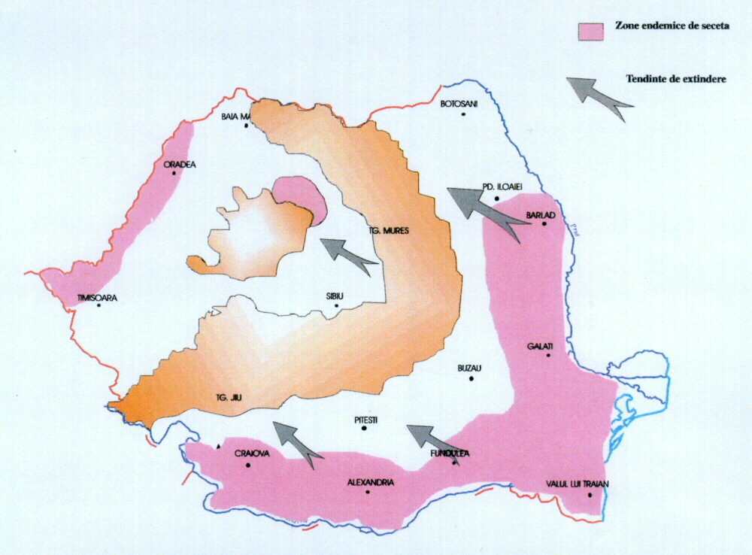
Figure 2. The expansion of the drought phenomenon in central and western zones

The characteristics of the hydrological drought
- The existence of 4 long drought periods: 1858 - 1866, 1888 - 1908, 1942 - 1954 and 1982 – 1996;
- The interval of hydrological drought returning is 30 – 32 years;
- Between two periods of severe drought occur other two shorter droughty periods;
-The year 1953 – 1954 was excessively droughty for Moldavia, especially for the Barlad Plateau;
- Between 1942 – 1945 Oltenia and Romanian Plains were strongly affected;
- Between 1950 – 1953 Transylvania was strongly affected by the drought.
For the hydrological drought from Romania is characteristic the fact that in the last decades and the beginning of the third millennium, the most affected area by the meteorological and hydrological drought was the south of Romania, with excessive aspects for the Oltenia area.
The water deficits have as results with intermittent runoff of the rivers in the plainer, represented in figure 3. These areas are located in the river basins in the southern part of the Romania, Dobrogea and partially central Moldavia.
Another special aspect resulted from the effectuated analysis is the occurrence of the hydrological drought phenomenon in some high mountainous areas too, phenomenon that wasn’t registered in other droughty interval. The explanation is the human influence upon the alpine and sub-alpine environment of the mountainous chain.
The year 2002 is droughty for the Romanian Plain and Barlad Plateau, having an aspect of normal year, for the rivers situated in the central part of Romania (figure 4).

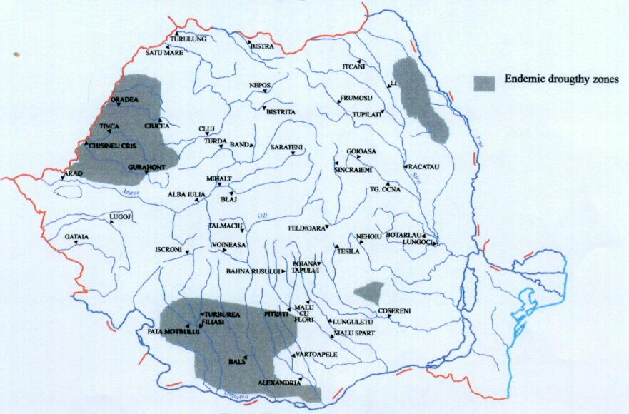
Figure 3. The endemic droughty zones

Figure 4. Map regarding the repartition of the mean annual discharges compared to the mean multiannual discharge and the hydrographs of the mean monthly discharges ( ) compared to the normal monthly values ( ) for some representative areas of the country

The Danube River has also, in the Bazias section, the aspect of a normal year, with exceeding over the normal values during the last months of the year.
For the Romanian inland rivers, the year 2003 is characterized by module values situated over 50% (figure 5). But for the Danube the discharges at Bazias reached the minimum value of 1500 m³/s (3 – 5 September), which is over the minimum of 1200 m³/s occurred in January 1954 and reported at the period 1840 –2003 (1520 m3/s).
For Cernavodǎ section is also characteristic the registered level –247 cm (Q = 230 M³/S) (figure 6), the least one during the observed period (1896 –2003). For the year 2003 (figure 7), is characteristic, in Bazias section, a smaller duration of the minimum discharges action than in 1947, influenced by the hydrological drought occurred on the Romanian inland rivers.

Figure 5. Map regarding the repartition of the mean annual discharges compared to the mean multiannual discharge and the hydrographs of the mean monthly discharges ( ) compared to the normal monthly values ( ) for some representative areas of the country

Figure 6. Danube -Cernavoda – daily discharges 2003

Figure 7. Danube-Orsova – daily medium discharges

The statistical models used in the flow analysis on rivers and Danube provided much information regarding the minimum discharges occurring, but for the forecasting, the results aren’t relevant.

Conclusions

The excessively droughty hydrological years in the east of the Romanian Plain were: 1952, 1964, 1982, 1992 – 1993. But after the severe drought ended in 1996, between 1999 – 2002 there were registered constantly deficits from the annual mean in the Romanian Plain area. From seasonal point of view, these deficits are big especially during the March-May spring period (accomplished modules 0.3 – 0.7). It is found that from evolution in time point of view, the frequency of droughty years increased almost continuously, fact that demonstrates a tendency of dryness in Oltenia, Romanian and Barlad Plains, less obvious yet in the Western Plain area; exceptions are Tisa, Somes and Crisuri Basins, which constantly exceeded annual means discharges. Thus, from a frequency of 33.4% of droughty and especially droughty years, in the last two decades 1982 – 2002 the frequency exceeded 80%.
The major objective of the strategy for the development of the policy in the water domain refers to the provision of the water resources with a proper quantitative and qualitative level for the population in the urban an rural areas as well as for agriculture and industry.
The amplification of the drought phenomena during the last years has determinate the development of research and technological programs for the study of the causes and for knowing the trends of drought phenomenon in order to carry out the actions to reduce the negative effects upon several significant domains of the Romanians economy.

