WORK PROCEDURES DURING THE EVALUATION OF THE AUGUST 2002 FLOOD

Petr Šercl, Pavel Polcar

Czech Hydrometeorological Institute, Praha, Czech Republic, e-mail: sercl@chmi.cz

Czech Hydrometeorological Institute, České Budějovice, Czech Republic,

e-mail: polcar@chmi.cz

Abstract: The evaluation of the amount of water which was flowing through the river network during the flood which in August 2002 occurred in the Czech Republic, represented a demanding problem for the hydrologists of the Czech Hydrometeorological Institute (CHMI). Because the number of significant direct discharge measurements made during the flood and needed for the extrapolation of existing discharge rating curves was not sufficient, it was necessary to extrapolate the rating curves in the individual watergauging cross-sections with the help of hydraulic models. Unfortunately, the flooding and sometimes the destruction of the measuring devices also occurred, and this resulted in the missing or incomplete record of the water stage, which it was necessary to subsequently reconstruct. The experience from the August 2002 flood evaluation shows, that hydrologists, in co-operation with hydraulic and water resources engineers, can solve these problems quite well. Certain measures were suggested, which will enable to a certain extent to remove the prevailing shortcommings, as are for example the improvement of the possibility of direct discharge measurement or the improvement of the resistance of watergauging stations during floods.
Key words: flood, evaluation of discharges, hydraulic model, balance of passed volume.

1.0 Introduction

The product of a correctly functioning watergauging station is in the case of a passed flood a recorded course of the flood wave (hydrograph) in the form of stages. The stage is however a quantity, with which it is not possible to reliably evaluate the extremity of a flood, neither in relation to other cross-sections in the river network, nor in relation to floods that occurred in the past. The main reason is that the discharge conditions of natural river beds and floodplains change in time and space due to the erosive and anthropogenous activity, and that means that stage recorded for example fifty years ago does not have to correspond by its significance to a stage recorded during the flood in August 2002. A quantity which enables to make all ensuing evaluations is discharge, therefore the basic aim during a hydrological evaluation is to determine the discharge hydrograph of a flood. Its correct derivation is however, in the case of extreme floods, often a more complicated task than all other ensuing work, which are above all balance and statistical calculations.

- Measuring and evaluation of water stages

During a normal (“non-flood”) situation, the evaluation of stages consists in the revision and sometimes a correction of the record of stage from the stage recorder or an automatic device, usually based on the control reading of the gauge staff. The reading of the gauge staff is done regularly by a voluntary observer or an expert worker-hydrologist who visits the station and is responsible for its correct functioning. Unless there is a discontinuation in observation caused by the malfunctioning of the automatic apparatuses, the processing of stages presents no greater problem.

During an extreme flood situation, such as was no doubt the August 2002 flood, a partial or full flooding of some watergauging stations may – and did – occur. This resulted in not only discontinuations in observation because of electricity blackouts, but unfortunately also in the destruction of the digital stage record, or the limnigraph record. In such cases, it was necessary to reconstruct the missing part of the record. In this respect, the reporting stations were somewhat advantageous, because they saved the data, which were relayed by distance relay at the time before the flooding of the apparatus itself.

Immediately after the passing of the flood, it was necessary to survey the high water marks, especially for these reasons:

- the determination of the actual maximum water level and the verification of the automatic
apparatus record during the peak discharge,

- the securing of data for the hydraulic calculation of the peak discharge (here it was also
necessary to survey the water surface slope and several cross-sections).

Generally it may be said, that the reconstruction of the missing part of the hydrograph, when usually missing is the peak part of the flood wave, is relatively difficult. In such cases it is necessary to use data from other stations on the same stream, and any information on the time of the occurrence of the peak is very valuable. It is very significant, if stand-in observation of stage can be secured during the flooding of the station. This proved to be very valuable during the August 2002 flood, when it was possible to reconstruct the flood wave course on the basis of such information for example on the Labe River in Mělník or in Ústí nad Labem. When there is a scarcity of such information, the reconstruction of the stage record is a mere expert estimate with a smaller or a greater error. During certain situations, it is possible to supplement the missing parts of the stage hydrograph by the simulation of a mathematical model of continuous flow (see Chap. 3.2).

On the basis of the experience from the August 2002 flood evaluation, we may draw the following conclusions in the area of measurement and evaluation of water stages:

- It is necessary to secure emergency energy sources for automatic apparatuses; the dependency
is lasting even at present on energy supplied from on-earth connections, which were during the August 2002 flood often cut off.

- New or reconstructed stations must be more resistant building-wise to water action, so that
during their flooding their stability is not endangered.

- It is necessary to secure emergency or supplementary observation during a flood, for example
in the form of an extraordinary report of a voluntary observer or by other means.

New building of houses and installations destroyed or damaged by the August 2002 flood has already been realised from the means of the ISPA project which has been financed mostly by the European Union states, and further modernization of the station network is anticipated in the period of 2004-2007 within the framework of the project “Modernization of forecasting and warning service” which is financed by the government of the Czech Republic (CR).

  - Measurement and evaluation of discharge amounts

Discharges are derived from the discharge rating curve (DRC), which is a non-linear relationship between the stage and discharge, constructed and verified usually with the help of discharge measurement by a hydrometric propeller ( current meter). A general problem when evaluating extreme flood situations is that usually a discharge rating curve reliably extrapolated into the region of high water stages on the basis of flow measurements is not available. The reason for the lack of flow measurements during high stages is the low frequency of occurrence of these extreme situations and their relatively short duration. Moreover, with respect to high velocities, floating objects and often also the inaccessibility of the measuring cross-section during a flood, these measurements are hard to perform, and in many cases they are unpracticable altogether. During such situations, it is necessary to extrapolate the discharge rating curve with the help of other, more complicated methods.

  - Measurement of discharges during a flood

As has already been said, the measurement of discharges by a hydrometric propeller during a flood is very difficult. It is mostly performed on the receeding limb of the hydrograph, when the amount of floating debris in the river is not so great and when velocities of flowing water are smaller.

Despite the fact that during the August 2002 flood, altogether 130 measurements were performed, out of which some were very significant, it was confirmed that the possibilities of direct measurement of discharges by a hydrometric propeller during an extreme flood are very limited.

Apart from measurement of discharges by a hydrometric propeller, the surface velocity on the Vltava in Prague was for example measured with the help of floats, which contributed to a comparatively precise determination of the peak discharge through Prague.

To however conclude, it is necessary to state the fact, that there was only a minimum of measurements made in the water surface range near the peak flow, and the evaluation of peak discharges had to be mostly made by their indirect determination with the help of hydraulic and balance calculations.

  - Evaluation of discharges with the help of hydraulic models

Hydraulic modelling gives very valuable information during the evaluation of discharges, because it gives a qualified first estimate of the extrapolation of the rating curve, providing that a direct discharge measurement is not available.

Hydraulic models of non-uniform unsteady flow, if they are correctly compiled and calibrated, can estimate the size of the peak flow from surveyed marks, or it is even possible with their help to reconstruct the whole course of the flood wave. For this, it is necessary to have at one’s disposal:

- a surveyed section of the stream with several cross-sections and the course of maximum water
surface,

- a qualified estimate of roughness coefficients for the river bed and the floodplain,

- for the case of the simulation of the flood wave course, the upper and lower boundary
condition in the form of an evaluated flood hydrograph.

For the evaluation of the August 2002 flood, one-dimensional hydraulic models were mostly used, however in places with complicated flow (the confluence of Vltava and Labe) a two-dimensional model was used.

The estimate of the size of peak discharges with the help of models was, within the framework of the evaluation of the August 2002 flood, mostly solved by the form of external orders. The biggest advantage of this external approach is the factual non-dependence of the method, because the performer usually does not have at his disposal, apart from the survey itself, any other information (e.g. about fallen precipitation, passed volume from near-by stations etc.). With respect to the uncertainty of the determination of roughness coefficients, it is suitable to determine the estimate of the peak flow calculated with the help of a hydraulic model within a range, and the performer will determine, according to his expert opinion, a most likely value.

The result of the hydraulic calculation is a significant source information for a hydrologist, who in further evaluation judges this result in the form of balance calculations in the context of the whole catchment that is being processed.

  - Hydrological approaches of evaluation of flood discharges

It is the duty of the hydrologist, when evaluating flood discharges, to utilise all reachable information, of which there is usually not enough. In the first place, it must be a properly verified record of stage from a watergauging station (see Chap. 2). Other important sources for making a credible extrapolation of the rating curve are:

- all results of hydrometric measurements during the flood (including historical measurements),

- results of hydraulic calculations (models of uniform and non-uniform flow),

- information on fallen precipitation and the estimate of the passed volume in neighbouring stations,

- other information, e.g. on the breakages of levees or pond dikes, calculations of outflow from reservoirs in the catchment etc.

The hydrologist must in his deliberation, when choosing the right approach, take care that the parameters of the resulting flood wave hydrograph are not in an obvious disagreement with parameters of hydrographs from the neighbouring stations. Usually of importance is the consideration of the size of the passed volume in relation to the fallen precipitation. The hydrological approaches therefore consist of balance calculations of passed volumes in a system of interrelated stations, where one also considers the corresponding estimate of a inflow from a subcatchment in relation to the amount of precipitation fallen on this subcatchment.

The balance processing finds out the time balance between the amount of precipitation water fallen on the individual catchments delineated by the watergauging stations, and the amount of water that runs off from these catchments. Its detail solution rests in the time balancing of the whole system, that is all catchments and subcatchments controlled flow-wise by the watergauging stations. The difference between the hydrographs from a section of a stream delineated by two stations represents the hydrograph of a tributary from a subcatchment. Similarly, the adding of hydrographs of two streams above their confluence and from a subcatchment should correspond to a hydrograph of the station below the confluence. A relationship that must hold is:

W_{zav} = ΣW_{hor} + W_{mez}, where

W_{zav} is the volume of the flood wave in the closing cross-section,
W_{hor} is the volume of the flood waves in the upper cross-section on the same stream and on cross
sections on the tributaries,
W_{mez} is the volume of the flood wave from the subcatchment.

However, the balance calculations must be made for a sufficiently long period, and not merely for a fraction of the duration of the flood wave. The length of the balance period should cover the whole duration of the flood wave, from the beginning of the discharge rises to their lowering in an optimum case to the value of the long term average, or at least to the time when the discharge does not significantly drop.

Hydrographs so derived are a control element of the correctness of basic hydrographs in stations, because also their shape and size must correspond to the real precipitation and to the runoff loss for the corresponding subcatchment. An example of such rainfall-runoff relationship for chosen catchments of the tributaries of the Vltava above the Orlík dam can be seen in Fig. 1.

Fig. 1 Rainfall-runoff relationship on chosen catchments

For the first estimate, the balance calculations use extrapolation of the rating curve with the help of hydraulic calculations, while the most-likely result stated by the performer-hydraulic engineer is applied. If the hydrograph so constructed does not satisfy the balance calculations, it is possible to change the extrapolation of the rating curve, but only in a certain possible range (see Chap. 3.2). If during the extrapolation of the rating curve the result falls outside the stated range, it is necessary to make an overall re-evaluation of the discharge determination in the whole catchment.

A serious problem that accompanies the discharge evaluation of flood waves is the changeability of the stage-discharge relationship in time, which is usually known as the instability of the rating curve. This phenomenon is the general property of rating curves for a number of watergauging stations even for normal discharges. Usually no big changes are involved, and their speed of development is also not significant. During floods however, this instability reaches much larger proportions, which are more pronounced with a larger flood. The phenomenon has two basic causes. Firstly it is the known and in textbooks described hysteresis or ambiguity of the rating curve, which is caused by the continuous flow during the passing of a flood wave. During the rising of the water surface before the peak flow, the water flows through the cross-section with a greater slope of the water surface than during steady flow. A greater slope and therefore a greater energy of the flow results in greater discharge than would result if the same stage occurred during steady flow. On the receeding limb of the flood wave, the reverse situation applies. The deviations of discharge, caused by this hysteresis, reach in the normal conditions of the streams in the CR the size in the order of a few percent of the stabilised discharge. Their identification during the standard accuracy of direct measurements is therefore difficult to impossible. Due to the combination of a systematic influence of the hysteresis and a random error of measurement, the final result is a magnification of the deviation of the measurement.

Much worse a circumstance is an instability which is caused by the morphological changes of the river bed, not only directly in the watergauging cross-section, but also in the whole section of the stream, which hydraulicaly influences the discharge through the cross-section. The resulting deformation of the stage-discharge relationship is happening in a much more chaotic manner, than was the case for the relatively easily describable interference by the dynamic hysteresis. Changes of the discharge capacity because of the passing of the extreme August flood waves reached tens of percent of the original capacity towards both higher and lower discharges, according to at which cross-section and at what stage of erosion or sedimentation we make the comparison. To this one must add also random influences, such as e.g. the limiting of discharge capacity by fallen trees, the increase in capacity after their removal, and other eventualities. The complications described above explain, why, when determining the discharge of an extreme floodwave, it is usually not possible to use just one form of the rating curve.

During extreme floods, another significant complication during the evaluation of discharge are the destructions of side levees, when part of the flood discharge may be bypassing the watergauging cross-section or may form widespread flooding, during which active and passive zones of water flow originate in the inundations. A great part of the inundations in the countryside is usually passive discharge-wise, to which contribute, apart from the flat configuration of the terrain, numerous linear structures (railway and road fills), which are often oriented perpendicularly to the direction of flow and therefore act as dams. In this respect, aerial photographs may be of significant help. For especially complicated flow and flooding of the territory in inundations for example by a backwater it is even not possible to apply the balance calculations, because in such cases as a result of back flow a strong ambiguity of the rating curve occurs and the discharge estimate must be done by a two-dimensional (2D) hydraulic model. This method had to be used e.g. at the confluence of the Vltava and the Labe, where without the use of the 2D model the discharge in the watergauging cross-section of Mělník could not be evaluated at all.

On the basis of the experience from the evaluation of the August 2002 flood, for measuring and evaluation of discharges the following holds true:

- The measurement of discharge by the hydrometric propeller is usually during a flood hard to
perform with respect to high velocities and usually is significantly more erroneous than during normal conditions. For this reason, it was decided to gradually equip the CHMI with acoustic ADCP apparatuses able to measure discharge even during more difficult conditions.

- For the evaluation of extreme discharges, it is necessary to use hydraulic models. For this
purpose, the watergauging cross-section must be regularly surveyed in every watergauging station as the necessary minimum for the application of the calculation of the uniform flow. It is however recommended for every watergauging station to survey a suitable (in this case straight if possible) river section with several cross-sections for the calculation of non-uniform flow.

- Because the hydraulic procedures during the extrapolation of the rating curve are usually
weighed by an uncertainty stemming from the impossibility of the exact determination of some model parameters (especially the roughness coefficient), it is necessary to further verify and adjust the rating curves so gained with the help of the balance of the passed volume, rainfall-runoff relationships, relationships between the specific runoff and the catchment area, etc.

- Optimum, but a very laborious procedure is the simultaneous evaluation of discharges in a
system of watergauging stations, through a combination of hydraulic procedures and a detailed balance processing of the floodwave hydrographs.

- When evaluating the extreme discharges, it is not possible to adhere to procedures usually
valid during normal situation, e.g. an increase in discharges or a decrease in runoff with catchment area etc. During extreme situations, the discharges in the river are influenced by phenomena that don’t usually occur, e.g. the routing effects of flooding that result in the decrease of the peak discharge with catchment area, breakages of levees or pond dikes with the effect of a sudden rise or fall of the discharge etc.

- Example of extrapolation of discharge rating curve

The watergauging station Podedvorský Mlýn on the Blanice river (Blanice is a right hand tributary of the Otava river monitors the main inflow to the Husinec dam. It is a typical example of a station with the absence of hydrometric measurements that measure discharge when flooding into the floodplain occurs. The main reasons for this are the remotness of the locality, quick onset of floodwaves, their quick recession, and last but not least the flooding of the access path to the station. The watergauging station is located on a concave, steep and forested bank of a slight river bend. The convex bank above the level of the permanent river bed has smaller slope and tree vegetation of a more solitary character.

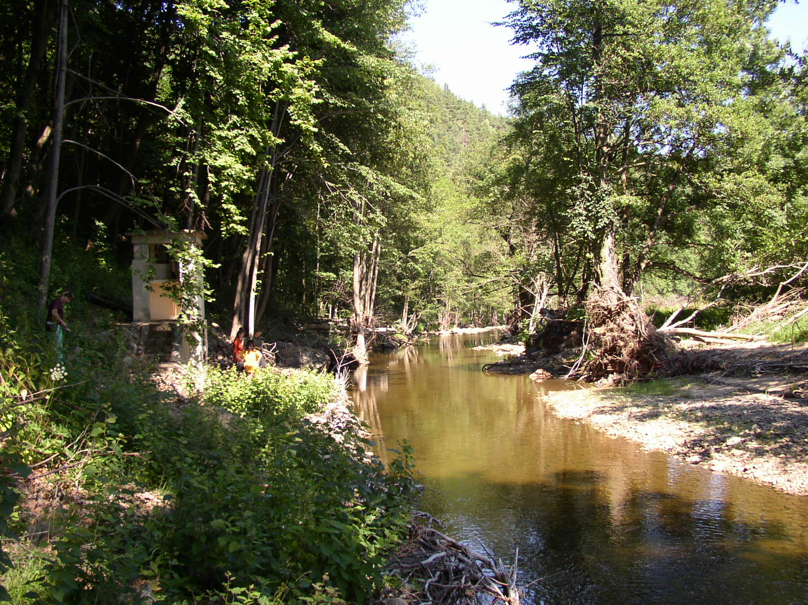

Fig.2 Blanice near Podedvorský Mlýn about a year after the catastrophic flood

From the point of view of rating curve construction, flooding over the banks does not pose serious problems, because here we have a stream in a relatively narrow valley with a relatively large slope. A dominant phenomenon, which complicates the time validity of the lower part of the rating curve, is however a significant river bed and bank erosion, which occurred during the passing of the August 2002 flood. The measurements during low stages before and after the flood showed, that the capacity of the river cross-section has been increased by the passing of the flood wave in minimums (for a stage of 50 cm) almost five times. It can be assumed, that the erosion phenomena occurred gradually at the head of the floodwave with a maximum during the occurrence of the greatest flow velocities just before the peak. On both banks however massive deposition of floating material occurred (wood and other material from a higher-situated timber yard), which gradually limited the discharge capacity at the height zone of the river bed above the flooding over the banks, see Fig. 2. The construction of the rating curve therefore is based on the premise, that the amplification of the area of the lower part of the cross-section is related mostly to the capacity of the river cross-section itself and its influence on the change of the discharge capacity during extreme water stages is not important. The premise so accepted projects into the only position of the rating curve at the height zone with the absence of hydrometric measurements above the flooding over the banks and its “bifurcation” for the river bed itself, resting on sufficient measurements before and after the passing of the floodwave. The change of the time validity of a rising and decreasing variant of the rating curve is given by the time of the peak of the second August 2002 wave. In this context it must be said, that the rating curve in the case of non-uniform flow is a mere schematisation of a complex temporally variable relationship between water stage and discharge.

The hysteresis of the rating curve caused by the dynamics of the movement of the floodwave, i.e. by unequal water surface slope on its rising and recession limbs, has a reverse character from the above described hysteresis, caused by the erosion of the river bed. In usual practice of curve construction it is neglected, because its size is of the same order or smaller than the probable error of hydrometric measurement. In this case, its manifestations are most likely quite overshadowed by the morphological changes of the cross-section.

The resulting shape of the extrapolated part of the rating curve is in effect the result of an iteration procedure, during whose steps were balanced the bonds between the balance agreement of the shape of the resulting discharge hydrograph with the hydrographs of the neighbouring stations and the acceptability of the hydraulic parameters of the curve, i.e. the sizes of the mean cross-sectional velocities and the course of the roughness coefficient.

The rating curve in its whole range is plotted on the background of the cross-section in Fig. 3. In red is shown the variant for the stage before the peak of the floodwave, valid for the non-eroded river bed, which is also shown in red. The blue curve is valid for the stage in the eroded river bed after the peak, while the corresponding cross-section is also shown in blue, and the same colour scheme is preserved also in the next pictures. Fig. 4 is a detail of Fig.3, on which the lower parts of both curves are shown.

Fig. 5 shows the relationship between the average cross-sectional velocities and the stage for the river bed before and after the peak of the floodwave. The curve for the stage before the flood has typical exponential shape, its steep growth in the surveyed part of the river bed is afterwards somewhat slowed by the flooding especially into a right hand inundation (the orientation of the graph is against the flow of the stream). The velocity curve in the eroded river bed is less curved because of the increased discharge capacity of the eroded river bed, while the cross-section in the inundation remained unchanged. The average cross-sectional velocity during the peak is logically smaller than it would be, if the river bed remained unchanged (or the same peak flow would pass through the cross-section with a somewhat higher stage). Providing that during the peak flow the shape of the river bed was approximately the same as the later surveyed one, the average cross-sectional velocity of the peak flow was, according to the blue version of the curve, 2.65 m/s.
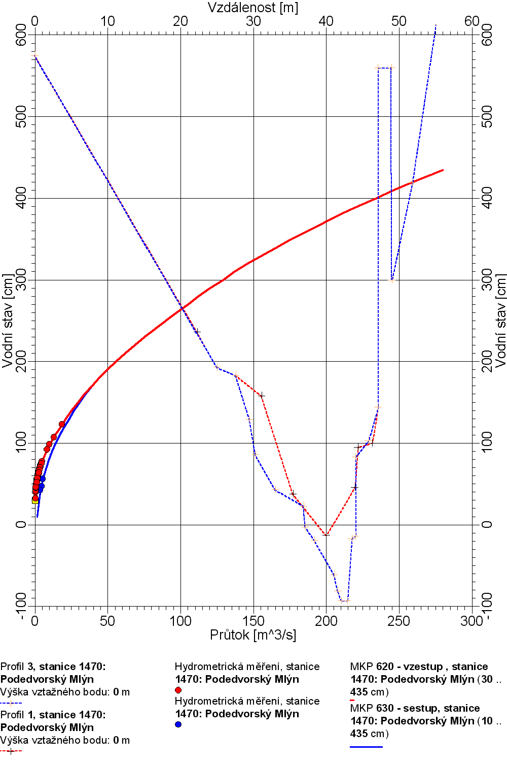

Fig. 3 Rating curve of the Podedvorský Mlýn cross-section with a sketched-in
cross-section before and after the flood

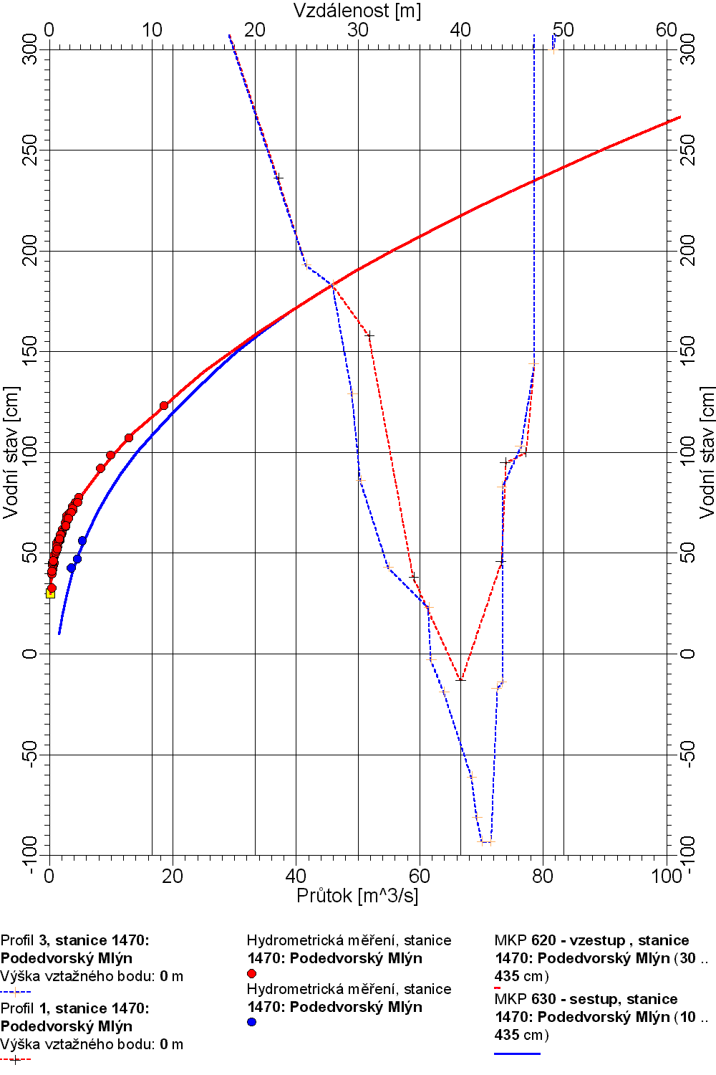

Fig. 4 Rating curve of the Podedvorský Mlýn cross-section with a sketched-in
cross-section before and after the flood (detail of the lower part)

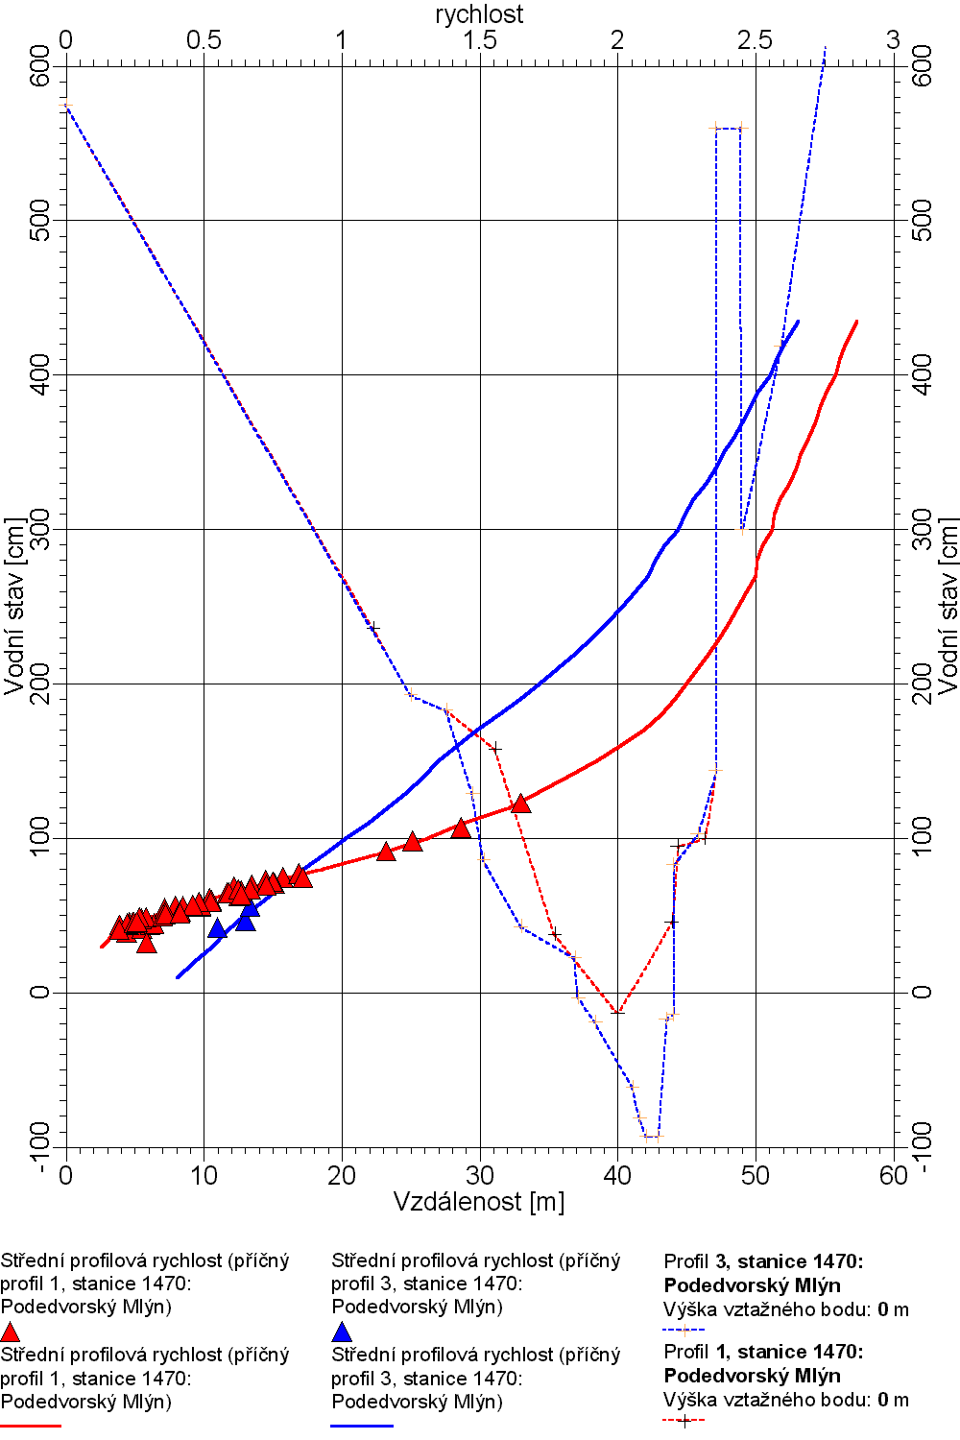

Fig. 5 Graph of the dependence of average cross-sectional velocity on the stage in cross-section
Podedvorský Mlýn with a sketched-in cross-section before and after the flood

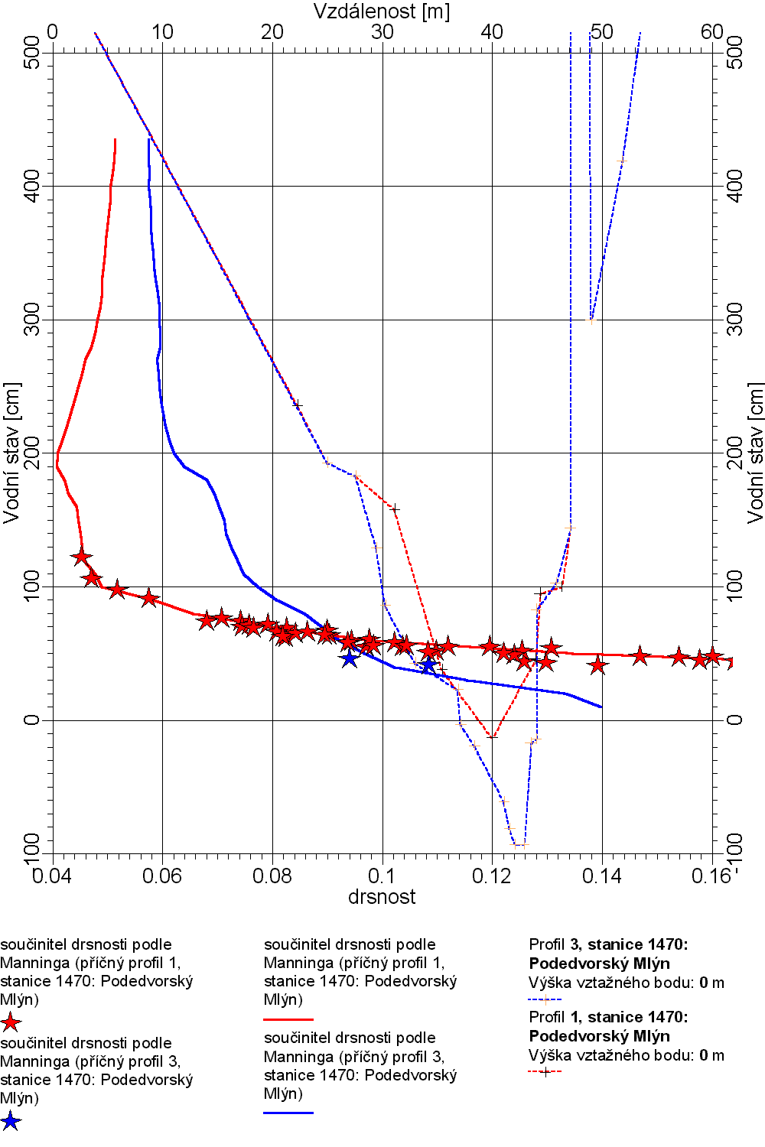

Fig. 6 Graph of dependence of roughness coefficient on stage in the Podedvorský Mlýn cross-section with sketched-in cross-section before and after the flood
¨

Fig. 6 shows the courses of values of a calculated roughness coefficient for both versions of the discharge rating curve and the relevant discharge cross-section. In question is merely the result of the Manning’s equation, applied on the whole range of the rating curve. The calculation is very sensitive to the entry parameter, which is the longitudinal slope of the water surface. Because of the lack of detail information about its size, a constant value of 0.008 was used, which corresponds to the average slope of the bed of the relevant section of the stream, and also to peak water marks. The size of the slope so determined is drawing near to reality especially in the zone of higher stages after complete flooding by inundation, during low stages it may essentially differ because of a local rise caused by small debris in the river bed. This is the cause of unnaturally high values of the roughness coefficient in the height zone under 100 cm of the staff gauge (more correctly, smaller water surface slope should be used in the calculation in this height zone, however its value was not available). As conclusive can be considered rather the middle and upper parts of both curves of the roughness coefficient roughly above 100 cm of the staff gauge, lying between the values of 0.040 to 0.080.

Roughness coefficient used in the Chézy’s equation is because of the difficulty of its determination a problematical quantity, which is during the judging of correctness of extrapolation of the rating curve only an orientation indicator. It should not deviate from limits that are valid for the characteristics of the river bed, and its course in dependence on the stage should have a logical and justifiable shape. For example a strong decrease of the values of the roughness coefficient with growing stage height is usually suspect and may inter alia mean that the extrapolated part of the rating curve is “overdesigned”. The constructor of the rating curve had in this case an exceptional advantage in that he did not have to rely only on table values of the roughness coefficient.

By coincidence, the river bed of the Blanice in the cross-section of Podedvorský Mlýn was one of the localities of research activity aimed at the determination of accurate values of the roughness coefficient, which was in the eightees performed by experts from the Chair of Hydraulics of the ČVUT University. The measuring works were then performed of course during smaller stages than those that were reached during the August 2002 floods, but they characterise very well the roughness of the river bed of the Blanice itself in the given locality during usual stages. The values of the roughness coefficient then determined during stage of 110 cm were in the range of 0.043 to 0.045. This is in agreement with the course of the red “roughness” curve of the river bed before the flood in Fig. 6. The blue curve is valid for the state after the flood, it characterises increased roughness and from a stage of 200 cm it roughly oscillates around the value of 0.06. Towards the peak, both curves draw near to each other and during the peak they deliminate the range of the calculated roughness coefficient for the cross-section as a whole in the interval from 0.052 to 0.058. It is possible to interpret in two ways the mutual difference between both curves in the region of the peak (when the premise of equal water surface slope for both variants of the curve apply the most):

- because the change of the value of the calculated roughness coefficient when using only one rating curve for the river bed before and after the flood is not negligible even in the region of the peak, it was more suitable to use two variants of the rating curve for the whole height range of the stage including the peak stage,

or

- the only version of the rating curve for the height region of overtopping the banks outside the
river banks (within the framework of the accuracy of extrapolation methods) is usable providing we allow a time change of roughness of the inundations expressed by the increase of the values of the roughness coefficient for the state after the flood roughly in such a way, as is shown on the graph.

The presumption b) was pronounced and justified already at the beginning when describing the influencing of the capacity of the cross-section by the amount of the drifted material. It is therefore possible to consider the processed construction of the rating curve from the point of view of basic hydraulic parameters of one cross-section as acceptable.

As was already said, the rating curve is, especially during the complicated conditions of continuous flow during an extreme flood, a mere schematisation of the real complicated and temporally changeable relationship between stage and discharge. The worker cannot have an absolute certainty about the correctness of the extrapolated part of the curve, only a certain suspicion about the measure of reliability of the result given by the extent of own experiences. It is therefore necessary to verify the correctness of the solution by another, independent method.

Such a method is the simulation of flow by a mathematical model, which as opposed to one-dimensional solution in an only cross-section works in a system of mutually dependent cross-sections and the calculation procedure has therefore a very much smaller degree of freedom. In that lies its advantage, the disadvantage is though still the uncertainty of determination of roughness characteristics. Most operational workplaces of the CHMI (including the Regional Office in České Budějovice, which administers the watergauging station Podedvorský Mlýn) so far do not have a lot of experience with the application of mathematical flow models, and that’s why the solution has been asked of the specialised workplace of the ČVUT University. The specific line for the finding of the needed inputs into the model and the following simulation of the peak discharge has been chosen about 100 m downstream from the cross-section of the watergauging station. The resulting values of the peak discharge simulations lie in the interval from 240 to 295 m³/s and therefore validate the acceptability of an independently made extrapolation of the CHMI.

According to the highness of the described construction of the rating curve, the Blanice river in the Podedvorský Mlýn cross-section on the 12th August 2002 had a stage of 435 cm and a corresponding peak discharge of 280 m³/s with an average cross-sectional velocity of 2.65 m/s. For an average longitudinal slope of the water surface of 0.008 at the peak, the overall flow resistance of the cross-section is characterised by a coefficient of roughness found from the Manning’s equation of 0.058. The average return interval (ARI) of this discharge was assessed as greater than 500 years.

- Conclusion

The experiences obtained from the discharge evaluation of the August 2002 flood have shown unambiguously, that for the extrapolation of the discharge rating curves it is necessary to combine hydrological and hydraulic approaches. While hydrological approaches guarrantee a certain dependence of the passed amount on the basis of volume balance within the framework of a cross-sectional system, the hydraulic approaches allow to explain some phenomena, which from the balance calculations do not have to be obvious but still influence the shape of the hydrograph, such as is the hysteresis of the rating curve, back rise or routing effects of river beds and above all of inundation volumes.

The discharge evaluation of the August 2002 flood was despite the possibilities of utilisation of e.g. hydraulic modelling very demanding time-wise, and in some cases the values of the peak discharges were being corrected even after more than a year from the occurrence of the flood. With respect to the fact, that the gained results are an input into further important evaluations, such as is e.g. the statistical processing of the N-yearly discharges with the resulting changes of the design values of maximum discharges, it is necessary to devote corresponding care to the development of methods of evaluation of (not only) flood discharges at operational hydrology workplaces even in the future.

