ENVIRONMENTAL AND SOCIO-ECONOMIC ASPECTS OF FLOOD RISK ANALYSIS

Lidija Tadić¹, Zdenko Tadić², Ivo Crnčan³

¹Faculty of Civil Engineering, Osijek, Croatia, e-mail: ltadic@gfos.hr
²Osijek, Croatia, e-mail: zdenkot@hidroing-os.hr
³Hrvatske vode, Donji Miholjac, Croatia, e-mail: icrncan@os.hinet.hr

Abstract: This paper is going to present methodology of defining flood risk maps for the one smaller catchment area in the Danube basin on the basis of integrative water management. The main parameters are related to natural features of the area, land use and human impacts. The purpose of the project is to test and evaluate the methodology, which can be applied for the other catchment areas in the Danube river basin. According to the risk maps for the return periods of 5,10, 25, 50, 100 and 1000 years cost -benefit analysis has been made. Paper is concluded with general recommendations for the further activities in the flood protection development and improvement.
Key words: flood, risk maps, cost-benefit, integrative water management

ÖKOLOGISCHER UND SOZIAL-ÖKONOMISCHER ASPEKT DER HOCHWASSERRISIKOANALYSE

Zusammenfassung: In der vorliegenden Arbeit wird die Methodologie zur Erstellung der Hochwasserrisikokarten für ein kleinerer Flussbereich im Donauflussgebiet präsentiert, die auf dem Prinzip der integralen Wasserbewirtschaftung beruht. Die Hauptbestimmungen sind dabei Naturcharakteristiken des Flussgebietes, Bodennutzung und Menscheneinwirkungen. Das Projektziel ist die Untersuchung und Bewertung der Methodologie, damit man sie an andere Flussgebiete anwenden könnte. Nach den Risikokarten für die 5,10,25,100 und 1000-jährige Rückperiode wurde die Nutzen-Kostenanalyse (cost-benefit) durchgeführt. Anschließend wurden weitere Aktivitäten zur Entwicklung und Verbesserung des Hochwasserschutzsystems empfohlen.

1. Introduction
History of water management in the Croatia began with flood protection development. Besides the great experience and relatively developed flood protection system, floods appear very often, generating bigger or smaller damages, mostly on agricultural fields and hydro technical structures and sometimes on urban area too. It is an economic aspect of floods, which is the most common. The social aspect, considering the uncertainty of investments in agricultural production, decreasing of estate prices and quality of life in general must be also taken into account. In this field development of institutional protection and regulations are very important. The next aspect of flood damages which must be considered is environmental, which was very much neglected in the past decades. Extreme hydrological events, like floods and droughts are, deteriorate stability of ecosystem and induce the change of its original features. Processes of water erosion and sedimentation occur as far as biological changes. These changes are opposite to the principles of sustainable development and they show inappropriate water management in the catchment area. So integrative approach towards flood protection, based upon sustainable development must involve all of these aspects.

2. Integrative approach towards flood protection
Modern flood protection system must satisfy human needs, protect natural and environmental resources and be justified in economic sense. Efficient and safe flood protection can be achieved only by parallel development of all mentioned aspects. Scheme of integrative flood protection system is presented on Fig.1. It shows complex relation among number of technical ( structural) and non-technical ( non-structural) measures. Structural measures are very well known ( construction of dykes, dams and other hydro-technical structure ) and they have been applied for centuries. Non-structural measures like improvement of retention capacity of the catchment area, improvement of prognosis and information system, mapping the zones of with high-medium-low risk of flood and involving them in the physical planning documents still must be developed or improved ( Biondić, 2003).
Comparing to the traditional point of view where the excess water had to be conveyed out of the catchment area as soon as possible with the minimum of damages, new approach involves keeping water in the area in the natural reservoirs ( retentions) to the maximum extend beside the structural protection of urban area. In the conditions of extreme hydrological events ( floods and droughts) this different is very significant. Periods of floods and droughts are exchanging more or less every year. In the last decade average annual precipitation did not change significantly but its time distribution along the year did.
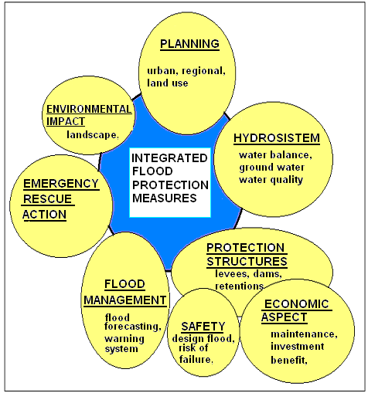
Figure 1. Scheme of integrated flood protection system ( Westrich, 2003)

In this way, combination of structural and non-structural measures together with proper water management could make possible coping with extreme hydrological events.

3. Characteristics of the catchment area
Applied methodology is based upon natural features of the catchment area, land use characteristics and human influences ( Tadić, 2002, 2003).

3.1. Natural features of the catchment area
Characteristics of Karašica and Vučica catchment area are: 75 % of the area is typical lowland with average slope of less than 0,01% and 25 % is hilly part with slopes from 2-18 % and local medium erosion problems. The most endangered part of the catchment is on the contact between hilly part and low part.
Annual amount of precipitation ranges from 985-689 mm. Maximum daily precipitation occurs in summer months. In the Table 1. maximum precipitation of different duration, from 10-120 minutes and different return periods are presented. The Gumbel distribution is used.

Table 1. Calculation of maximum precipitation on the basis of period from 1981-2001.
 | Return period ( years)
Duration(min) | 2 | 5 | 10 | 20 | 50 | 100 | 1000
10 | 9,4 | 14,2 | 17,4 | 20,4 | 24,4 | 27,3 | 37,0
20 | 13,8 | 20,6 | 25,2 | 29,5 | 35,1 | 39,3 | 53,3
30 | 16,1 | 23,9 | 29,1 | 34,1 | 40,5 | 45,3 | 61,3
40 | 17,6 | 25,7 | 31,1 | 36,2 | 42,9 | 47,8 | 64,3
50 | 18,6 | 26,9 | 32,5 | 37,8 | 44,6 | 49,8 | 66,7
60 | 19,4 | 27,9 | 33,6 | 39,0 | 46,0 | 51,3 | 68,7
120 | 22,3 | 31,6 | 37,8 | 43,7 | 51,4 | 57,1 | 76,1

Open watercourses network is very dense. In the hilly part of the catchment area most of the streams are dry during the summer period and in wintertime they have torrent characteristics. In the lower part natural watercourses are regulated in the past. The main watercourse is Vučica river (Pavletić et al, 1999). Figure 2. Shows hydrograph of maximum water levels in the period from 1975-1998.The red line represents the water level above which activities on flood protection start. Figure also shows mild upward trendline.
Figure 2. Maximum water levels for the Vučica river in the period from 1975-1998(Tadić, 2003)

3.2. Land use characteristics
Land use characteristics were developed according to topography. Lowland is basically agricultural area. There is also a large proportion of forests. Vegetation cover of higher part consists of vineyards, orchards and forests. One part of this area is protected as a Park of nature.

3.3. Human impacts
Beside the intensive human activities there are still a lot of forests with rich wild life. Agricultural area have very developed land drainage system, but its maintenance is insufficient. Water structures are old and their functioning is not reliable. Poor maintenance of drainage system is one of the reasons for such often appearance of flood episodes. Beside the drainage system main part of the flood protection system consists of one dam (volume of 2.4 m³), 21 sluices, 2 pumping stations and 32 km of dykes.
Settlements are mostly along the rivers. Process of urbanisation was very intensive in the last decades and now, on the catchment area live about 100.000 inhabitants.

4. Methodology of developing risk maps
Potentially endangered areas are defined on the maps of scale 1:5000 on the basis of mathematical modelling of water levels by HEC-RAS. Hydraulic calculation was performed for the most unfavourable scenario – coincidence of high water levels in Vučica river and Drava river. Input data consists of precipitation intensities and duration, geometry of sub-catchment areas, land use maps and geometry of watercourses. In the second step, mathematical model HEC-1 was used for rainfall-runoff modelling. Results are compared to the measured data and error was less than 5 % what is acceptable. Figure 3 presents discharge distribution curves for the return periods of 5, 10, 25, 50, 100 and 1000 years for the 10 sections along the Vučica river( Tadić, 2003).

Figure 3.Discharge distribution for the various return periods

Calculated water levels were draw on the maps as a flooding zones for the different return periods. According to land use maps potentially endangered area could be calculated for each type of use. Table 2 shows the results.

Table 2. Potentially endangered area for different return periods
LAND USE (ha) | RETURN PERIOD ( YEARS)
LAND USE (ha) | 5 | 10 | 25 | 50 | 100 | 1000
SETTLEMENTS | 140 | 234 | 418 | 774 | 1252 | 2558
FORESTS | 903 | 1607 | 3229 | 5407 | 7183 | 13365
ARABLE LAND | 1357 | 3013 | 7702 | 12256 | 14761 | 26880
WATER | 230 | 359 | 737 | 955 | 1305 | 1684
TOTAL | 2631 | 5214 | 12088 | 19392 | 24500 | 44487

For the 1000-years return period flood endangers 1/5 of the all catchment area and about 27 500 people. Figures 4 and 5 show three risk maps – for the return periods of 5,10, 25, 50,100 and 1000 years. Figures show two separated locations.
The location on the east side of the catchment upstream the mouth of the Vučica river is flooded due to the Drava back water. On this downstream section of the Vučica river dykes have been constructed many years ago, but their height is not appropriate for the floods of longer return periods. This flooded area around the river mouth is a wetland which have very rich wildlife developed basically due to the water. Because of its environmental values this area should be preserved in this conditions. Severe damages in urban areas are expected for the floods of more than 25 years return period
The location on the west side is mainly flooded because of the extreme natural depression around the big fishponds.

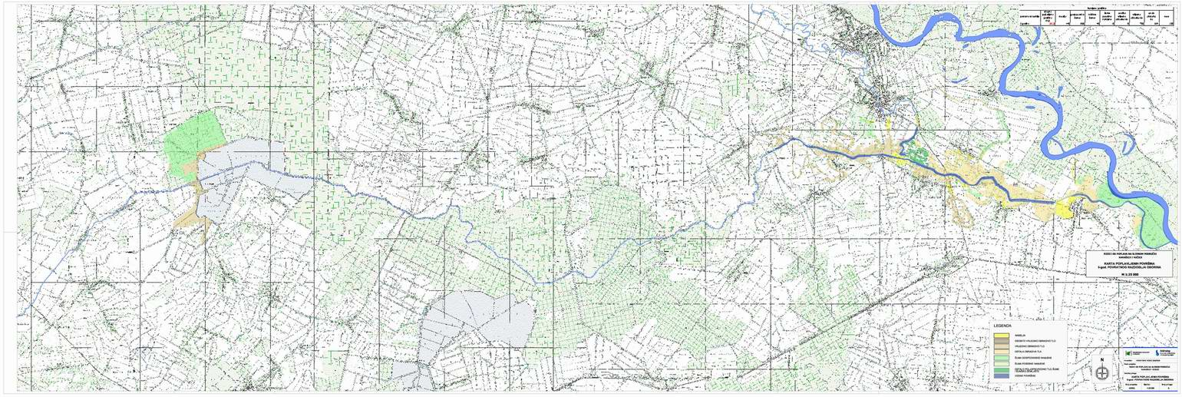
5 years RETURN PERIOD

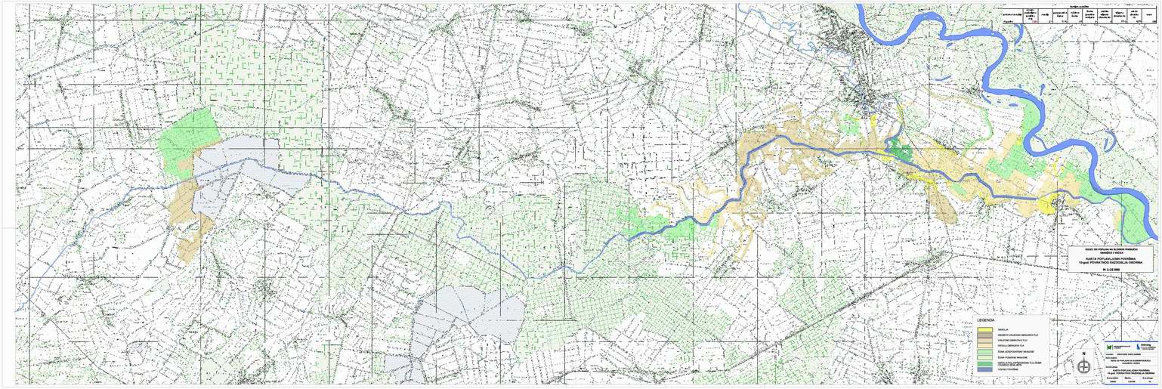
10 years RETURN PERIOD

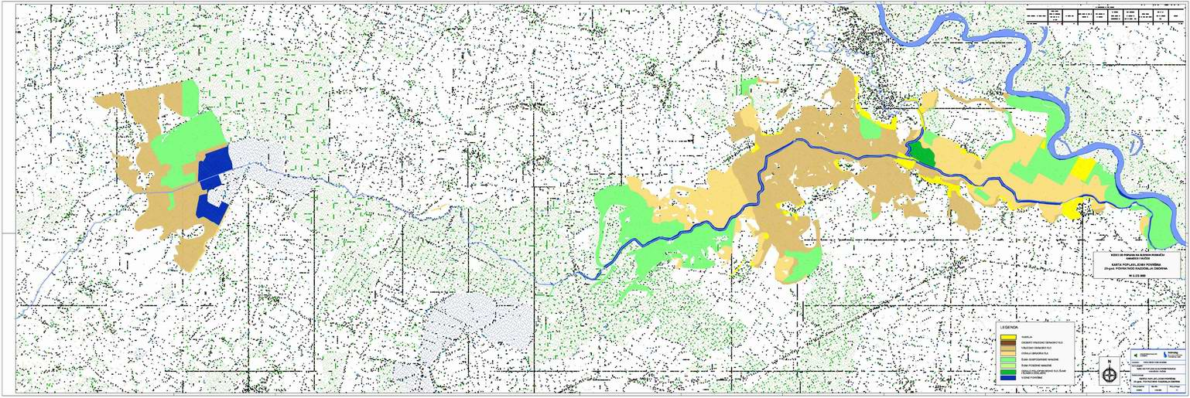
25 years RETURN PERIOD
Figure 4. Risk maps for the 5, 10 and 25 years return period

100 years RETURN PERIOD

50 years RETURN PERIOD

1000 years RETURN PERIOD
Figure 5. Risk maps for the 50, 100 and 1000 years return period

4.1. Estimation of damages
Estimated potential damages for analysed return periods are huge. Besides, only measurable (economic) damages are taken into account. There are also a number of non-measurable damages which make a total damage much bigger ( transport problems, environmental impacts, uncertainty of investments, pollution, etc). Increment of estimated damages for each return period is presented on Figure 6.
Figure 6. Estimated damages for the various return periods ( Tadić, 2003)

5. Proposed solutions
Synthesis of the previously elaborated analysis, boundary conditions modelling results and cost benefit analysis, must be given as a set of proposed solutions. Long term designs and studies of the complete catchment area plan the construction of more then 20 smaller dams and accumulation. This analysis proved the four of them have the absolute priority. Besides, their construction would have another important purpose – supplying water for irrigation which is in expansion lately.
Secondly, dykes along the Vučica need to be constructed or reconstructed. The third part of the activities is related to non-structural measures:
- improvement of water management
- improvement of monitoring system and hydrological analysis of future flood episodes in order to improve proposed solutions
- enabling flooding of biologically valuable areas ( wetlands) by controlled retentioning water inside the wetland
Figure 7. Proposed measures of the integrated flood protection system

Proposed measures are presented on Figure 7. It shows all structural measures including wetlands that will become controlled retention ( reservoirs) in the flood time. According to cost –benefit analysis these measures are economically acceptable. Estimated damages of 50-years return period flooding are about five times bigger then investments to the proposed structural and non-structural measures. In other way, it has been evaluated that reconstructed and improved flood protection system would be able to protect the area from floods equal and less then 50-years return period. Besides, better water management in the condition of draughts would make benefits through the irrigation development and environmental conditions.

6. Conclusion
Comparing the obtained flood episodes and modelling results, three main reasons of high flood frequency can be distinguished:
- frequent rainfalls of high intensity- more than 100 mm in 24 hours
- low level of maintenance of drainage system
- lack of retention capacities on the catchment area ( accumulations and reservoirs)
The analysis of flood risks conclude with a plan of further activities. Beside the previously mentioned structural and non-structural measures, one of the most important conclusion is initiative for involving flooding zones of various return periods into physical planning maps.

7. References
Biondić, D. (2003): Sustainable Flood protection, Seminar Practical hydrology, Proceeding, 145-161, Zagreb
Pavletić, J., Rušanac, S., Lončarić, M.(1999): Hydrotechnical Structures on the Karašica-Vučica catchment area, Proceedings 2nd Croatian Conference on waters, 703-710 Dubrovnik
Stancalie, G.,Alecu,C., Catana, S., Simota, M.(2000):Estimation of Flooding Risk Indices Using the GIS and Remotely Sensed Data, Proceedings of the 21st Conference of the Danubian Countries, Bratislava, Slovakia
Stancalie, G.,Predescu,C., Savin, E., Catana, S.(2002):Elaboration of products derived from EO data and GIS info-layers for flooding risk analysis, Proceedings of the 21st Conference of the Danubian Countries, Bucharest, Romania
Tadić, L.(2001): Analysis of Indicators Relevant for the Sustainable Water Management on the Karašica-Vučica catchment Area, Disertation, Osijek
Tadić,L.,Tadić, Z., Crnčan, I., Korov, J. (2002): Analysis of flood frequency on the area of Drava River basin, Proceedings of the 21st Conference of the Danubian Countries, Bucharest, Romania
Tadić, L. Tadić, Z.(2003): Study of Risk Analysis of the Karašica and Vučica Catchment Area, Osijek
Westrich (2003): Risikomanagement – Hochwasser und Unfälle- DAAD Programme- Proffessional Course, Faculty of Civil Engineering Sarajevo
DHMZ (2003): Metheorological Input Data, Zagreb
***ICPR Rhine Atlas, 2001
***Metodologija za procjenu šteta od elementarnih nepogoda, NN 96/98
***National Plan of Flood Protection, NN 8/97, Zagreb

