Extreme soil moisture events as pedoconflicts in Hungary

György Várallyay

Research Institute for Soil Science and Agricultural Chemistry (RISSAC) of the Hungarian Academy of Sciences, Budapest, Hungary, e-mail: g.varallyay@rissac.hu

Abstract: Two important elements of sustainable development in Hungary are rational land use, conservation of soil resources, the maintenance of their multifunctionality; and the prevention of the pollution of surface and subsurface water resources. These are significant joint tasks of agriculture and environment protection, the joint responsibility of the state, land owner and land-user, requiring priority attention and full support from the society.
Hungarian water resources are limited. Consequently, their efficient use will be one of the key-issues of agricultural production, rural development and environment protection, and proper soil moisture control has particular significance.
The average annual precipitation may show extremely high territorial and temporal variability – even at micro-scale. Under such conditions a considerable part of precipitation is lost by surface runoff, downward filtration and evaporation. The non-uniform distribution of atmospheric precipitation combined with heterogeneous relief and soils with unfavourable physical/hydrophysical properties are the reasons of the increasing frequency of extreme moisture regime events: the simultaneous hazard of waterlogging or over-moistening and drought-sensitivity in extensive areas, sometimes on the same places within a short period during a year or vegetation period. Consequently, an efficient „double function” soil moisture control is an unavoidable element of sustainable and rational management of soil and water resources.
The extreme moisutre regime and its primary, secondary and tertiary economical (low biomass production) and environmental (soil degradation processes, decreasing soil fertility) consequences represent a more and more serious pedoconflict in Hungary, requiring particular attention and efficient conflict management actions.
Soils are the highest-capacity (natural) „water reservoirs” in Hungary. Consequently, helping infiltration into the soil; increasing the water storage capacity and available moisture range of soils are efficient tools for the mitigation (or at least moderation) of the extreme situations. Measures and technologies for efficient soil moisture control are – simultaneously – beneficial actions of environment protection.
During the last years a comprehensive soil survey–analysis–categorization–mapping–monitoring system was developed and successfully applied in Hungary for the prediction and control of soil moisture regime and for the risk (probability, frequency, rate and duration) reduction of extreme hydrological events, as flood, waterlogging or drought.
Key words: hydrophysical soil properties, moisture regime, ecological limitations, drought, waterlogging, moisture control

Introduction
According to global assessments the availability of good-quality water will be one of the main conflict problems of sustainable development and the most important limitation to the extension of biomass production for food, fodder, energy and raw material for industry. The „quality of life” depends – to a great extent – on the rational use of limited sweetwater resources, becoming a strategic element of the environment in many parts of the World. Consequently, the increase of water use efficiency, including a proper soil moisture control, has particular significance.
Under Hungarian natural conditions it is predictable with high probability that for the improvement of life quality, for rural development, for agricultural production and for environment protection the quantity and quality of the water resources will be the main limiting factor and extreme hydrological events and unfavourable soil moisture regime will create a serious „pedoconflict”. Consequently, the improvement of water use efficiency, including proper soil moisture control, has particular significance – without any other alternative.
Rational land use, conservation of soil resources, the maintenance of their multifunctionality; and the prevention of the pollution of surface and subsurface water resources are important elements of the necessary pedoconflict management strategies, which are the joint responsibility of the state, land owner and land-user, requiring priority attention and full support from the whole society (Láng et al., 1983; Várallyay, 1989a, 1997).

Soils and their functions
Land (soil–water–near surface atmosphere continuum, with its geology, relief and biota) represents a considerable part of the natural resources of Hungary. Consequently, rational land use and proper soil management – to guarantee normal soil functions – are important elements of the sustainable use of agro-ecosystems, having special importance both in the national economy and in environment protection.
The main soil functions are as follows (Várallyay, 2003):
- conditionally renewable natural resource;
- reactor, transformer and integrator of the combined influences of other natural resources (solar radiation, atmosphere, surface and subsurface waters, biological resources), place of „sphere-interactions”;
- medium for biomass production, primary food-source of the biosphere;
- storage of heat, water and plant nutrients;
- natural filter and detoxication system, which may prevent the deeper geological formations and the subsurface waters from various pollutants;
- high capacity buffer medium, which may prevent or moderate the unfavourable consequences of various environmental stresses;
- significant gene-reservoir, an important element of biodiversity;
- conserver and carrier of the heritage of natural and human history.
Society has utilized these functions in different ways (rate, method, efficiency) throughout history, depending on the given natural conditions and socio-economic circumstances. In many cases the character of the particular functions was not properly taken into consideration during the utilization of soil resources, and the misguided management resulted in their over-exploitation, decreasing efficiency of one or more soil functions, and – over a certain limit – serious environmental deterioration.
Primary, secondary and tertiary agricultural production has traditionally great significance in the Hungarian national economy. The relative importance of its criteria (quantity, quality, efficiency, profitability, environmental impacts) have changed considerably during the history of agriculture, depending on the socio-economic conditions and according to political decisions.
Hungary (with a territory of 93 000 km² and 10 million inhabitants) is situated in the deepest part of the hydro(geo)logically closed Carpathian Basin, where the natural conditions show high spatial and temporal variability. The majority of the land surface is covered by Quaternary or more recent geological deposits: loess, aeolian, alluvial, colluvial deposits. The weather is under the combined and changing influences of the Atlantic, Continental and Mediterranean climates, with a negative water balance (500–550 mm average annual precipitation vs. a 800–900 mm potential evapotranspiration) in the Hungarian plains, which is equilibrated by surface runoff, seepage and groundwater flow from the surrounding hilly regions to the lowland and results in the accumulation of soluble materials (carbonates, Na-salts) originating from an extensive water catchment area (Várallyay, 1985).
According to the comprehensive agro-ecological assessment which was carried out between 1978–1983, Hungarian natural conditions (climate, water-, soil- and biological resources) are generally favourable for rainfed biomass production. These conditions, however, are highly sensitive to frequent environmental and human induced stresses: extreme weather conditions and hydrological events, improper land use and soil management, pollution etc (Várallyay, 2001, 2002).
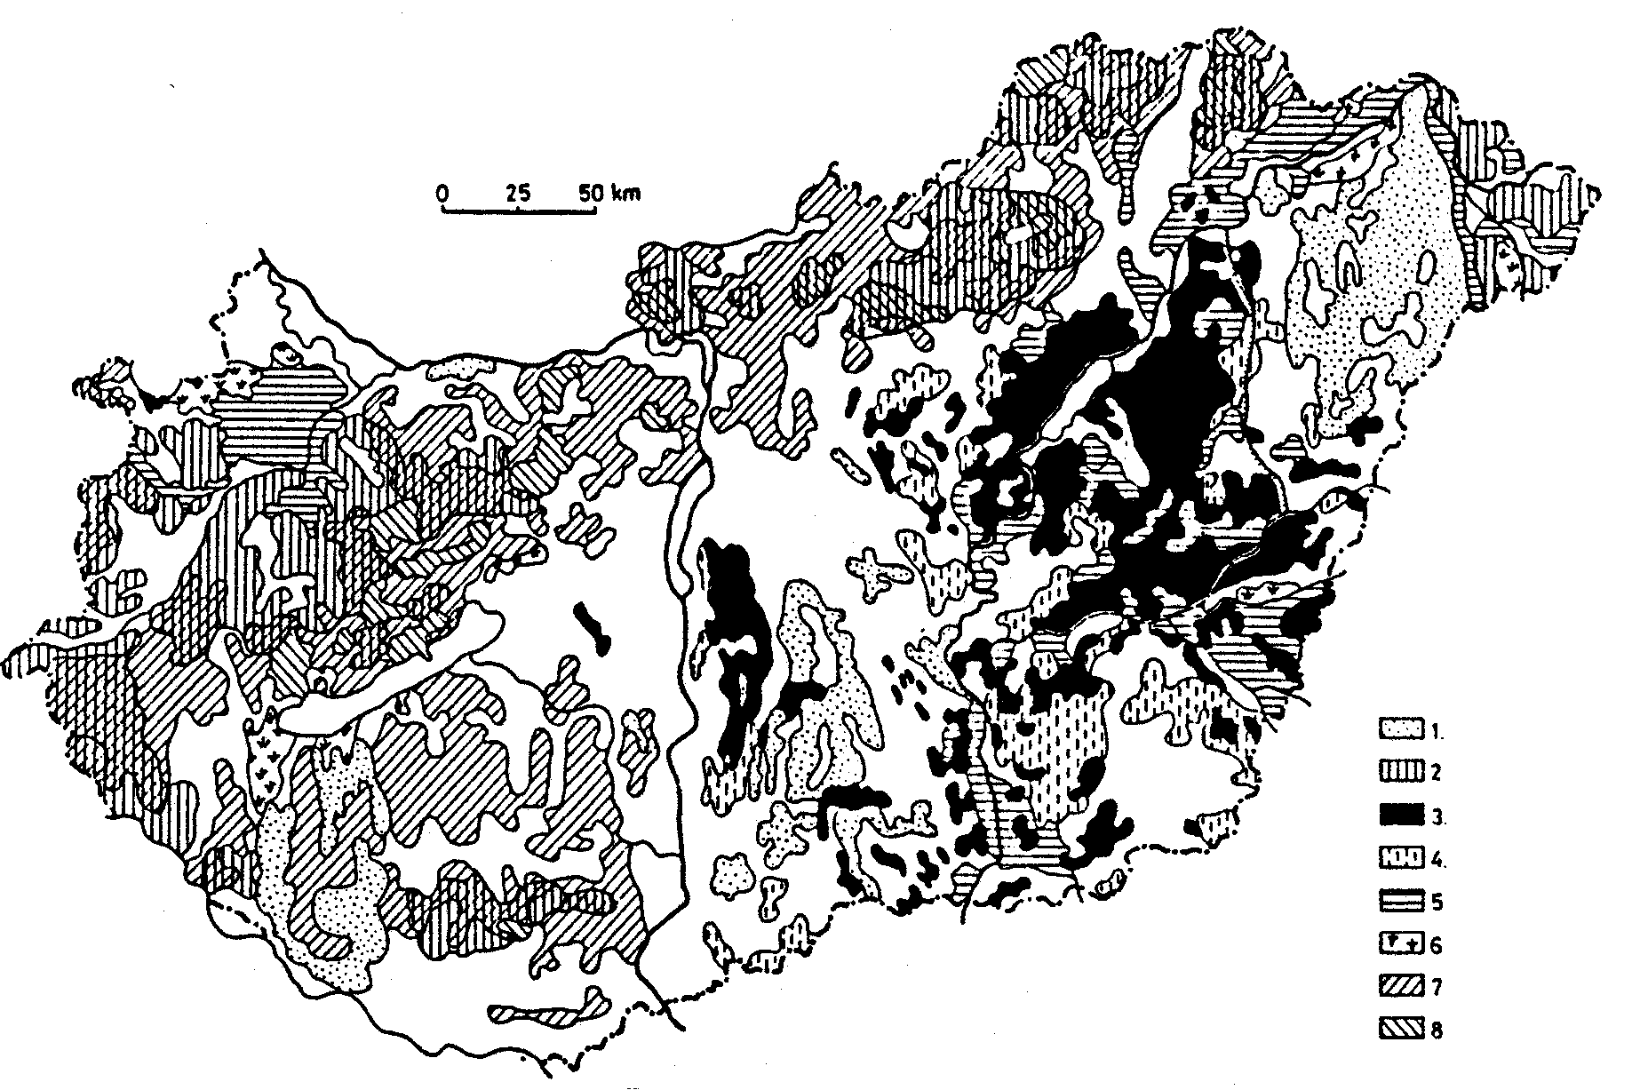
More than half of the country’s land is affected by various ecological constraints (Figure 1) (Szabolcs and Várallyay, 1978). In addition to the existing limitations extensive areas are threatened by various unfavourable soil processes (Table 1).

Figure 1
Map of the limiting factors of soil fertility in Hungary. 1. Extremely coarse texture. 2. Acidity.
3. Salinity and/or alkalinity. 4. Salinity and/or alkalinity in the deeper layers. 5. Extremely heavy texture. 6. Waterlogging. 7. Erosion. 8. Shallow depth.

Table 1
Limiting factors of soil fertility and soil degradation processes in Hungary

 | Limiting factor of soil fertility | Area,  1000 ha | % |  | Soil degradation processes
1. | Extremely coarse texture | 746 | 8.0 | 1. | Soil erosion: - by water
2. | Soil acidity | 1200 | 12.8 |  | - by wind
 | - combined with erosion | (348) | (3.7) | 2. | Soil acidification
 | - combined with shallow depth | (67) | (0.7) | 3. | Salinization/alkalization
3. | Salinity/alkalinity | 757 | 8.1 | 4. | Physical soil degradation
4. | Salinity/alkalinity in the deeper layers | 245 | 2.6 |  | - structure destruction  - compaction
5. | Extremely heavy texture | 630 | 6.8 |  | - surface sealing
6. | Peat formation, waterlogging | 161 | 1.7 | 5. | Extreme moisture regime
7. | Soil erosion | 1455 | 15.6 |  | - overmoistening, waterlogging
 | - combined with acidity | (348) | (3.7) |  | - drought sensitivity
8. | Shallow depth | 217 | 2.3 | 6. | Biological degradation
 | - combined with acidity | (67) | (0.7) |  | - decrease of organic matter
 |  |  |  |  | - deterioration of soil biota
 |  |  |  | 7. | Unfavourable changes in the nutrient regime
 |  |  |  |  | - leaching
 |  |  |  |  | - biotic and abiotic immobilization
 |  |  |  | 8. | Decrease of the buffering capacity, soil  pollution, „toxicity”

Among these the following four are the most significant:
1. Soil degradation processes
The main soil degradation processes are: soil erosion by water or wind; soil acidification; salinization and/or alkalization; physical degradation (structure destruction, compaction); extreme moisture regime: drought sensitivity and waterlogging hazard; biological degradation; unfavourable changes in the plant nutrient regime; decrease of natural buffering capacity, soil (and water) pollution (Várallyay, 1989c, 2000).
2. Extreme moisture regime (Várallyay, 1989a, 1997).
3. Nutrient stresses
Deficiency or accumulation and/or toxicity of one or more elements in the biogeochemical cycle are strongly increasing environmental threats, mainly due to the non-scientifically based, improperly controlled, sometimes over-chemized social development, including biomass production and waste management.
4. Environmental pollution
Accumulation or mobilization of various, potentially harmful (or even toxic) elements (or compounds) in the „life media” of various organisms, in air, in water, in soil; or in the biomass of various organisms within the soil–water–plants–animals–human beings „food chain”.
All these processes are in close connection with soil moisture regime.

Limited water resources
Hungarian water resources are limited. Consequently, their efficient use will be one of the key-issues of agricultural production, rural development and environment protection (Várallyay, 1989a, 1997, 2002).
The average 450–600 mm annual precipitation may cover the water requirement of the main crops even at high yield levels. But the average shows extremely high territorial and temporal variability – even at micro-scale. Under such conditions a considerable part of precipitation is lost by surface runoff, downward filtration and evaporation. The non-uniform distribution of atmospheric precipitation is one reason of extreme moisture regime: the simultaneous hazard of waterlogging or over-moistening and drought-sensitivity in extensive areas, sometimes on the same places within a short period. The other two reasons of extreme moisture regime are the relief (undulating surfaces and the heterogeneous microrelief of the „flat” Hungarian Plain) and the unfavourable hydrophysical properties of some soils, as it was proven by the serious drought in four consecutive dry years in the mid-90’s and in 2003 on one hand, and the catastrophic waterlogging and flood disaster in early 1999 and 2000 on the other hand.
The annual water balance is negative in the Hungarian Plain: 450–600 mm precipitation vs. 680–720 mm potential evapotranspiration. The negative water balance is equilibrated by horizontal inflow (on the surface as runoff; in the unsaturated zone as seepage; and in the saturated zone as groundwater flow) which leads to the accumulation of soluble constituents, the weathering products of a large watershed (Carpathian Basin) in the deeper parts of the area (the Hungarian Plain). This is the main reason for the predominance of accumulation processes and the wide-spread occurrence of salt affected soils under such climatic conditions.
Annual precipitation will not be more in the future (in the contrary, it may be less according to the forecasted climate change) and its unfavourable territorial and time distribution will not become more even. An opposite tendency has been forecast: increasing risk (frequency, intensity) of extreme weather events and soil moisture situations,
The available quantity of surface waters (rivers) will not increase, particularly in the critical low-water periods. Most of the rivers (85–90% of their water quantity) flow in from, and flow out to neighbouring countries: Hungary gets a certain amount of water with a certain quality at the entrance points of the rivers, and we have to guarantee a certain quantity and quality at the southern borders – even during the critical low water periods.
A considerable part of the subsurface waters (especially in the Hungarian Plain) cannot be used for irrigation because of their poor quality (salinity, alkalinity, sodicity). Another part of subsurface waters cannot be used because of environment control regulations preventing the lowering of the water table and its unfavourable ecological consequences (e.g. the serious „desertification symptoms” in the Danube-Tisza Interfluve sand plateau).
The increasing demand and water use of the other sectors of national economy (animal husbandry, industry, etc.) and social development (urbanization, rural development, drinking water supply and canalization; recreation; environment protection; etc.) and the unfavourable changes in water quality due to multipurpose water use.
The increasing water requirements for yield security in agricultural production; for prevention, elimination or moderation of unfavourable environmental impacts/deterioration have to be satisfied from these limited water resources. This combined water- and pedoconflict can be solved only through the increase in agricultural water use efficiency with successfuly soil moisture control.
From this aspect it is an important fact that soil is the largest natural water reservoir (water storage capacity) in Hungary. The 0–100 cm soil layer may store about 25–30 km² water, which is more than half of the average annual precipitation. About 50% of it is „available moisture content”. The capillary moisture transport from the good-quality groundwater to the overlying horizons (and to the root zone) is two- or three-times higher than the total irrigation capacity of the country! Consequently, the efficient use of this natural water reservoir has great importance in the prevention of extreme hydrological events. In many cases, however, this huge potential water storage capacity cannot be used because of three reasons:
- it is not „empty”, it is filled to a certain extent by a previous source (rain, melted snow, capillary transport from groundwater, irrigation, etc.);
- the empty pores cannot be filled by the above-mentioned sources, because there is a poorly permeable layer either on the soil surface or near to the surface within the soil profile;
- the water retention of soil is poor and the infiltrated water is not stored, it only percolates through the soil profile.
The main factors limiting the optimum moisture regime are summarized in Figure 2 (Várallyay, 1997).
These are the main reasons of extreme moisture regime, which is a characteristic feature in the Carpathian Basin, especially in the Hungarian Plain:
- hazard of waterlogging or overmoistening: due to limited infiltration;
- drought sensitivity: because the limited quantity of stored water can satisfy the water requirements of plants only for a short dry period.
Extreme moisture regime formulates the need for a „two-way” („double-face”) soil moisture control. Irrigation and drainage, however, have serious economic and environmental limitations:
(a) Drainage limitations:
- poor vertical drainage of the soil profile due to heavy texture, high amount of expanding clay minerals, high salinity/alkalinity (in salt affected soils) with the predominance of Na-CO₃(HCO₃) type salt accumulation, low permeability;
- lack of frost-free period in winter (after the vegetation season);
- lack of drainwater recipient (there is no sea or uncultivated land where the saline drainwaters can be placed without environmental deterioration and the drainwaters cannot be put into rivers and canals because of water quality regulations).
(b) Irrigation limitations:
- relief;
- limited and still decreasing water available for crop production.
Consequently, there are no other alternatives for rational and sustainable agricultural water management than the increase of water use efficiency by proper soil management.

1. Limited infiltration, shallow wetting zone |  | 3. Low availability of soil moisture
A) Impermable layer (crust) on the soil surface |  | 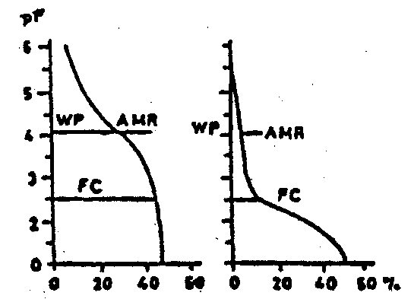
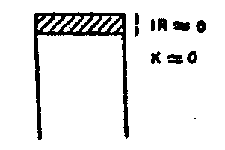 | a) cemented by salts  – Na salts  – gypsum  b) compacted by improper soil management  – over-tillage, heavy machinery  – improper irrigation methods |  | 1. Low AMR (FC–WP)  (as a result of matrix suction, p)  a) high clay content  b) high rate of dispersion  c) high alkalinity, ESP  d) poor structure  e) too low clay content
B) Impermeable layer near to the soil surface
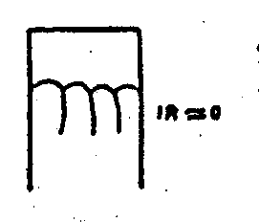 | a) solid rock  b) hardpans (fragipans, duripans, orstein, ironpan, etc.)  c) layer cemented by exch. Na⁺, clay, CaCO₃ and other factors (clay-pan, concretionary horizons, petrocalcic horions, etc.)  d) layer compacted by improper soil management (plough pans, etc.) | 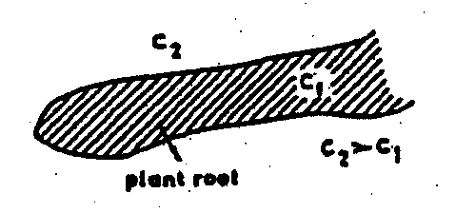 | 2. Low AMR  (as a result of high osmotic potential, ψ)  a) high salinity  ψ_{s} = 0.32 (0.8+0.109 C₁)^{1.03}  C₁ = Cl⁻ conc., meq/litre
⇒ extreme water regime |  | 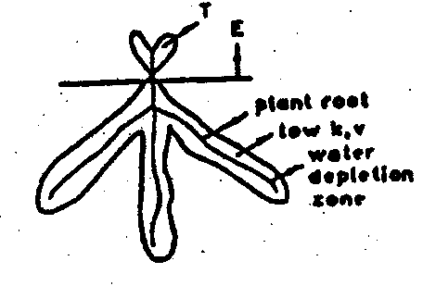 | 3. Low transmissability coefficients (k, D)
 | [oversaturation (aeration problems) ⎢waterlogging problems  [surface runoff – water erosion |  | wilting: V < ET  a) low moisture content  b) high water retention
 | drought sensitivity |  | c) high alkalinity, ESP  d) poor structure
2. Cracking (swelling-shrinkage phenomena)
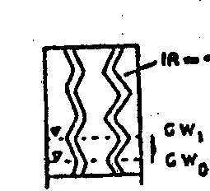 | Dry conditions (shrinkage, cracking)  → filtration losses  → rising water table  → too wet conditions (oversaturation, water-logging)  → secondary salinization/alkalization from the groundwater (in case of stagnant, saline or alkaline groundwater)  → evaporation losses (drying of deep layers) | Figure 2  Limiting factors of optimum moisture regime
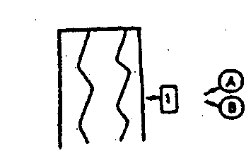 | Wet conditions (swelling)  a) high amount of clay  b) high amount of expanding clay minerals  c) high ESP

The significance and characteristics of soil moisture regime
Soil moisture regime has particular significance both in soil fertility and environmental sensitivity („vulnerability”). It determines the water supply of plants, influences (sometimes determines) the air- and heat regimes, biological activity, biogeochemical cycles and plant nutrient status of soil. It has an impact on the technological properties of soils, determining the necessity, optimum time (interval) of various agrotechnical measures and their technical requirements and energy consumption. It determines the ability of soil buffering or tolerating the influence of environmental stresses and their ecological consequences at present, in the near and far future, in a given area or its surroundings, including the impacts of surface and subsurface water resources.
Most of the main limiting factors of soil fertility and soil degradation processes (Figure 1, Table 1) are related to (are reasons or consequences of) soil moisture regime (Várallyay, 1989c, 2000) (Figure 3).
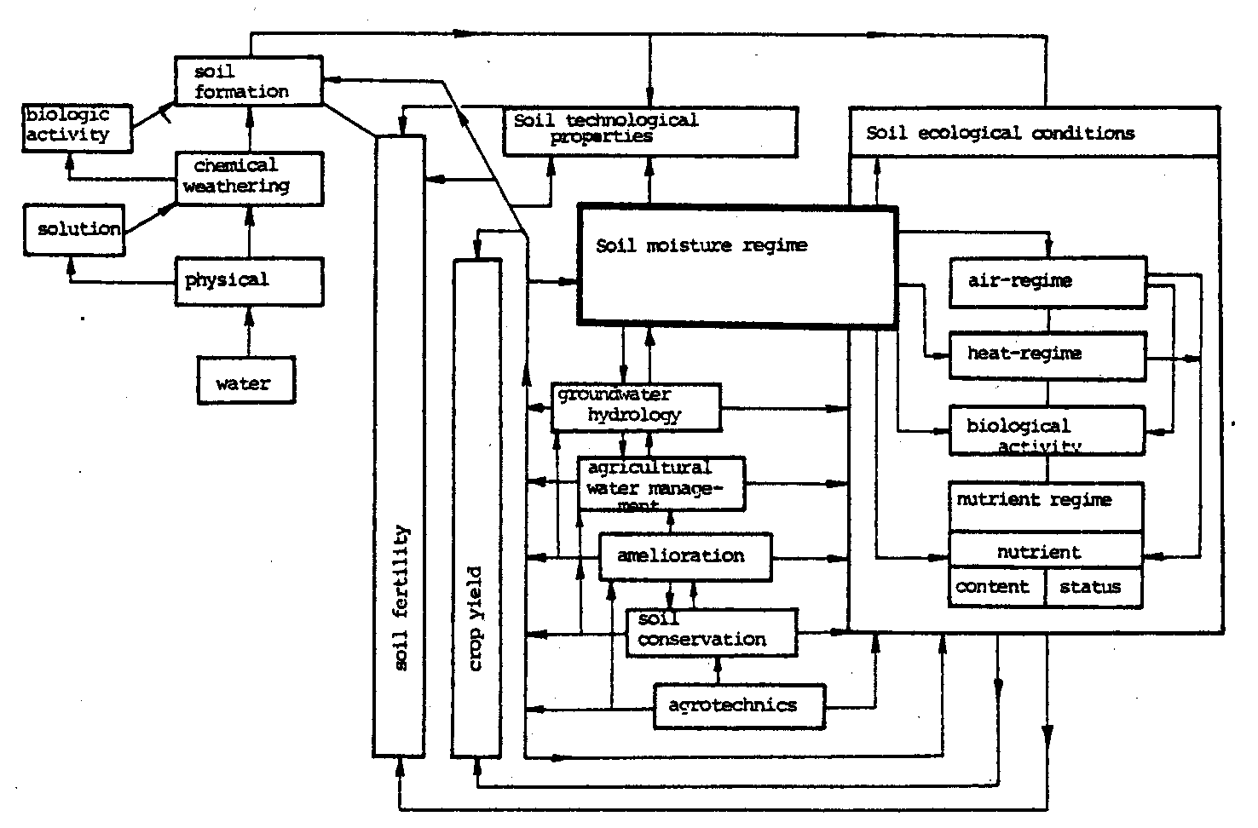

Figure 3
The influence of soil moisture regime on ecological conditions and possibilities of its regulation

According to our comprehensive assessment (Várallyay, 1989a, Várallyay et al., 1980), 43% of Hungarian soils have unfavourable hydrophysical characteristics due to very coarse texture (10.5%), very heavy texture (11%), salinity-alkalinity (10%), waterlogging (3.0%) and shallow depth (8.5%). In 26% of the soils hydrophysical properties are moderately unfavourable due to coarse texture (11%), heavy texture or clay accumulation in the B-horizon (12%), and salinity-alkalinity in the deeper horizons (3%); and only 31% of the soils can be characterized by good hydrophysical properties. In Figure 4 the territorial distribution of these categories are presented for the whole country.

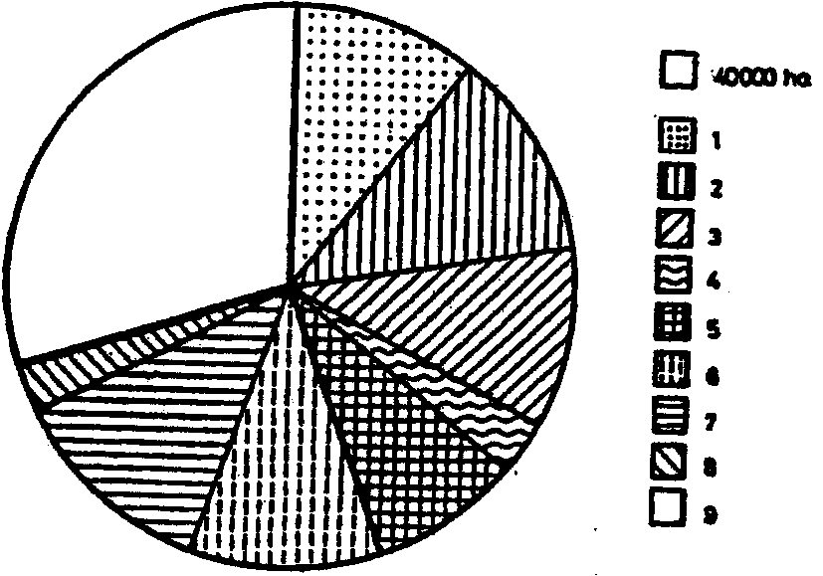 | Figure 4  Distribution of soils according to their hydrophysical properties in Hungary.  1–5 = Soils with unfavourable hydrophysical properties: 1: due to very coarse texture; 2: due to very heavy texture; 3: due to strong salinity-alkalinity;  4: due to waterlogging; 5: due to shallow depth;  6–8 = Soils with moderately unfavourable hydro-physical properties: 6: due to coarse texture; 7: due to heavy texture or clay accumulation in the B-horizon; 8: due to moderate salinity/alkalinity in the deeper layers; 9 = Soils with good hydrophysical properties

Scientific bases of soil water management
For an efficient, scientifically-based soil moisture control adequate information are required on well-defined soil and land properties (especially physical/hydrophysical properties and soil moisture parameters), with the characterization of their spatial (vertical and horizontal) and temporal variabilities, soil processes and pedotransfer functions. These are necessary on various levels (national, regional, farm and field scales) and in all phases (decision making, planning, implementation, control).
In the last decade a comprehensive soil survey–analysis–categorization–prognosis–mapping–monitoring–evaluation system was developed for the exact characterization of hydrophysical properties, modelling and forecasting of water and solute regimes of soils. The computerized, GIS-based soil and water information (including measured, calculated or estimated data on the most important hydrophysical characteristics and soil moisture constants) represent a good scientific basis for the exact assessment on the necessity and on the possibilities of an efficient soil moisture control, beneficial both for agricultural production and environment protection (Várallyay, 1997, 2000, 2001).
The most important elements of the system are as follows:
- Elaboration/adaptation of a methodology for the determination (field or laboratory measurement, calculation, estimation, expert judgement) of the most important physical–hydrophysical properties of soils and the development of an up-to-date digital database for the rational storage, arrangement, evaluation and task-specific interpretation of these information (Várallyay, 1993).
- Development of a category system of hydrophysical soil properties and the preparation of their 1:100 000 scale map (Figure 5) (Várallyay, 1989b; Várallyay et al., 1980).
On the basis of the GIS-supported database the FC, WP and AMR values can be quantitatively interpreted for soil layers, soil profiles, physico-geographical, administrative, farming or mapping units (e.g. ecological region, water catchment area, county, settlement, farm, agricultural field etc.) and serve as a basis for the evaluation of the waterlogging or overmoistening hazard and drought sensitivity, for rational regional or local water management activities.

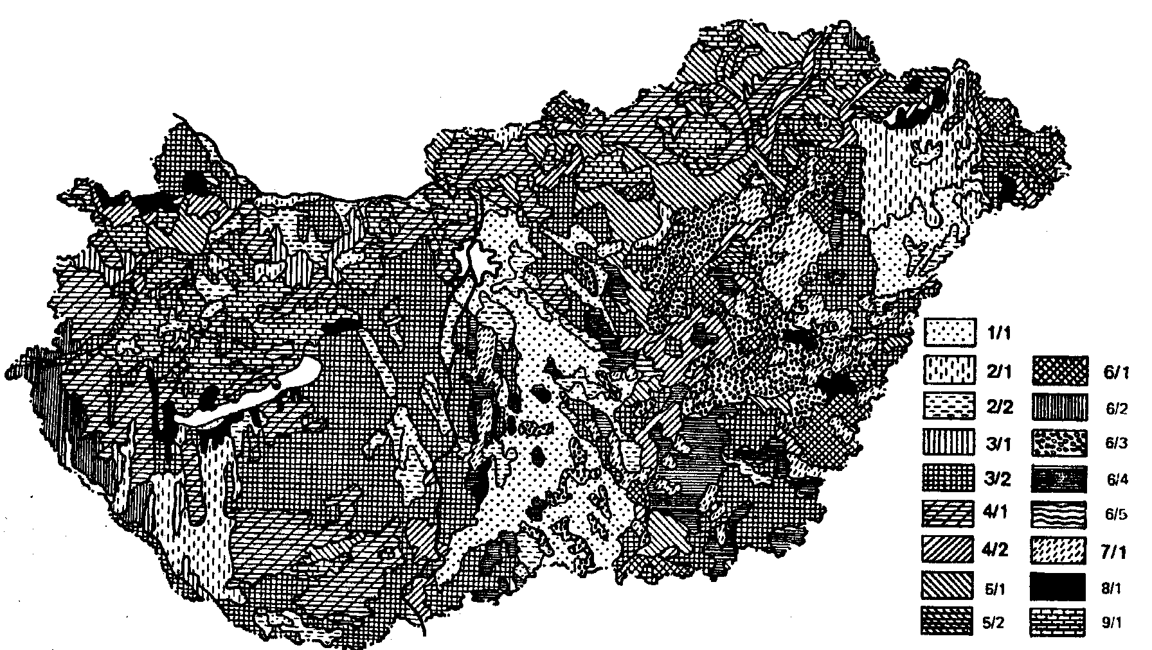
Figure 5. Map of soil water management categories.
The 9 main soil water categories are as follows: 1. Soils with very high infiltration rate (IR), permeability (P) and hydraulic conductivity (HC); low field capacity (FC); and very poor water retention (WR). 2. Soils with high IR, P and HC; medium PC; and poor WR. 3. Soils with good IR, P and HC; good FC; and good WR. 4. Soils with moderate IR, P and HC; high FC; and good WR. 5. Soils with moderate IR, poor P and HC; high PC and high WR. 6. Soils with unfavourable water management: low IR, extremely high WR. 7. Soils with extremely unfavourable water management: very low IR, extremely low P and HC; and very high WR. 8. Soils with good IR, P and HC; and very high FC. 9. Soils with extreme moisture regime due to shallow depth. The main profile variants: (1) texture becomes lighter with depth (soils formed on relatively light-textured parent material): 2/1, 3/1. (2) uniform texture within the profile: 1/1, 2/2, 3/2, 4/2, 5/2. (3) relative clay accumulation in the horizon B: 4/1, 4/1. Profile variants of category 6: 6/1: heavy-textured soils with poor structure and a compact layer formed under the influence of misguided soil management; 6/2: pseudogleys; 6/3. deep meadow solonetzes, solonetzes turning into steppe formation and solonetzic meadow soils (with an A horizon thicker than 15 cm); 6/4: soils with salinity/alkalinity in the deeper horizons.

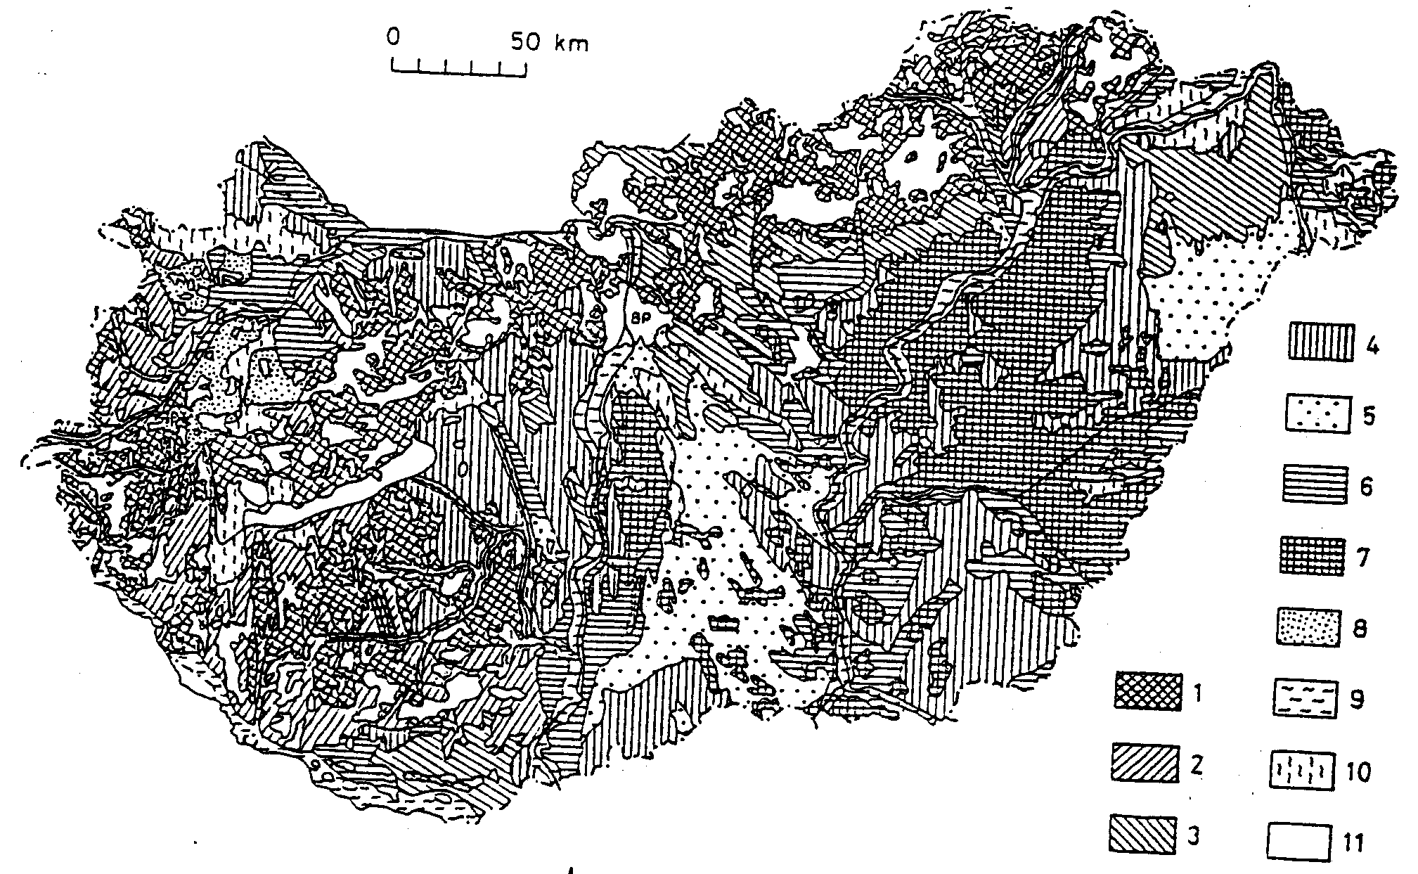

Figure 6
Map of the main moisture regime types of Hungarian soils (simplified schematic version of the original 1:500 000 scale map). 1. Heavy surface runoff. 2. Heavy downward flow. 3. Moderate downward flow.
4. Equilibrium type. 5. Rapid filtration type (light-textured soils). 6. Groundwater-wetted type (upward flow is dominant). 7. Extreme moisture regime due to salinity–alkalinity. 8. Extreme moisture regime due to shallow depth. 9. Soils under the influence of rivers and surface streams. 10. Regularly waterlogged areas.
11. Forest with special moisture regime.

- Development of category systems for moisture and substance regimes and the preparation of their maps in the scale of 1:500 000 (Figure 6) (Várallyay, 1985).
- Elaboration of the methodology of the large-scale (1:10 000–1:25 000) mapping of physical and hydrophysical soil properties. The databases and the thematic maps give opportunity for the planning and implementation of farm- and/or field level soil moisture control (Várallyay, 1989b).
- Development of various models for the exact and quantitative characterization and prediction of soil moisture regime, solute transport, moisture stresses and water-related environmental impacts. E.g. elaboration of a 4-step model for the quantitative determination of capillary water (and salt) transport from the groundwater to overlying horizons (to the root zone) in stratified (layered) soil profile with fluctuating water table (Várallyay and Rajkai, 1989). The model was used efficiently for the determination of the
- „optimum depth” or „optimum regime” of the groundwater table ensuring the necessary additional moisture supply of plants from a good-quality groundwater; and the
- „critical depth” or „critical regime” of the groundwater table preventing salt accumulation, salinization–alkalization–sodification from poor-quality, saline groundwater.

Soil moisture control as an integral part of soil–water pedoconflict management
The scientific results give opportunities for the prediction of the impacts of various climate/weather conditions, land use and cropping patterns, and agrotechnical measures on the soil moisture regime, for the forecast of extreme hydrological events (overmoistening, waterlogging; drought), surface runoff and erosion hazard, as well as their ecological consequences. On the basis of these information the undesirable impacts can be prevented

Table 2
Elements and methods of soil moisture control with their environmental impacts

Elements |  | Methods | Environ-mental impacts*
Reducing | surface runoff | Increase in the duration of infiltration  (moderation of slopes; terracing contour ploughing; establishment of permanent and dense vegetation cover; tillage; improvement of infiltration; soil conservation farming system) | 1,1a  5a, 8
Reducing | evaporation | Helping infiltration (tillage, deep loosening)  Prevention of runoff and seepage, water accumulation | 2,4
Reducing | feeding of ground-water by filtration losses | Increase in the water storage capacity of soil; moderation of cracking (soil reclamation); surface and subsurface water regulation | 5b, 7
Reducing | rise of the water table | Minimalization of filtration losses (↑);  groundwater regulation (horizontal drainage) | 2,3  5b,5c
Indreas-ing | infiltration | Minimalization of surface runoff (tillage practices, deep loosening) (↑) | 1,4,5a, 7
Indreas-ing | water storage in soil in available form | Increase in the water retention of soil; adequate cropping pattern (crop selection) | 4,5b,7
Irrigation |  | Irrigation; groundwater table regulation | 4,5c,7,9,10
Surface  ⎬ drainage  Subsurface |  | surface  ⎬ moisture control (drainage)  subsurface | 1,2,3,5c,6,7, 11

* Referring numbers: See below

Favourable environmental effects | Unfavourable environmental effects

Prevention, elimination, limitation or moderation of:
- water erosion (1)  - sedimentation (1a)  - secondary salinization, alkalization (2)  - peat formation, waterlogging, overmoistening (3)  - drought sensitivity, cracking (4)  - plant nutrient losses by:  - surface runoff (→ surface waters eutrophication) (5a)  - leaching (→ subsurface waters) (5b)  - immobilization (5c)  - formation of phytotoxic compounds (6)  - “biological degradation” (7)  - flood hazard (8) | - overmoistening, waterlogging, peat and swamp formation, secondary salinization/ alkaliza-tion (9)  - leaching of plant nutrients (10)  - drought sensitivity (11)

or reduced, and the necessary soil moisture regulation measures can be efficiently implemented in time. The comprehensive soil physical–hydrophysical database is, and will be used in such national or regional projects as wetland reconstruction, irrigation development; and it is an integral part of regional, continental and global projects on pedoconflict management.
Under the Hungarian natural conditions, the main objective of efficient soil moisture management is to increase the water storage within the soil in plant available form without any unfavourable environmental consequences:
- to reduce evaporation, surface runoff and filtration losses of water (atmospheric precipitation and irrigation water);
- to increase the available moisture range of the soil (to help infiltration into the soil; increase the water storage capacity; reduce the immobile moisture content);
- to improve the vertical and horizontal drainage condition of the soil profile or the given area (prevention of over-saturation and waterlogging).
The highly variable moisture regime of soils would necessitate a special „two-way”, „double-faced” soil moisture control in Hungary:
- ensuring (or making possible) the drainage of excess water, and
- giving the necessary additional water.
Because both direct actions (irrigation, drainage) are faced with serious limitations in Hungary and are rather expensive, all efforts have to be taken to improve agricultural water use efficiency by proper moisture control and rational soil management. Their most significant possibilities are summarized in Table 2. Most of these measures are – at the same time – efficient elements of environment protection. Their potential favourable and unfavourable environmental impacts are also presented in the Table.
The basic concepts and methodologies of these actions are generally known. Their up-to-date precise technologies have to be elaborated and their large-scale practical implementation has to be stimulated by using a wide spectra of direct and indirect tools, as teaching, education, advisory service; legislation, and the development of an environment-friendly, water-saving and rational land use moral in the entire society.

References
Láng, I., Csete, I. & Harnos, Zs., 1983. [The Agro-ecological Potential of Hungarian Agriculture in 2000]. (H) Mezőgazdasági Kiadó. Budapest.
Szabolcs, I. & Várallyay, Gy., 1978. [Limiting factors of soil fertility in Hungary] (H,e,g,r) Agrokémia és Talajtan. 27. 181–202.
Várallyay, Gy., 1985. ]Main types of water regimes and substance regimes in Hungarian soils] (H,e,g,r) Agrokémia és Talajtna. 34. 267–298.
Várallyay, Gy., 1989a. Soil water problems in Hungary. Agrokémia és Talajtan. 38. 577–595.
Várallyay, Gy., 1989b. Mapping of hydrophysical properties and moisture regime of soils. Agrokémia és Talajtan. 38. 800–817.
Várallyay, Gy., 1989. Soil degradation processes and their control in Hungary. Land Degradation and Rehabilitation. 1. 171–188.
Várallyay, Gy., 1993. Soil data-bases for sustainable land use: Hungarian case study. In: Soil Resilience and Sustainable Land Use. (Eds.: Greenland, D. J. & Szabolcs, I.) 469–495. CAB International. Wallingford.
Várallyay, G., 1997. Environmental relationships of soil water management. Proc. 2nd Intern. Seminar on Soil, Plant and Environment Relationships, Debrecen, 1996. Current Plant and Soil Science in Agriculture. No. 1–2. 7–32.
Várallyay, Gy., 2000. Soil degradation processes in Hungary: assessment, risk analysis, forecast and prevention. In: Proc. Conf. “Soils in Central European Countries, New Independent States, Central Asian Countries and in Mongolia” “Present situation and future prospects”. 86-99. C. L. Mayer Foundation ESB, Prague.
Várallyay, Gy., 2001. Soil conditions influencing extreme hydrological events. Proc. 19th European Regional Conference of ICID, 4–8 June, 2001. Brno. (161) 1–9.
Várallyay, Gy., 2002. The role of soil and soil management in drought mitigation. In: Proceedings of the International Conference on Drought Mitigation and Prevention of Land Desertification, Bled, Slovenia, April 21–25, 2002. ICID–CIIC. (CD)
Várallyay, Gy., 2003. The role of soils’ multifunctionality in future sustainable agricultural development. Acta Agronomica.
Várallyay, Gy. & Rajkai, K., 1989. Model for the estimation of water and solute transport from the groundwater to the overlying soil horizons. Agrokémia és Talajtan. 38. 641–656.
Várallyay, Gy., Szûcs, L., Rajkai, K., Zilahy, P. & Murányi, A., 1980. [Hydrophysical properties of Hungarian soils and the map of their categories in the scale of 1:100,000] (H,e,g,r) Agrokémia és Talajtan. 29. 77–112.

