MEAN ANNUAL DISCHARGES IN COVERED CROATIAN KARST

Ranko Žugaj¹, Krešimir Plantić², Vladimir Jurak¹

University of Zagreb, Faculty of Mining, Geology and Petroleum Engineering, Zagreb, Croatia
2Hidroinženjering, Zagreb, Croatia

Abstract: The upstream part of the Kupa river basin and the basins of its main tributaries Gornja Dobra, Mrežnica and Korana is a karst area with similar main characteristics of runoff. It belongs to the upper basin of Danube in Croatia. The influential basin area of the Kupa river in the upper karstified part and of its tributaries is about 5,000 km², and the total mean discharge of water from that region is about 150 m³/s – which corresponds with the main specific inflow of 30 l/s/km².
In the paper, the results of the regional hydrological analysis for the mean annual discharges are presented. The available data of observations and measurements of hydrological parameters collected from 35 hydrological stations from 18 watercourses were used. The data analysed are from the period from 1951 to 2000. On the basis of the correlation analysis for the characteristic parameters of mean annual discharges, eight biparameter mathematical formulas having the coefficients r>0.90 were defined.
Key words: karst hydrology, regional hydrological analysis, discharge, Kupa basin, Croatia

Zusammenfasung: Die obere teilen fon Kupa Flussgebiet und die wichtigste Nebenflüssen: Gornja Dobra, Mrežnica und Korana, in obere Karst, die gleiche Abfluss Karakteristik haben. Sie sind die Teile fon obere Donau Flussgebiet in Croatien. Die influentische Flussgebit fon Kupa mit ihren Nebenflüssen 5,000 km² groß ist, und die totale mitte Wasser Abfluss fon die Region umgefahr 150 m³/s ist – welche koresponden fur die wichtige specifiche Abfluss fon 30 l/s/km² ist.
In diese Vortrag, die Resultaten fon die regionale hidrologische Analyse für die Jahresmittelwasser presentiren sind. Die Messendaten und die hidrologische Parameter fon 35 hidrologischen Messteilen fon 18 Wasserlaufen in Peride fon 1951. bis 2000. sind. Corelatische Analysen für die karakteristische Parametern für Jahresmittelwasser, acht biparamerische matematische Formulen die corelatische Koefficient r>0.90 haben.
Schlüsselworte: Karsthidrologie, regionale hidrologische Analyse, abfluss, Kupa Flussgebiet, Croatien

1. Introduction

The analysed basin area of the upstream part of the Kupa river belongs to the Dinaric karst (Figure 1), which comprises Slovenia, southern part of Croatia, Bosnia and Herzegovina and Montenegro. It spreads parallel with the Adriatic Coast along a 50 to 150 km wide and about 700 km long belt. The total area of the Dinaric karst is about 57,000 km² (Herak, Stringfield, 1972).

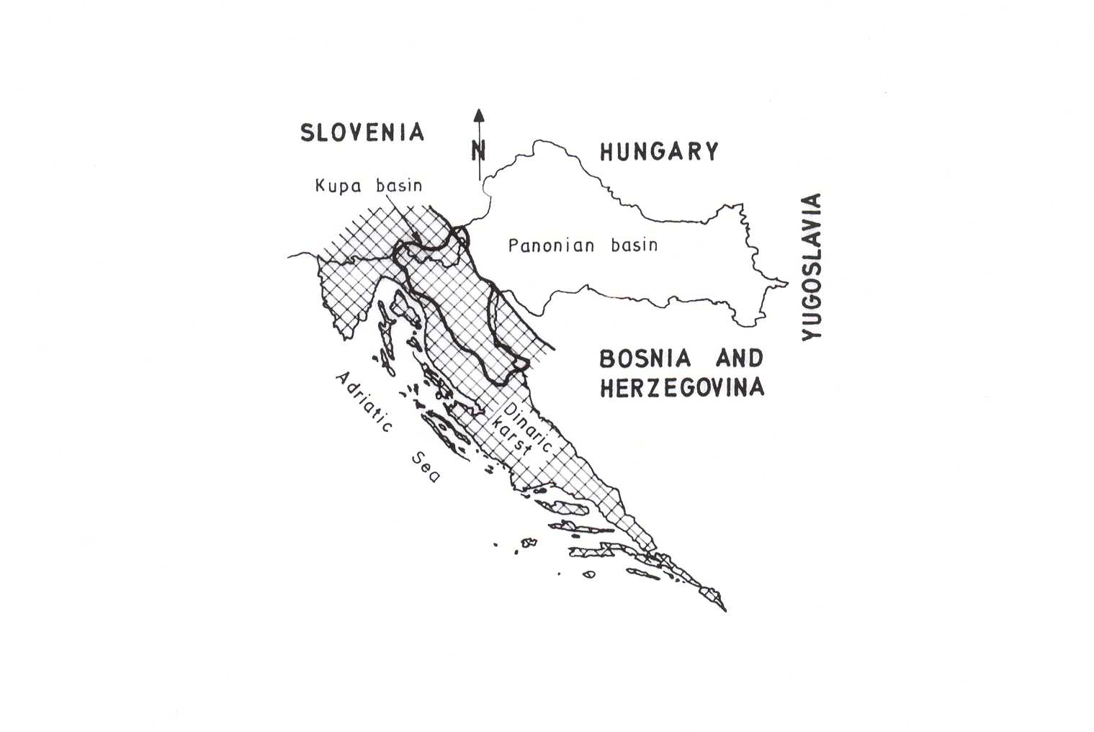

Figure 1 The region of the Dinaric karst in Croatia (according to Biondić et al., 1998)
The influential basin area of the Kupa river in the upper karstified part and of its main tributaries Dobra, Mrežnica and Korana is about 5,000 km² large (Figure 2).

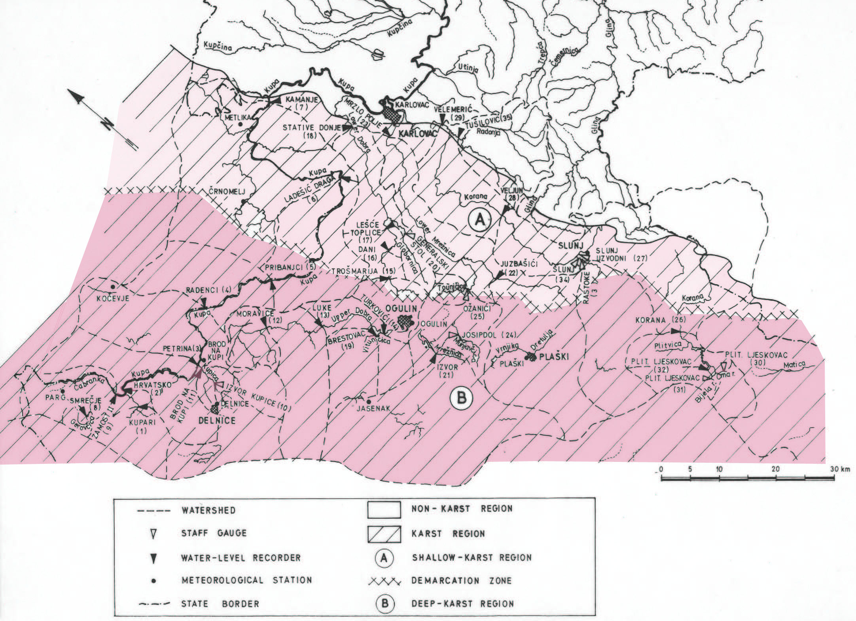

Figure 2 Situation of the Kupa basin

For the karst basins, the differences in their size according to different analyses are not unusual. In this analysis, the results of the recent available hydrogeological cognitions were used and according to them the situation of the basin in Figure 2 finalized. Despite that, all the questions on the position of the drainage divide have not yet been solved, so field and study hydrogeological investigations should at any rate be continued. The analyses described were carried out in the context of the scientific projects of the Ministry of Technology and Science of the Republic of Croatia (Žugaj et al., 2003).

2. Results of the investigation

Out of 35 hydrological stations analysed in only one station (Kupa, Radenci) data on mean annual discharges were not acceptable for the regional hydrological analysis. Hence, the data from 34 hydrological stations were treated regionally. During the analysed 50 years, from 1951 to 2000, the hydrological series analysed had 33 data on average within the limits from 7 to 50.
Special attention was paid to the quality tests of the input calculated data, so homogeneity and the trends of series of annual discharges were particularly analysed. The incidence of a dry period after 1980 was established, which had an effect on the homogeneity of the series of mean discharges. Out of the total of 34 series of maximum annual discharges analysed, the applied non-parameter Wilcoxon's test of homogeneity showed the occurrence of inhomogeneity in 15 of them. The investigation of the trends of the most series of mean annual discharges showed declining trends.
Some of the interesting essential features of the characteristic parameters analysed are shown in the histograms in Figure 3.

Figure 3 Frequency histogram of influent catchment areas A, average annual gross precipitation P, effective precipitation P_{e}, variation coefficient of mean annual flows c_{v} and asymmetry c_{s} and outflow coefficients c
The area of the basins up to the particular hydrological profiles range from A = 8.9 km² (the basin of Bijela Rijeka to the profile of Plitvički Ljeskovac) to A = 2337 km² (the basin of Kupa to the profile of Kamanje). Most frequently basins – in 37 percent of cases – cover the area from 100 to 500 km².
From the histogram in Figure 3, it is evident that the quantities of mean annual precipitation P most frequently – in 37 percent of cases – range between 1540 and 1850 mm.
The values of mean annual effective precipitation P_{e} most frequently – in 36 percent of cases – range between 780 and 1040 mm, and in eight percent of cases are very high – from 1820 to 2080 mm.
The coefficients of variation of mean annual discharges are not particularly high, most frequently ranging (in 44 percent of cases) within the limits of c_{v} = 0.15 – 0.20.
The range of the coefficients of asymmetry of mean annual discharges is rather high – from c_{v} = -0.70 to c_{s} = 1.88, most frequently (in 68 percent of cases) ranging from –0.50 to 0.50.
The coefficients of the runoff of mean waters can be estimated as high, ranging in 64 percent of cases from c = 0.6 to 0.8.

Figure 4 Standard deviation of mean annual discharges σ and average annual discharges Q - nonlinear correlation

Figure 5 Average annual effective precipitation Pe and average annual gross precipitation P - linear correlation

Figure 6 Average annual discharges Q and influential catchment areas A linear correlation

Figure 7 Average annual discharges Q and influential catchment areas A nonlinear correlation

After having reviewed the values of the coefficients of correlation, mathematical formulas for the patterns of the relations of two variables were defined. On the basis of the data from the period of homogeneity, eight formulas for characteristic parameters of mean discharges were defined and presented in Table 1. In Figure 4 the linear pattern of the relation Q = f (A), relation (1), is presented, and in Figure 5 a non-linear pattern of the relation Q = f(A) – relation (2). Probable deviations within which there are 5 percent of input calculating data are very large being in relation (1) σ_{p} = ± 192% and in relation (2) σ_{p} = ± 68.4%.
In Figure 6 the pattern of the relation σ = f(Q) defined by relation (6) is presented and in Figure 7 the linear pattern of the relation P_{e} = f(P) defined by relation (7). According to relation (6), probable deviations of the input calculating data from the values are σ_{p} = ± 36.8% and according to relation (7), they are σ_{p} = ± 25.1%.
In Table 2, three patterns of the relations – relation (9), (0) and (1) – were derived for characteristic parameters of mean annual discharges for the dry period that occurred after 1981.

Table 1. The most important patterns of the relations of characteristic parameters of mean annual discharges – the period of homogeneity

Relation  number | Relation | Number of  calc. data  n | Coeff. of  correlation  r | Figure  number | Annotation
(1)  (2)  (3)  (4)  (5)  (6)  (7)  (8) | Q = 0.0313A + 1.50  Q = 0.0425A^{0.97}  σ = 0.0053A + 0.92  σ = 0.0163A^{0.87}  σ = 0.165 Q + 0.63  σ = 0.300 Q^{0.88}  P_{e} = 0.86 P – 380  P_{e} = 0.0468 P^{1.35} | 25  25  25  25  25  25  25  25 | 0.94  0.98  0.95  0.99  0.95  0.99  0.94  0.91 | 4  5  -  -  -  6  7  - | σ_{p} = ± 192%  σ_{p} = ± 68.4%  σ_{p} = ± 296%  σ_{p} = ± 45.2%  σ_{p} = ± 200%  σ_{p} = ± 36.8%  σ_{p} = ± 25.1%  σ_{p} = ± 25.2%

Table 2 The most important patterns of the relations of characteristic parameters of mean annual discharges – dry period

Relation  number | Relation | Number of  calc. data  n | Coeff. of  correlation  r | Figure  number | Annotation
(9)  (10)  (11) | P' = 0.93 P' - 500  P'_{e} = 0.0048 P' ^{1.654}  σ' = 0.210 Q^{0.96} | 19  19  19 | 0.92  0.91  0.98 | -  -  - | σ_{p} = ± 34.0%  σ_{p} = ± 31.9%  σ_{p} = ± 51.6%

3. Conclusions

- In the large number of the analysed patterns of relations from Table 1 and 2 the coefficients of correlation were very high – higher than r = 0.90 – but probable deviations, where 95 percent of cases occurred (reliability level of five percent) – in 45 percent of cases were higher than σ_{p} = ± 50%.

- For the relation between effective and gross precipitation (7): P_{e} = 0.86 P – 380, r = 0.94 (Figure 7), acceptable limits of probable deviation σ_{p} = ± 25.1% were obtained, and for that reason this relation pattern could be applied in practice.

- The pattern of the relation between standard deviations of mean annual discharges and mean discharges (6): σ_{p} = ± 0.300 Q^{0.88}, r = 0.99, (Figure 6), also had acceptable probable deviations: σ_{p} = ± 36.8%.

- When comparing the patterns of the relations derived in this Study with the patterns of the relations from regional karst analysis in Croatia (Žugaj, 1995) in Figure 4, 5, 6 and 7, some logical differences can be observed. They are more expressed in mean discharges and basins presented in Figure 4 and 5 than in mean effective and gross precipitation presented in Figure 7.

4. References

Biondić, B., Biondić, R., Dukarić, F. (1998): Protection of Karst Aquifers in the Dinarides in Croatia, Environmental Geology 34 (4), 309-319.
Herak, M., Stringfield, V.T. (1972): Karst - Important Karst Regions of the Northern Hemisphere, Elsevier, Amsterdam.
Žugaj, R. (1995): Regional Hydrological Analysis in the Karst of Croatia, Croatian Hydrological Society, Zagreb.
Žugaj, R., Jurak, V., Plantić, K. (2003): Regional Analysis of the Basin Areas of Kupa and the Tributaries in Karst, University of Zagreb, Faculty of Mining, Geology and Petroleum Engineering, Zagreb.

