CONSIDERATIONS CONCERNING THE OVEREXPLOITATION
OF GROUNDWATERS RESOURCES

Mihai Bretotean

National institute of Hydrology and Water Management, Bucuresti, Romania,
e-mail: mihai.bretotean@hidro.ro

Abstract: Starting from the signification of exploitation resources definition of groundwater, it characterisizes their overexploitation state, taking into account the decisions of parliament and European Commission Directive (60 /2000 /EC) regarding the establishing of a framework in water policy domain.
It presents the overexploitation impact on qualitative and quantitative state by means of following assessment indices:
- The variation annual index of levels depth;
- The variation annual index of chemical contamination specific indicators;
- The variation annual index of the critical depth from ecological point of view of the groundwater level.
In case of groundwater modeling it specifies the establishing mode of descent admissible limit of piezometric levels as basic for the groundwater resources assessment.
The groundwater monitoring is seen as one of most important methods for the overexploitation state assessment.
Keywords: groundwater bodies, groundwater resources, overexploitation groundwater, assessment indices.

BETRACHTUNGEN ÜBER DIE UBERNÜTZUNG DER GRUNDWASSERVORRÄTE

Zusammenfassung: Ausgehen von der Bedeutung der Bestimmung der nutzbaren Grundwasservorräte, hat man ihnen Übernutzungszustand charakterisiert, weil man die Richtlinie 2000/60/EC des europäischen Parlamentes und des Rates zur Schaffung eines Ordnungsrahmens für Massnahmen der Gemeinschaft im Bereich der Wasserpolitik berücktsicht sein.
Man stellt die auswirkungen der Grundwasserübernutzung über den mengemäβigen und chemischen Zustand des Grundwasserkörpers dar, durch die nächsten Berechnungindexen:
- Den jährlicher Variationsindex der piezometrische Druckflächentiefe;
- Den jährlichen Variationsindex der Spezifikindicatoren der Verschmutzung;
- Den jährlichen Variationsindex Grundwassergrenztiefe aus dem ökologische Gesichtspunkt.
Im Falle der Grundwasserströmungsmodellierung, wird es den Weg der Bestimmung der zullässigen absteigenden den Grenztiefe der piezometrischen Druckfläche der Berechnung der Grundwasservorräte detalliert ausgeführt.
Die Grundwasserüberwachung wird als eine der sehr wichtigen Berechnungsmethode der Übernutzung betrachtet.
Schlüsselworte: Grundwasserkörper, Grundwasservorräte, Grundwasserübernutzung, Berechnungindexen.

1. Introduction
The Water Frame Directive 60/2000/EC stipulates, for the delimitation and description of the groundwater bodies “at risk”, that their overexploitation must be taken into consideration.
The overexploitation is considered in connection with its impact upon the groundwater bodies, as follows:
- The impact upon the quantitative status;
- The impact upon the qualitative status (Figure 1);
- The impact upon the interdependent ecosystems (Figure 2).

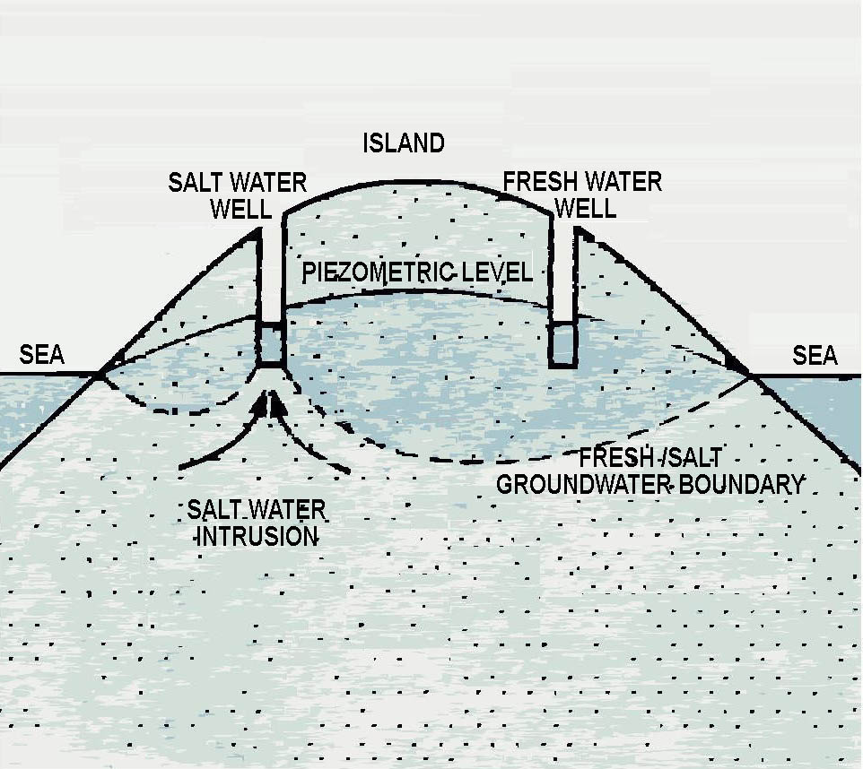
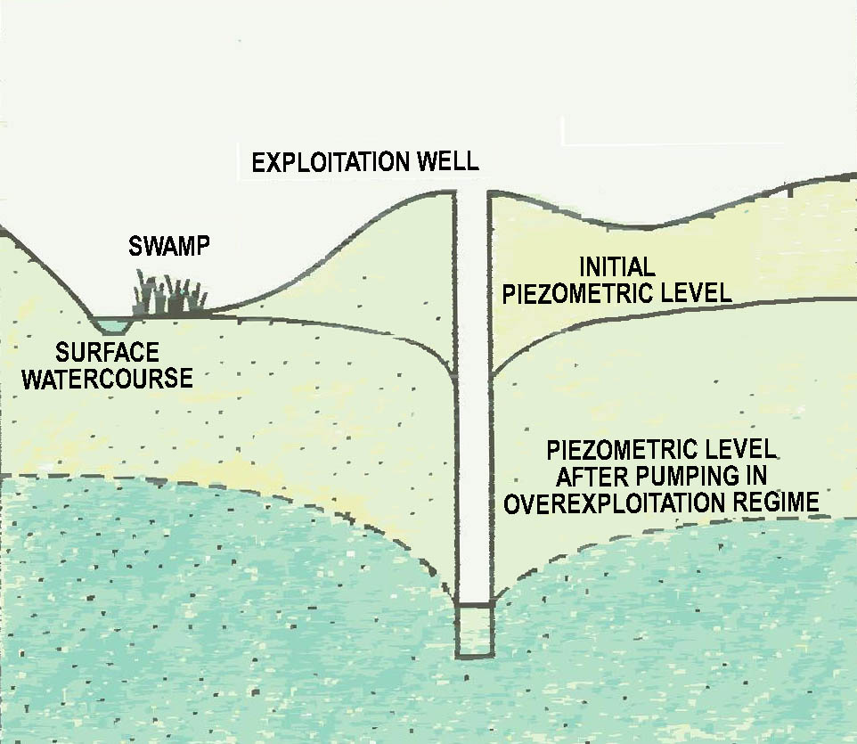

Figure 1. Overexploitation impact upon Figure 2. Overexploitation impact upon
groundwater qualitative status ecosystems being in interdependence

2. Overexploitation indices
The main indices through which the impact of the groundwater bodies overexploitation could be evaluated, are represented by:
- The variation annual index of the levels depth ;
- The variation annual index of the specific chemical (e.g. organic substances, NH4, NO2, NO3, Cl etc.) and microbiological (e.g. total germs, feces coliforms) pollution indicators of the groundwater;
- The variation annual index of the critical depth, from ecological point of view, of the groundwater level.

a. The variation annual index of the levels depth is defined as follows:
Ih_{n} = h_{n}/si_{n,} n = 1,5,
where,
- Ih_{n} is the annual index (n=1:5 successive years) of the levels depth variation, for a constant discharge of the considered groundwater catchment;
- h_{n} – the decreasing of the dynamic levels depth from an year to another, expressed in m;
- si_{n} – the difference between the present dynamic level and the initial piezometric level (measured when the groundwater catchment is started), in the case of a drilling of the considered groundwater catchment, used for monitoring (there will be selected for monitoring, preferably the drillings situated at the two extremities of the groundwater catchment, in the middle of the groundwater catchment and at one quarter of the groundwater catchment extremities);

b. The variation annual index of the specific chemical and microbiological pollution indicators is defined as follows:
Ip_{n} = c_{n}/cma, n = 1,5,
where,
- Ip_{n} represents the annual index (n=1:5 successive years) of the specific chemical and microbiological pollution indicators variation;
- c_{n} – variation of the specific chemical and microbiological pollution indicators (for each indicator), mg/l, respectively number of bacteria/100 cm³;
- cma – the maximum concentration admitted by the Law of the drinking water, in case of the specific chemical and microbiological pollution indicators (for each indicator), mg/l respectively number of bacteria/100 cm³;

c. The variation annual index of the critical depth, from ecological point of view, of the groundwater level is defined as follows:
Ie_{n} = (Npcrt-Np_{n})/Npcrt, n = 1,5,
where,
- Ie_{n} represents the annual index of the critical depth variation from ecological point of view, of the groundwater level
- Np_{n} – the depth of the annual medium level (n = 1:5 successive years) of the groundwater water, expressed in m;
- Npcrt – the depth of the critical piezometric level of the groundwater water from ecological point of view;

3. Groundwater bodies classification depending on overexploitation indices value
Depending on the indices considered above, the groundwater bodies are grouped as follows:
- Groundwater bodies that are not submitted to the overexploitation are represented by those groundwater bodies, whose variation annual index of levels depth (Ih_{n}) in the wells of the considered groundwater catchment, presents values relatively constant from an year to another, in the limit of ±3% (Ih_{n} = h_{n}/si_{n} = ±0,03, n = 1,5 successive years), the variation annual index of the specific chemical and microbiological pollution indicators, presents relatively constant values in the admissible limits of the Law of the Drinking Water (Ip_{n} = c_{n}/cma <1, n = 1,5 successive years), and the variation annual index of the critical depth of the groundwater level from ecological point of view presents positive values (Ie_{n} = (Npcrt-Np_{n})/Npcrt >0, n = 1,5 successive years);

- Groundwater bodies candidates to overexploitation are represented by those groundwater bodies that, increasing the exploitation discharges of the considered groundwater catchment, could become overexploited in the future, the variation annual index of the levels depth (Ih_{n}), in this case, presents decreased values from an year to another, over the limit of 3% (Ih_{n-1} > Ih_{n} > 0,03), the variation annual index of chemical and microbiological pollution indicators, presents increased values in the admissible limits, stipulated by the Law of the Drinking Water (Ip_{n-1} < Ip_{n} < cma) , in areas adjacent to the groundwater catchment and in its wells, and the variation annual index of the critical depth from ecological point of view of the groundwater level, presents null values (Ie_{n} = (Npcrt-Np_{n})/Npcrt = 0, n = 1,5 successive years);

- Overexploited groundwater bodies are those groundwater bodies whose variation annual index of the levels depth (Ih_{n}), in the considered groundwater catchment wells, presents equal values or increased ones, from an year to another, over the limit of 3% (Ih_{n-1} > Ih_{n} > 0,03), the variation annual index of microbiological and chemical pollution indicators presents increased values over the admissible limits stipulated by the Law of the Drinking Water (Ip_{n} > Ip_{n-1} > cma), in areas adjacent to the groundwater catchment and increased values under the admissible limits stipulated by the Law of the Drinking Water (Ip_{n-1} < Ip_{n} < cma) in the groundwater catchment wells, no matter the values of the variation annual index of the levels depth, and the variation annual index of critical depth of the ground water level, from ecological point of view, presents negative values (Ie_{n} = (Npcrt-Np_{n})/Npcrt < 0, n = 1,5 successive years).

4. Groundwater monitoring in overexploitation evaluation aim
In order to determine the quantitative and qualitative status of the groundwater bodies for overexploitation assessment it is necessary their monitoring through a continuously survey program, which includes measurements records regarding the water quantity and quality, the inventory of the existing or potential sources of degradation, and also the prediction of the future changes, by mathematical modeling of groundwater dynamics (Bretotean, 1983, 1984, 1985)
In Romania, the groundwater monitoring achieves by means of the national hydrogeological network and by monitoring local networks.
Total numbers of observation wells for shallow aquiferous strata, at national level, is about 4000, in which it measures groundwater levels, at 3 days.
From these wells, in a number of 1200 it achieves samplings and analyses, twice /year, at minimum and maximum level, for the water quality surveying.
The depth aquiferous strata surveying makes by ca. 500 observation wells.
At present, in Romania, the groundwater monitoring priorities are the following:

- In case of the national hydrogeological network
- In the first stage, the endowment, in an experimental way, of some observation wells with sensors for measuring the levels and determining the water quality regarding the pollution indicators (e.g. organic substances, NH4, NO2, NO3, Cl etc.) and, depending on the results, the extension of the endowment;
- The endowment of the Water Directorates with easy carrying pumps, in order to extract from wells the stagnant water (two volumes of well), before the samples collecting for analyzing;

- In case of the local monitoring networks
- The settlement, by different units that administrate groundwater catchment or potentially polluted objectives of the groundwater, of some local networks of monitoring wells of the respective objectives;
- The accomplishment, in these wells, of systematical measurements of levels and the groundwater quality evolution surveying, taking into account by pollution specific indicators for each considered case;
- Obtained data periodical transmission to the water management authority.

5. References

Bretotean M., (1983): On establishing the exploitation optimum solutions for an confined aquifer.
Proceed. of International Symposium U.N.E.S.C.O. Groundwater in water resources planning, II, Koblenz, Germany.
Bretotean M., (1984): Mathematical modeling for establishing optimum schemes in groundwater
management. Meteorology and Hydrology, I, Inst. Meteo.Hidro, Bucharest, Romania.
Bretotean M., (1985): Groundwater resources evaluation and exploitation optimum schemes
establishing in localities catchment areas. Hidrotehnica, 6, Bucharest, Romania.
Peters, J.H. (1998): Artificial Recharge of Groundwater, A.A. Balkema, Roterdam, Holland.
C.I.S. Working Group for Analysis of Pressures and Impact (2002): Guide for the Analysis of
Pressures and Impact in accordance with the Water Framework Directive, http://forum.europa.eu.int/Public/irc/env.
C.I.S. Working Group for Monitoring (2003): Guide on Monitoring for the Water Framework
Directive, http://forum.europa.eu.int/Public/irc/env.
*** The Water Framework Directive 60 /2000 /EC .

